**Cairo University**

**Faculty of Computers and Artificial Intelligence Information Technology Department**



**HAWKEYE**

**Intrusion Detection System**

### Supervised by

### Dr. Sanaa taha

### TA. M. Saad

**Implemented by**

|  |  |
| --- | --- |
| **ID** | **Name** |
| **20210322** | **Magdy Ibrahim Sayed Ahmed** |
| **20210236** | **Abdullah Ali Abdeltawab** |
| **20210357** | **Mohamed Nabil Mahmoud** |
| **20210272** | **Omar Mohammed Baddour** |
| **20210578** | **Mahmoud Alaa Mahmoud** |
| **20210284** | **Fares Osama Mohammed** |

Graduation Project Academic Year 2024-2025 Mid Documentation

## Abstract

This graduation project aims to develop an **Intrusion Detection System (IDS)** with a **web-based dashboard** from Scratch to enhance network security by monitoring, detecting, and alerting malicious activities in real-time. The system uses **signature-based detection** to identify known threats and **anomaly-based detection** to detect unusual patterns in network traffic. The IDS is designed to detect common cyber threats such as **DoS attacks**, **DDoS attacks,** **XSS Attacks**, and **SQL injections**.

The project includes a **user-friendly dashboard** that provides administrators with a comprehensive overview of network activity, including real-time alerts, attack summaries, and detailed logs. The dashboard allows users to filter and sort alerts, view attack trends through visual charts, and manage rules for threat detection. Additionally, the system stores historical data for analysis and reporting, enabling administrators to identify recurring threats and improve network defenses.

The IDS is implemented using **Python** for backend processing, **Scapy** for packet capture, **Flask** for the web-based dashboard, and **SQLite** for data storage. The system is evaluated on simulated network traffic to evaluate its effectiveness in detecting intrusions and generating accurate alerts. The results demonstrate that the IDS achieves a high detection rate with minimal false positives, making it a reliable tool for securing networks against cyber threats.

This project contributes to the field of **network security** by providing an accessible and efficient solution for intrusion detection, particularly for small to medium-sized networks. Future work includes integrating **machine learning** for improved anomaly detection and scaling the system for larger networks.

## 

## Acknowledgement

## Our gratitude to those who helped us cannot be put into words. First, we would like to express our appreciation and thankfulness to our supervisor,

## Dr. Sanaa taha, for accepting our approach and her utmost care and support for us during our work. Her guidance and mentorship have been critical to our success.

## We would also like to thank TA. Mohammed Saad for his effort with us.

Table of Contents

[Abstract 3](#_Toc190042004)

[Acknowledgement 5](#_Toc190042005)

[Chapter 1 Introduction 11](#_Toc190042009)

[1.1. Background 12](#_Toc190042010)

[1.1.1. The main area of the project 12](#_Toc190042011)

[1.1.2. Main techniques and applications 12](#_Toc190042012)

[1.1.3. Motivation and Justification 12](#_Toc190042013)

[1.2. Problem Statement 13](#_Toc190042014)

[1.3. Objectives 13](#_Toc190042015)

[1.4. Project Scope and Limitations 13](#_Toc190042016)

[1.5. Project Methodology 14](#_Toc190042020)

[1.6. Project Report Outline 16](#_Toc190042022)

[Chapter 2 Network Security & IDS 17](#_Toc190042023)

[2.1 Foundations of Computer Security 18](#_Toc190042024)

[2.1.1 Introduction to Computer Security 18](#_Toc190042025)

[2.1.2 CIA Triad 18](#_Toc190042026)

[2.1.3 Additional Security Concepts 19](#_Toc190042027)

[2.2 Common Security Attacks in the OSI/ISO Layers 20](#_Toc190042028)

[2.3 Network Security: Principles 21](#_Toc190042029)

[2.4 Intrusion Detection System (IDS): 22](#_Toc190042030)

[2.4.1 Introduction 22](#_Toc190042031)

[2.4.2 Different Approaches to the IDS 22](#_Toc190042032)

[2.4.3 Signature-IDS VS Anomaly-IDS 23](#_Toc190042033)

[2.4.4 What is the best? 24](#_Toc190042034)

[2.4.5 Different Forms of the IDS 24](#_Toc190042036)

[Chapter 3 Market and Literature Survey 27](#_Toc190042037)

[3.1 Market & Challenges 28](#_Toc190042038)

[3.1.1 Market Overview 28](#_Toc190042039)

[3.1.2 Market Trends & Adoption 28](#_Toc190042041)

[3.2 Competitors in IDS Market 29](#_Toc190042042)

[3.2.1 Open-Source IDS Solutions 29](#_Toc190042043)

[3.2.2 Commercial IDS Solutions 31](#_Toc190042050)

[3.3 Comparison table 32](#_Toc190042057)

[Chapter 4 33](#_Toc190042058)

[4.1. Project specifications 34](#_Toc190042061)

[4.1.1. Stakeholders 34](#_Toc190042062)

[4.1.2. System architecture 34](#_Toc190042068)

[4.1.3. Functional Requirements 35](#_Toc190042071)

[4.1.4. Non-Functional Requirements 37](#_Toc190042072)

[4.1.5. Use-case Diagram. 39](#_Toc190042073)

[4.1.5.1. Admin 39](#_Toc190042074)

[4.1.5.2. IDS System 41](#_Toc190042076)

[4.1.6. System Component Diagram 44](#_Toc190042078)

[4.1.7. Class Diagram 45](#_Toc190042080)

[4.1.8. Sequence Diagram 46](#_Toc190042082)

[4.2. System Design 55](#_Toc190042083)

[4.2.1. The Whole System **Error! Bookmark not defined.**](#_Toc190042084)

[4.2.2. Summary Section **Error! Bookmark not defined.**](#_Toc190042085)

[4.2.3. Alerts Section **Error! Bookmark not defined.**](#_Toc190042086)

[4.2.4. Logs Section **Error! Bookmark not defined.**](#_Toc190042087)

[4.2.5. Attack Types Statistical Section **Error! Bookmark not defined.**](#_Toc190042089)

[4.2.6. Rules Section **Error! Bookmark not defined.**](#_Toc190042090)

[4.2.7. Attack frequency Section **Error! Bookmark not defined.**](#_Toc190042091)

[4.3. Testing and Evaluation **Error! Bookmark not defined.**](#_Toc190042092)

[4.3.1. Implementation **Error! Bookmark not defined.**](#_Toc190042093)

[4.3.1.1. Traffic PCAP Files **Error! Bookmark not defined.**](#_Toc190042094)

[4.3.1.2. Database 66](#_Toc190042098)

[4.3.1.3. Snort / Suricata Rules 69](#_Toc190042110)

[4.3.1.4. Deep packet Inspection (DPI) 74](#_Toc190042126)

[4.3.1.5. Matching Packets with Rules 82](#_Toc190042179)

[4.3.1.6. What would happen if the rule matched with Packet? 87](#_Toc190042191)

[4.3.1.7. Front-End (UI) 142](#_Toc190042199)

[4.4. Technologies and Tools 158](#_Toc190042224)

[4.4.1. Front-End & UI 167](#_Toc190042225)

[4.4.2. Database 167](#_Toc190042231)

[4.4.3. DPI 167](#_Toc190042233)

[4.4.4. Programming Language 167](#_Toc190042235)

[4.4.5. Tools 168](#_Toc190042237)

[Chapter 5 **Error! Bookmark not defined.**](#_Toc190042247)

[5.1 Introduction **Error! Bookmark not defined.**](#_Toc190042248)

[5.2 History of Anomaly IDS **Error! Bookmark not defined.**](#_Toc190042249)

[5.3 Types of Anomalies **Error! Bookmark not defined.**](#_Toc190042250)

[5.4 Detection Techniques **Error! Bookmark not defined.**](#_Toc190042251)

[5.5 Common Algorithms used. **Error! Bookmark not defined.**](#_Toc190042252)

[5.6 Deep learning for Anomaly Detection **Error! Bookmark not defined.**](#_Toc190042253)

[5.7 Challenges of Anomaly-Based IDS **Error! Bookmark not defined.**](#_Toc190042254)

[5.8 Future Trends in Intrusion detection **Error! Bookmark not defined.**](#_Toc190042255)

[5.9 Real World Implementation of Anomaly-Based IDS **Error! Bookmark not defined.**](#_Toc190042256)

[Chapter 6 Conclusions and Future Work 169](#_Toc190042257)

[6.1 Conclusions 170](#_Toc190042258)

[6.2 Suggestions and Future Work 171](#_Toc190042270)

[References 173](#_Toc190042271)

# 

# Chapter 1 Introduction

## Background

### The main area of the project

* + - * The primary focus of this project is the development of an **Intrusion Detection System (IDS)** designed to monitor, analyze, and detect malicious activities within a network. Cybersecurity threats have become increasingly sophisticated, making it essential to implement an IDS that can identify potential attacks in real time and alert administrators to take appropriate actions.
      * **Intrusion detection** is one of the most important and wide-ranging topics in the field of network and organizational security and protection of individuals. There are many methods used in this field, as well as many intrusion detection systems available. Despite the prominent role it plays, it still suffers from some drawbacks, so there is a need to continue researching intrusion detection systems to develop an optimal structure that achieves a high level of protection.

### Main techniques and applications

* + - * Web Dashboard for frontend (Flask).
      * Scapy for DPI (Python).
      * SQLite for the Database.

### Motivation and Justification

* + - * **Intrusion detection** (IDS) is an essential component of modern security infrastructure for networks and organizations. IDS are designed to detect and respond to security threats, such as hacking attempts, malware infections, and unauthorized access.
      * The motivation for using **IDS** is to protect critical assets and data from several types of attacks, including insider threats, external attacks, and advanced persistent threats. **IDS** can help organizations identify security breaches early on, allowing them to respond appropriately to mitigate damage and prevent further attacks. Furthermore, **IDS** can provide organizations with valuable insights into their security posture, by analyzing network traffic and identifying patterns and anomalies that may indicate potential security threats. This information can then be used to improve security policies and procedures, and to implement additional security measures as needed.
      * The justification for **IDS** lies in the fact that threats to network security are constantly evolving, and traditional security measures such as firewalls and antivirus software may not be.

enough to protect against them. **IDS** can provide an additional defense, allowing organizations to identify and respond to threats in real time, and to continuously monitor and improve their security posture. Overall, **IDS** are a critical tool in the fight against cyber threats, and their use is essential for organizations that want to protect their assets and data from malicious actors.

## Problem Statement

* + - * With the rapid expansion of digital networks and online services, cyber threats have become more **sophisticated, frequent, and damaging**. Organizations and individuals face a constant risk of cyberattacks such as **malware infections, unauthorized access, denial-of-service (DoS) attacks, and data breaches**. Traditional security measures like **firewalls and antivirus software** are not always sufficient to detect and prevent these advanced threats, especially those that exploit vulnerabilities in network communication.

## Objectives

- **Detection of Security Threats**: The primary objective of an **IDS** is to detect security threats on the network, such as unauthorized access, malware, and other attacks.

- **Real-time Alerting:** **IDS** should provide real-time alerts to security personnel when a threat is detected, allowing for immediate action to be taken to mitigate the threat.

- **Incident Response: IDS** should provide information to support incident response activities, including forensic analysis of security incidents.

- **Reporting and Analytics: IDS** should provide comprehensive reporting and analytics capabilities to help security personnel identify trends and patterns in network traffic, and to help identify areas where additional security measures may be needed. - Detection of Security Threats: The primary objective of an **IDS** is to detect security threats on the network, such as unauthorized access, malware, and other attacks.

## Project Scope and Limitations

### Project Scope

- This project focuses on designing and implementing an **Intrusion Detection System (IDS)** to enhance network security by identifying malicious activities in real time. The system is built using a signature-based detection approach, leveraging **PCRE (Perl Compatible Regular Expressions)** for pattern matching, a structured database for storing rules, and a Flask-based web interface for monitoring and management.

**Key Features and Functionalities:**

* Network Traffic Analysis.
* Signature-Based Intrusion Detection.
* Logging and Alerting System.
* Web-Based Monitoring Interface.
* Performance and Optimization.

### Limitations

### - While this IDS project provides an effective solution for detecting cyber threats, it has several limitations that should be considered:

* + Signature-Based Intrusion Detection only.
  + Limited Network Coverage.
  + Single-Node Deployment.
  + Database Performance Considerations:
* Using an SQLite database may limit scalability when handling extremely large rule sets or high-speed network traffic.

## Project Methodology

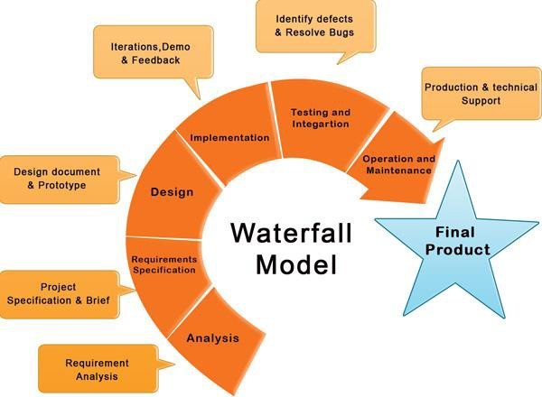- The waterfall method, also known as the waterfall model, is a sequential software development process that progresses through distinct phases, such as requirements, design, implementation, testing, deployment, and maintenance.

*Figure 1*

***Waterfall***

Waterfall model divides software development process into separate phases. The outcome of each phase is the input for the next phase. Development moves from analysis, through design, implementation, testing, installation and ends up at deployment and maintenance. Each phase of development proceeds in strict order.

***Requirements***

The first phase involves understanding what the user needs and what needs to design and what is its function, purpose, etc. Here, the specifications of the input and output or the final product are studied.

***Design***

The bridge that takes us from requirements to solutions (implementation), its objectives is to define and organize the components of the final solution as it serve as the blueprint (structure) for the next stage (implementation stage). In this stage, the design of applications, databases, and user interface are identified. Implementation The design that is identified in the previous stage is implemented through transforming each use case into a working functionality.

***Testing***

Once the system has been developed, it will be tested to ensure that it is working as expected without any defects. A test plan will be followed. Different test cases will be executed according to three types: unit testing, integration testing, and usability testing.

***Deployment***

Once the functional and non-functional testing is done, the product is deployed in the customer environment or released into the market.

### Why Waterfall?

***Clear Structure***

#### The waterfall model provides a clear and structured approach to development, with each phase building upon the previous one.

***Predictability***

Since the requirements are gathered and documented early in the process, and changes are minimized once development begins, the waterfall model offers predictability in terms of project timelines, budgets, and deliverables.

***Documentation***

The waterfall method emphasizes thorough documentation at each stage of the project. This documentation can serve as a valuable reference point for understanding the project's progress, requirements, design decisions, and testing procedures.

***Risk Management***

By breaking down the project into sequential phases, the waterfall model allows for early identification and mitigation of risks. Issues can be addressed in the initial stages, reducing the likelihood of major problems later in the development process.

## Project Report Outline

**Chapter 2. Network Security and Intrusion Detection System**

- In this chapter, we will introduce **network security** and its importance in protecting systems from cyber threats. We will discuss **Intrusion Detection Systems (IDS)** as a crucial defense mechanism for monitoring network traffic and identifying malicious activities. The chapter will cover **types of IDS** (signature-based vs. anomaly-based) and their role in detecting attacks like **DoS, SQL injections, and unauthorized access attempts**. Additionally, we will explain the classifying **IDS** by the Information Source.

**Chapter 3. Market and Literature Survey**

- In this chapter provides a comprehensive analysis of existing solutions, technologies, and research in the field, highlighting gaps and opportunities for innovation. It also examines market trends, user needs, and competitive landscapes to establish the relevance and feasibility of the proposed project. By synthesizing insights from academic literature and industry reports, this chapter lays the foundation for the project's design and implementation.

**Chapter 4. Signature Intrusion Detection System**

- In this chapter, we go deep into the first type of IDS, talk about the first phase specification and the implementation of it.

**Chapter 5. Anomaly Intrusion Detection System**

- In this chapter, we go deep into the second phase, talk about the different types of anomalies, and different techniques of detection

**Chapter 6. Conclusion and Future**

- In this chapter, summarizes the key findings, achievements, and contributions of the project, reflecting on how the objectives were met. It also discusses the proposed potential areas for future improvement and expansion. By outlining future directions, this chapter aims to inspire further research and innovation in the field.

# Chapter 2 Network Security & IDS

## Foundations of Computer Security

## Introduction to Computer Security

* + - * Modern computing has transformed the way individuals, businesses, and governments operate by fostering global connectivity and innovation. However, this progress also brings an increasing number of cybersecurity threats, ranging from data breaches and ransomware attacks to denial of-service incidents. Computer security, also known as cybersecurity or information security, is the practice of protecting systems, networks, and data from unauthorized access, modification, or destruction.
      * At its core, computer security is guided by the **CIA** triad, which stands for **Confidentiality, Integrity, and Availability**. These three principles form the foundation of security policies and frameworks designed to mitigate risks and protect critical assets.

### CIA Triad

* + - * The **CIA** triad is a widely accepted security model that ensures data protection and system reliability. Each principle plays a crucial role in maintaining a secure computing environment.
      * **Confidentiality:** ensures that sensitive information is accessible only to those who have the proper authorization. Unauthorized access to data can lead to identity theft, corporate espionage, and privacy violations. Various mechanisms help maintain confidentiality, including:
* **Encryption:** Encrypting data ensures that only authorized parties can decipher and access it. Algorithms like **AES** (Advanced Encryption Standard) and **RSA** (Rivest-Shamir Adleman) provide robust encryption techniques.
* **Access Controls:** Systems use authentication and authorization techniques such as passwords, multi-factor authentication (**MFA**), and biometric verification to restrict access.
* **Data Masking:** Techniques such as tokenization and anonymization prevent exposure of personally identifiable information (**PII**) or confidential business data.
  + - * **Real-World Example:** A healthcare provider storing patient records must implement encryption and access control measures to comply with regulations like HIPAA (Health Insurance Portability and Accountability Act). Unauthorized access to medical records could compromise patient privacy and lead to legal consequences.
      * **Integrity**: Integrity ensures that data remains accurate, consistent, and unaltered during storage or transmission. Any unauthorized modification, whether accidental or malicious, could lead to misinformation and critical failures. Integrity mechanisms include:
        1. **Checksums and Hashing**: Hash functions like **SHA-256** generate unique identifiers for data, making it possible to detect unauthorized changes.
        2. **Digital Signatures:** Used in email security and software distribution, digital signatures authenticate data sources and confirm their integrity.
        3. **Version Control and Logging:** Tracking changes in databases or files helps identify and restore any unauthorized modifications.
      * **Real World Example:** In financial transactions, banks use cryptographic hashing to ensure that electronic transfers are not tampered with. If a hacker attempts to alter transaction details, the system will detect mismatches in hash values and reject the modification.
      * **Availability:** it guarantees that authorized users have uninterrupted access to computing resources when needed. Cyberattacks such as Distributed Denial-of-Service (DDoS) attacks and system failures can lead to significant downtime and financial losses. Availability is maintained through:
        1. **Redundancy and Failover Systems:** Backup servers, cloud storage, and redundant network connections ensure continued service in case of hardware failure.
        2. **DDoS Mitigation:** Firewalls, load balancers, and intrusion prevention systems (**IPS**) help mitigate attacks that attempt to overwhelm network resources.
        3. **Regular Maintenance and Updates:** Keeping software and hardware updated prevents vulnerabilities that can be exploited by attackers.
      * **Real World Example:** A major e-commerce platform must ensure high availability during peak shopping periods. To prevent downtime from cyberattacks, they employ a Content Delivery Network (**CDN**) and load balancing strategies to distribute traffic efficiently.

### Additional Security Concepts

* + - * Beyond the **CIA** triad, modern cybersecurity includes several additional principles and practices:
      1. Authentication and Authorization.
      2. Security Policies and Compliance.
      3. Threat Detection and Prevention

**Intrusion Detection Systems (IDS)**. **“That What our Project will talk about.”**

**Firewalls**.

**Antivirus Software**.

## Common Security Attacks in the OSI/ISO Layers

* + - * Cyber attackers exploit vulnerabilities at different layers of the **OSI/ISO** model to compromise network security, steal sensitive information, and disrupt communication. We outline the common security threats associated with each layer.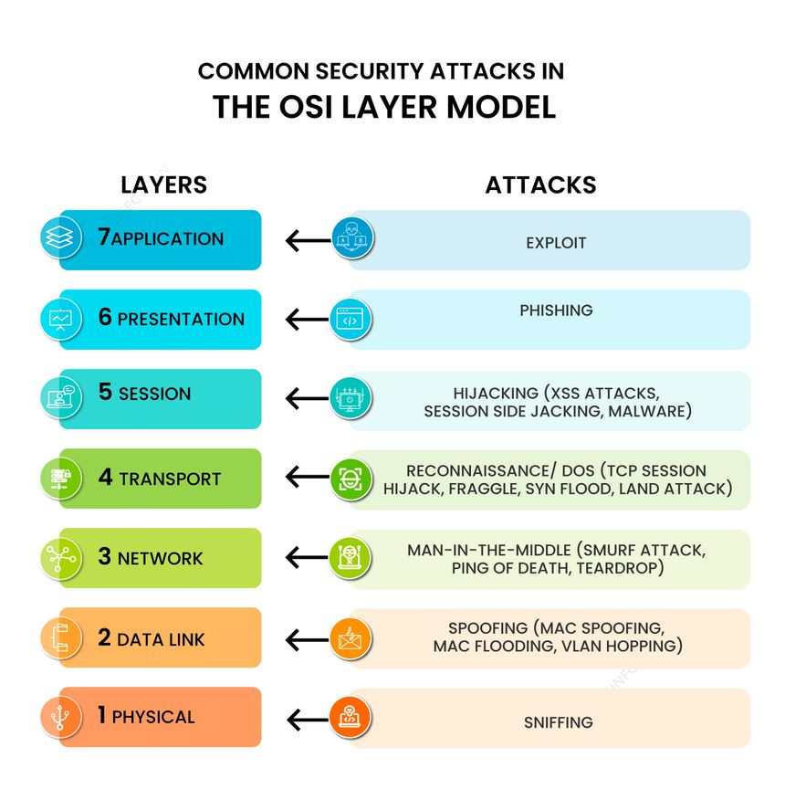
        1. **Application Layer Attacks**: it is the topmost layer of the OSI model, responsible for providing user services such as web browsing, email, and data exchange. Since this layer interacts directly with users and applications, it is a prime target for attackers. Examples:

**SQL Injection (SQLi):** Attackers inject malicious **SQL** code to manipulate or extract sensitive database information.

**Cross-Site Scripting (XSS):** Injecting scripts into web pages to steal user data or perform unauthorized actions.

* + - * 1. **Presentation Layer Attacks:** it is responsible for data encryption, formatting, and translation between application and network layers. Attackers often target this layer to steal sensitive user data through social engineering techniques. Examples:

**Fake Websites:** Cloned versions of real websites designed to steal login credentials.

**Phishing Emails: F**raudulent emails that impersonate trusted organizations to steal user information.

**Malicious Pop-Ups:** Pop-up messages urging users to click on fake links or download malware.

* + - * 1. **Session Layer Attacks:** it establishes and manages communication sessions between devices. Attackers target this layer to hijack active sessions and gain unauthorized access to user accounts or network resources. Examples:

**Session Fixation:** Forcing a victim to use a pre-defined session ID to gain unauthorized access.

* + - * 1. **Transport Layer Attacks:** it is responsible for data transmission between devices, using protocols like TCP and UDP. Attackers commonly target this layer to disrupt network communication or perform reconnaissance on a system. Examples:

**Port Scanning:** Identifying open ports to find potential attack entry points.

**SYN Flooding:** Overloading a system by sending numerous half-open **TCP** connections.

**TCP Reset Attack:** Forcing **TCP** connections to terminate unexpectedly.

**UDP Flooding:** Bombarding a system with massive amounts of **UDP** packets to cause service disruption.

* + - * 1. **Network Layer Attacks:** it is responsible for routing data packets between different devices and networks. Attackers often exploit vulnerabilities in this layer to intercept, modify, or reroute network traffic. Examples:

**Email Hijacking:** Intercepting email communications to steal sensitive information.

**Wi-Fi Eavesdropping:** Monitoring unsecured wireless network traffic to capture confidential data.

**Session Hijacking:** Manipulating session tokens to impersonate users.

**ARP Spoofing:** Sending fake **ARP** messages to trick devices into sending packets to an attacker’s device.

* + - * 1. **Data Link Layer Attacks:** it manages device-to-device communication and **MAC** address assignment. Attackers often use spoofing techniques to impersonate legitimate devices and gain unauthorized access. Examples:

**MAC Spoofing:** Changing a device’s MAC address to bypass network security.

* + - * 1. **Physical Layer Attacks:** it is responsible for transmitting raw data over cables, wireless networks, and other physical mediums. Attackers can exploit this layer to monitor network traffic or disrupt communication channels. Examples:

**Passive Sniffing:** Monitoring traffic without interfering with communication (e.g., capturing unencrypted data on public Wi-Fi).

**Active Sniffing:** Injecting traffic into the network to manipulate or redirect data flows.

## Network Security: Principles

* + - * Network security is based on multiple layers of defense mechanisms, ensuring that if one security measure fails, others are in place to mitigate risks. The core principles include:
        1. **Access Control:** its mechanisms restrict unauthorized users from entering a network or accessing sensitive data.
        2. **Firewalls:** act as a barrier between trusted internal networks and untrusted external sources, filtering traffic based on predefined security rules
        3. **Intrusion Detection and Prevention Systems (IDS/IPS):**

**Intrusion Prevention Systems (IPS):** Take IDS a step further by actively blocking or mitigating threats in real time.

**Intrusion Detection Systems (IDS):** Monitor network traffic for suspicious patterns and generate alerts when potential threats are detected.

## Intrusion Detection System (IDS):

### Introduction

* + - * In today's digital landscape, cybersecurity threats have become increasingly sophisticated, posing significant risks to organizations and individuals alike. Intrusion Detection Systems (IDS) serve as a critical component of modern cybersecurity defenses, designed to identify, alert, and sometimes respond to unauthorized access or malicious activities within a network or host system.
      * IDS operate by continuously monitoring network traffic and system activities, analyzing patterns to detect potential security breaches. By providing real-time alerts and actionable insights, IDS enable security teams to take initiative-taking measures to mitigate threats before they escalate into major incidents.

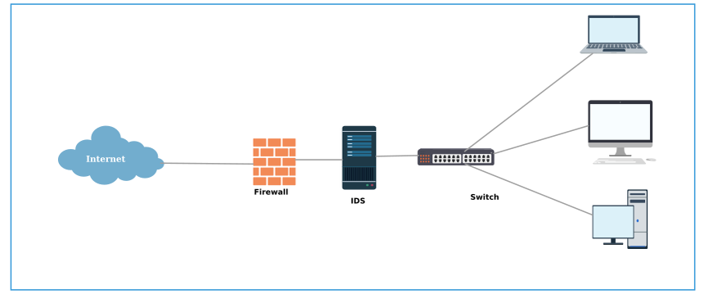

### Different Approaches to the IDS

* + - * IDS employ various methodologies to detect and respond to threats, with each approach tailored to specific security requirements. The primary detection methodologies include:
        1. 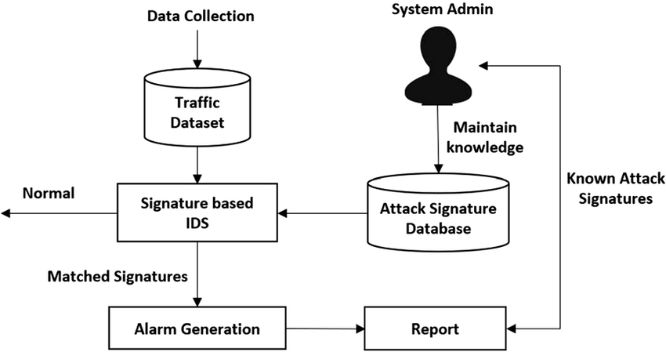**Signature-Based IDS:** It operates by comparing incoming network traffic against a database of known attack signatures. These signatures consist of predefined patterns of malicious activity that have been documented in past cyberattacks. When the **IDS** identifies a match between observed traffic and a stored signature, it generates an alert, enabling security teams to respond accordingly.
        2. **Anomaly-Based IDS:** It takes a different approach by establishing a baseline of normal system behavior and identifying deviations that may indicate potential attacks. These systems use artificial intelligence (**AI**), statistical models, and machine learning algorithms to distinguish between legitimate and suspicious activities.

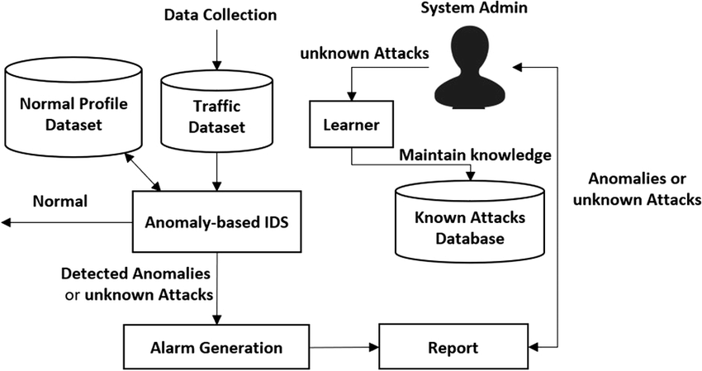

* + - * 1. **Hybrid-Based IDS:** Itcombines both signature-based and anomaly-based detection methods to provide a more comprehensive security solution. This approach leverages the strengths of each methodology, offering precision in detecting known threats while remaining adaptable to new and emerging attack techniques.

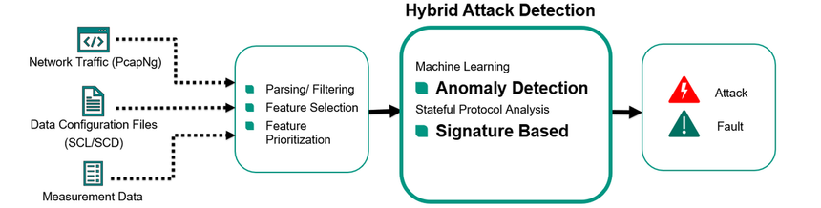

### Signature-IDS VS Anomaly-IDS

|  |  |  |
| --- | --- | --- |
| **Key** | **Signature IDS** | **Anomaly IDS** |
| **Advantages** | * High accuracy in detecting known threats. * Minimal false positives when signature databases are well-maintained. * Fast and efficient detection of common attack patterns. | * Effective against zero-day attacks and novel threats. * Adaptable to evolving attack tactics. * Can detect previously unknown vulnerabilities being exploited. |
| **Limitations** | * Ineffective against new, unknown threats **(zero-day attacks).** * Requires frequent updates to the signature database to remain effective. * It can be bypassed if attackers modify their tactics to avoid detection. | * Higher false positive rates due to variations in legitimate user behavior. * Requires fine-tuning to reduce unnecessary alerts. * More resource-intensive than signature-based **IDS** due to continuous learning and analysis. |

### What is the best?

* + - * + Signature-based IDS is fast and precise for known attacks.
        + Anomaly-based IDS can detect zero-day threats but needs more tuning.
        + Combining both methods provides stronger protection against cyber threats.

### 

### Different Forms of the IDS

* + - * Intrusion Detection Systems can be implemented in different environments, each serving specific security objectives. The primary forms of **IDS** include:
        1. **Network-Based IDS:** It monitors network traffic for signs of malicious activity by analyzing data packets in transit. These systems are strategically deployed at key network locations, such as firewalls, gateways, and routers, to detect unauthorized access attempts and potential cyber threats before they reach internal systems.

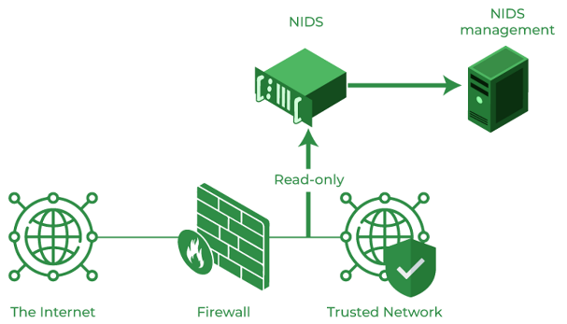

* + - * 1. **Host-Based IDS:** It is installed on individual systems **(e.g., servers, workstations)** to monitor internal activities, including file integrity, system logs, and process execution. HIDS focuses on detecting unauthorized changes, insider threats, and malware infections.

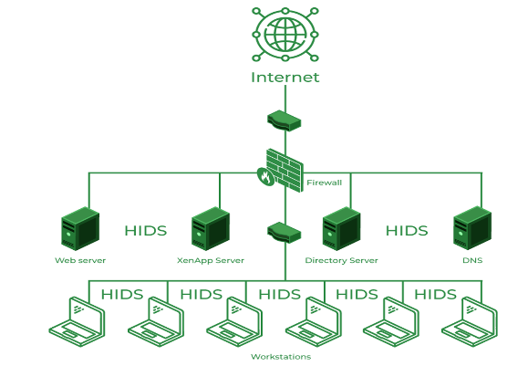

* + - * 1. **Hybrid-Based IDS:** Itintegrates **NIDS and HIDS** capabilities to provide a holistic security framework. By combining network-wide visibility with host-specific monitoring, hybrid IDS enhances an organization's ability to detect and respond to a wide range of threats.

|  |  |  |
| --- | --- | --- |
| **Key** | **Network IDS** | **Host IDS** |
| **Advantages** | * Provides broad visibility across an entire network. * Detects attacks targeting multiple systems. * It can operate passively without impacting system performance. | * Provides detailed insights into host-specific activities. * Effective at detecting insider threats and advanced persistent threats (APTs). * It can operate in environments where network visibility is limited. |
| **Limitations** | * May struggle with encrypted network traffic. * High-speed networks can limit deep packet inspection capabilities. * Requires integration with other security tools for effective incident response. | * Requires installation and maintenance on each host. * Consuming system resources, potentially impacting performance. * Limited scope, as it only monitors activities on the specific host where installed. |



# Chapter 3 Market and Literature Survey

## Market & Challenges

### Market Overview

* + - * The Intrusion Detection System (IDS) market has seen significant growth due to the increasing number of cyber threats and the need for advanced security solutions. Signature-based IDS remains a key component of network defense, particularly for organizations that require real time threat detection against known attacks.

# 

### Market Trends & Adoption

* + - * **The Growing Demand for Network Security Solutions:** 
        + Organizations worldwide are investing in IDS to protect sensitive data and critical infrastructure.
        + Industries such as finance, healthcare, and government agencies heavily rely on IDS to comply with security regulations.
      * **Widespread Use of Signature-Based IDS:** 
        + Despite emerging AI-driven anomaly detection, signature-based **IDS** (e.g., **Snort**, **Suricata**, **Zeek**) remains widely used due to its high accuracy in detecting known threats.
        + Businesses integrate **IDS** with firewalls and **SIEM** (Security Information and Event Management) solutions for a layered security approach.
      * **Cloud & Hybrid Deployments:** 
        + With the rise of cloud computing and remote work, IDS solutions are evolving to monitor both on-premises and cloud traffic.
        + Cloud-based IDS services are being developed to detect threats across distributed networks.
      * **Leading IDS Solutions in the Market**:
        + **Snort (Cisco)** – Open-source **IDS** with extensive community support.
        + **Suricata** – High-performance **IDS** with multi-threading capabilities.
        + **Zeek (formerly Bro)** – Offers deep packet inspection and forensic analysis.
        + **Trend Micro Tipping Point** – Enterprise-level **IDS** with automated threat response.

## Competitors in IDS Market

* + - * **The Intrusion Detection System (IDS)** market is highly competitive, with several vendors offering signature-based solutions tailored for different industries and use cases. Below is a comparison of key competitors in the market, including open-source and commercial **IDS** solutions.

### Open-Source IDS Solutions

### A cartoon pig with yellow text AI-generated content may be incorrect.Snort:

### Snort is the most widely used open-source IDS, originally developed by Martin Roesch and now maintained by Cisco.

|  |  |
| --- | --- |
| **Key** | **Description** |
| **Strengths** | Large community-driven rule set with frequent updates.  Can function as both **IDS** and **IPS** (Intrusion Prevention System).  Integration with Security Information and Event Management (**SIEM**) tools. |
| **Weaknesses** | Single-threaded processing limits performance on high-traffic networks.  Manual tuning is required to reduce false positives. |
| **Usage** | Small to mid-sized enterprises, researchers, and security enthusiasts. |

### A logo with a group of meerkats AI-generated content may be incorrect.Suricata:

### Suricata is a multi-threaded IDS/IPS with deep packet inspection (DPI) capabilities.

|  |  |
| --- | --- |
| **Key** | **Description** |
| **Strengths** | Multi-threading supports better performance in high-traffic environments.  Built-in protocol detection (e.g., **HTTP**, **TLS**, **DNS**, **SMB**) enhances visibility.  Supports **Snort** rules, making migration easy. |
| **Weaknesses** | Requires more system resources than **Snort**.  Complex rule management and tuning needed for optimal performance. |
| **Usage** | Large enterprises and cloud environments require scalable **IDS** solutions. |

### Zeek LogoZeek:

### Unlike traditional IDS, Zeek is a network security monitoring (NSM) tool focused on forensic analysis.

|  |  |
| --- | --- |
| **Key** | **Description** |
| **Strengths** | Provides extensive logging and analysis for threat hunting.  Supports custom scripting to define security policies.  Effective in detecting advanced persistent threats (**APTs**). |
| **Weaknesses** | Not designed for real-time alerting-like Snort or Suricata.  Requires expertise in **Zeek** scripting language. |
| **Usage** | Security researchers, forensic analysts, and **SOC** teams are looking  for deep network visibility. |

### Commercial IDS Solutions

### Trend Micro Tipping Point:

### A high-performance hardware-based IDS/IPS solution.

|  |  |
| --- | --- |
| **Key** | **Description** |
| **Strengths** | Zero-day threat detection with real-time updates.  Inline deployment as an IPS for automated threat blocking.  Scales well for large enterprise networks. |
| **Weaknesses** | Expensive licensing model compared to open-source solutions.  Requires specialized hardware for full functionality. |
| **Usage** | Large corporations and critical infrastructure requiring automated threat prevention. |

### Palo Alto Networks LogoPalo Alto:

### Palo Alto integrates IDS capabilities within its NGFW appliances.

|  |  |
| --- | --- |
| **Key** | **Description** |
| **Strengths** | Uses machine learning (ML) and AI for enhanced detection. Supports SSL decryption to analyze encrypted traffic.  Cloud-based threat intelligence for real-time updates. |
| **Weaknesses** | High cost of deployment.  Requires vendor lock-in with Palo Alto infrastructure. |
| **Usage** | Enterprises seeking an all-in-one security solution **(firewall + IDS + threat intelligence).** |

### IBMIBM QRadar IDS:

### QRadar is a Security Information and Event Management (SIEM) platform with built-in IDS capabilities.

|  |  |
| --- | --- |
| **Key** | **Description** |
| **Strengths** | Advanced correlation engine reduces false positives.  Automated response integration with incident management tools.  Supports multi-cloud environments. |
| **Weaknesses** | Complex deployment and maintenance.  High licensing costs for full **SIEM** capabilities |
| **Usage** | Enterprises looking for centralized security event management. |

## Comparison table

# Chapter 3 Requirements

# & Analysis



## Project specifications

### Stakeholders

## - In this Stakeholders mean individuals or groups that have an interest in any decisions or activities of the project. In the system there are four stakeholders:

## End Users (Network Administrators).

## Cybersecurity Experts and Consultants.

## System Integrators and IT Support Teams.

## Security Incident Response Teams.

### System architecture

### 

### A diagram of a system

### 

### 

### 

### 

### 

### *Figure()*

### Functional Requirements

|  |  |
| --- | --- |
| **Requirement ID** | **Description** |
| **FR01** | The system should **capture and analyze PCAP files** (pre-recorded traffic) using both signature and anomaly-based methods. |
| **FR02** | The system shall support multiple network protocols (e.g., **TCP, UDP, ICMP).** |
| **FR03** | The system shall **parse predefined signature rules** from .txt files or the database, and detect matches using content, flags, **dsize**, **pcre**, **itype**, and threshold options. |
| **FR04** | The system shall allow rules to be defined using **Perl-Compatible Regular Expressions (PCRE)** for advanced matching. |
| **FR05** | The administrator shall be able to **upload, view, and manage custom rules** from the dashboard. |
| **FR06** | The system shall apply **signature detection** logic and raise alerts when a rule is matched. |
| **FR07** | The system shall apply anomaly detection on traffic using a trained hybrid model **(Stacking Model + Isolation Forest)**, and raise alerts if anomalies are detected. |
| **FR08** | Alerts should include details such as:   * + Timestamp.   + Source IP address.   + Destination IP address.   + Attack type **(e.g., DDoS, port scanning, SQL injection)**.   + Detection Method **(Signature or Anomaly)**. |
| **FR09** | Alerts shall be searchable and filterable by timestamp, source IP, destination IP, and attack type. |
| **FR10** | The system shall store all alerts and logs in a structured SQLite database. |
| **FR11** | Logs shall be searchable and filterable by timestamp, source IP, destination IP, and attack type. |
| **FR12** | The system shall include a **web-based dashboard** built with Flask to allow real-time interaction and monitoring. |
| **FR13** | * + The dashboard shall allow the admin to: - View real-time signature alerts - View anomaly detection results - View logs - Upload PCAP files - Upload CSV files (anomaly detection only) |
| **FR14** | The dashboard shall show **statistical summaries**: - Top source IPs - Top destination IPs - Count of alerts by type and severity |
| **FR15** | The system shall generate reports summarizing network activity and detected threats. |
| **FR16** | Reports shall be exportable in multiple formats (e.g., PDF, CSV). |
| **FR17** | The system should send email or SMS notifications to administrators for high-severity alerts. |

### Non-Functional Requirements

|  |  |
| --- | --- |
| **Requirement name** | **Description** |
| **Usability** | * The web dashboard shall be **intuitive, modern, and clear**. * Tooltips and field hints will guide the admin during rule upload or CSV/PCAP selection. |
| **Performance & Response Time** | * The system shall process uploaded traffic and display results **within 1–3 seconds**. * Signatures and anomaly engines run in **parallel threads** to reduce latency. |
| **Scalability** | * The system shall support **extending rule sets**, larger PCAP files, and growing database logs. * It should support **multi-threaded detection** for faster processing. |
| **Security** | * Sensitive data (alerts, logs, rule content) must be **stored securely** in the local database. * The admin interface shall require **authentication** (to be implemented). * Support for **role-based access control** is planned. |
| **Maintainability** | * The codebase shall be **modular**, separating components like rules, packets, logs, alerts, and models. * Each component (e.g., Signature IDS, Anomaly IDS) can be **updated independently**. |
| **Reliability** | * The system must handle **unexpected inputs** (e.g., malformed PCAP or corrupted CSV) gracefully. * In case of failure, the system shall display user-friendly errors and continue serving the dashboard. |

### Use-case Diagram.

### Admin

## - This Use Case Diagram illustrates the interaction between the admin (the only human actor) and the Intrusion Detection System (IDS) User Interface. The system allows the admin to upload data, manage logs, and view alerts and statistics generated by both signature-based and anomaly-based detection engines.

|  |  |
| --- | --- |
| **Use Case** | **Description** |
| **Upload PCAP File** | The admin uploads a. **pcap** or. **pcapng** file containing raw network traffic data. This data is used for real-time detection by both signature and anomaly detection modules. |
| **Upload Rule File** | The admin uploads a rule set **(e.g., in Snort syntax)**. These rules are parsed, extracted, and stored in the database. The signature-based IDS engine later uses them for matching packets. |
| **View Signature Alerts** | The admin can view all alerts generated by the signature-based IDS. These alerts are based on pattern matches between the traffic and uploaded rules. |
| **Clear Logs & Alerts** | The admin can clear all logs and alerts from the database to reset the detection cycle or after maintenance. |
| **Upload CSV File** | The admin uploads a CSV file that contains pre-extracted features from traffic. This is used by the anomaly-based IDS to perform machine learning classification. |
| **View Anomaly Alerts** | The admin can view alerts generated by the anomaly-based IDS, which uses a trained ML model to detect unknown or rare behavior in network data. |
| **View Alert Statistics** | The admin can analyze statistical summaries such as the most frequent source/destination IPs or the distribution of attack types using an Alert Analyzer module. This helps prioritize responses. |

### 

### *Figure()*

### IDS System

## - This Use Case Diagram focuses on internal automated operations handled by the System actor, which includes:

## Parsing and managing rule sets,

## Running detection engines (signature & anomaly),

## Logging & alerting,

## Statistical analysis on collected data.

## Use Cases by category:

## Shared Operations:

|  |  |
| --- | --- |
| **Use Case** | **Description** |
| **Analyze Alerts** | The system reviews alerts to perform further analysis such as frequency, IPs, and attack patterns. This feeds into the UI for visualization. |
| **Analyze Top Src\_Ips** | Identifies and ranks the most frequent source IPs from which alerts have been generated. Useful in tracking potential attackers. |
| **Analyze Top Dst\_Ips** | Like the source IPs, the system lists top targeted destination IPs for deeper inspection. |

## Signature-Based IDS:

|  |  |
| --- | --- |
| **Use Case** | **Description** |
| **Parse & Store Rules** | When the Admin uploads a rule file, the system extracts the header and options and stores them in the database for real-time matching. |
| **Start Signature Detection** | Initiated after receiving packets (e.g., from a PCAP), the system starts comparing them with the stored signature rules. |
| **Generate Logs** | If a rule matches a packet, a log is written on the logs table indicating detection event details. |
| **Generate Alerts** | Simultaneously, an alert is issued indicating potential intrusion, stored in the alerts table with metadata. |

## Anomaly-Based IDS:

|  |  |
| --- | --- |
| **Use Case** | **Description** |
| **Start Anomaly Detection** | After feature extraction from traffic or CSV upload, the anomaly engine (ML model) starts evaluating traffic behavior. |
| **Generate Logs** | For each classified anomaly, a log entry is generated for audit trail and review. |
| **Generate Alerts** | If a behavior is considered malicious or unusual by the model, an alert is triggered and recorded in the alert database. |

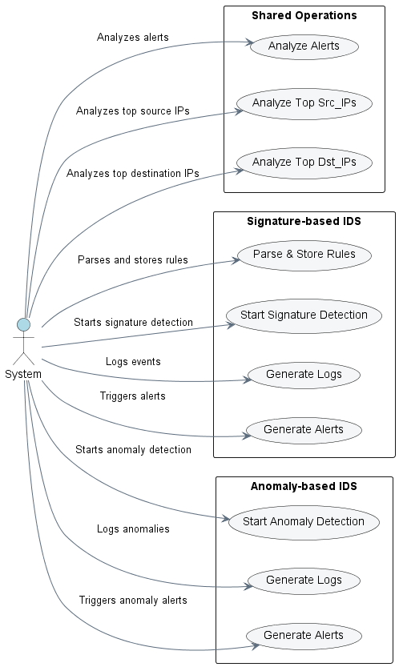

### *Figure()*

### System Component Diagram

### 

### 

### *Figure()*

### Class Diagram

### *Figure()*

### Sequence Diagram

#### *Figure()*

#### **Add Rules to Database**

#### *Figure()*

#### **Detecting Attack with Signature-Based Method**

#### 

#### 

#### *Figure ()*

#### **Detecting Attack with Anomaly-Based Method**

#### *Figure ()*

#### **CSV Upload Detection**

#### *Figure ()*

#### **PCAP Upload Detection**

#### *Figure ()*

#### **Web UI View**

#### *Figure ()*

#### **Display Rules for Admin**

#### 

#### 

#### 

#### *Figure ()*

#### **Display Alerts for Admin**

#### *Figure ()*

#### **Display Logs for Admin**

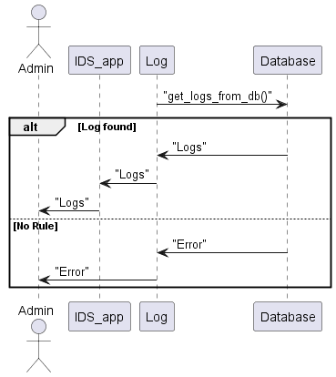

#### *Figure ()*

### Activity Diagram

#### **Display Logs for Admin**

#### *Figure ()*

#### **Adding Rules from File**

#### 

#### *Figure ()*

#### **Alert Analyzer Dashboard**

## *Figure ()*

#### **Anomaly Detection from CSV Upload**

#### *Figure ()*

#### **Real-Time Signature + Anomaly Detection**

**

#### 

## *Figure ()*

#### **Signature-Based Detection from PCAP File**

#### *Figure ()*

# Chapter 4 Design, Implementation & Testing

## System Design

### Signature-Based Dashboard

### 

### *Figure ()*

### Anomaly-Based Dashboard

### *Figure ()*

### Upload-CSV File UI

### *Figure ()*

### Upload-PCAP File UI

*

### *Figure ()*

### Rules-Dashboard

### 

### *Figure ()*

### Add-Rules

*

*

### *Figure ()*

## Implementation

### Traffic PCAP Files

### PCAP (Packet Capture) files are a common format for storing network traffic data. These files contain the raw data packets captured from a network interface, including headers and payloads. PCAP files are widely used in network analysis, troubleshooting, and security investigations. They are particularly useful for testing and evaluating Intrusion Detection Systems (IDS) because they provide real-world or simulated network traffic that can be used to assess the IDS's ability to detect malicious activity.

### PCAP files used to evaluate IDS typically contain network traffic that includes both normal (benign) and malicious activities. These files are designed to evaluate the effectiveness, accuracy, and performance of an IDS in detecting and responding to several types of threats.

### It is used to validate the detection capabilities of an IDS, to test the IDS's ability to differentiate, between normal and malicious traffic, and to evaluate the IDS's performance under different traffic conditions.

### *Figure ()*

### Database

## - The Intrusion Detection System (IDS) relies on an SQLite-based relational database to support both Signature-based and Anomaly-based detection components. SQLite was selected due to its lightweight architecture and seamless integration with Python, making it suitable for real-time processing without requiring a separate database server.

## Database Structure:

## The database consists of the following key tables:

## Rules - Stores signature-based detection rules, each containing fields such as action, protocol, source and destination addresses, ports, and options.

## Alerts - Records all generated alerts, regardless of whether they were triggered by a signature match or an anomaly detection model. Each alert entry includes metadata such as timestamp, source/destination IPs, attack type, and detection method (e.g., 'signature' or 'anomaly').

## Logs - Captures system events, packet evaluations, and audit trails. This table ensures visibility into the system's decision-making process and provides context for each detection.

## Functionality:

## During runtime, the system:

## Loads predefined signature rules from the Rules table.

## Processes incoming network packets using both detection engines.

## If a packet matches a rule or is classified as anomalous, a corresponding entry is created in the Alerts table.

## All events, including normal traffic evaluations and generated alerts, are stored in the Logs table for auditing.

## A centralized Database class handles:

## Connecting to IDS.db located under the DB/ directory.

## Creating tables if they do not already exist.

## Resetting or cleaning data at system startup.

## Executing all insert, update, and retrieval operations for logs, alerts, and rules.

## Integration:

## The database plays a pivotal role in unifying the outputs of the two detection methodologies and acts as the central repository for:

## Storing detection logic (rules).

## Logging analysis history.

## Facilitating alert presentation in the web interface.

## Now we show the code used to perform all of this:

### *Figure ()*

### *Figure ()*

### Now this is the result after running the previous code:

### Snort / Suricata Rules

## Snort and Suricata are open-source Intrusion Detection and Prevention Systems (IDS/IPS), meaning they are freely available and can be used across multiple platforms including Linux, Windows, and others.

## These systems monitor network traffic in real time and analyze it against a predefined set of rules with the objective of identifying suspicious or potentially malicious activities.

## Rules in Snort or Suricata serve as detailed instructions that define how the system should respond to specific patterns or behaviors within the network traffic. They function as structured guidelines or filters to detect anomalies, threats, or known attack signatures.

## Each rule typically specifies the protocol, source and destination IP addresses and ports, the direction of the traffic, and a set of options such as content matching, message tags, or classification types.

## So, we use the same Syntax as Snort Rules.

## snort rule

## *Figure ()*

## A Snort rule is composed of two main components:

## the Rule Header and the Rule Options

## The header defines the basic structure (such as protocol and IP addresses).

## while the options provide detailed matching criteria and metadata.

## To ensure clarity and consistency, all rules were written and processed using a standardized format that is easy to read and maintain.

## The implementation followed a structured pipeline:

## Initial Rule Collection: Each team member wrote Snort rules in a plain .txt file. Initially, the rules varied in formatting and structure.

## Rule Extraction: A script was developed to read and extract individual rules from these text files.

## Normalization Process: Another script was implemented to unify the format of all rules, standardizing their structure to match a consistent template.

## Database Insertion: Once the rules were standardized, they were inserted into the database in a structured and searchable format.

## This process ensured that all Snort rules are handled uniformly and can be programmatically retrieved, displayed, or updated through the application interface.

## Now this shows how it is implemented by code.

## *Figure ()*

## *Figure ()*

## *Figure ()*

## 

## *Figure ()*

## 

### Deep packet Inspection (DPI)

### Deep Packet Inspection (DPI) is an advanced technique used for analyzing and managing network traffic. Unlike traditional packet inspection methods that only examine packet headers, DPI inspects the entire packet, including the payload. This provides a more comprehensive understanding of the traffic, enabling improved security, monitoring, and network performance optimization.

### Key Components of DPI:

### Packet Capture:

### DPI tools begin by capturing network packets as they pass through a network interface.

### Header Inspection:

### The headers of packets (e.g., IP addresses, port numbers, and protocol types) are analyzed to determine fundamental information about the flow.

### Payload Inspection:

### The data portion (payload) of each packet is inspected to identify:

### Application-layer protocols such as HTTP, FTP, and DNS.

### Specific keywords or patterns, including malware signatures or sensitive information.

### File types such as documents, images, or videos.

### Analysis and Action:

### Based on the inspection, DPI can:

### Detect malicious activity (e.g., malware, intrusions).

### Enforce network policies (e.g., blocking certain applications).

### Optimize traffic (e.g., prioritizing critical applications).

### DPI Implementation Using Scapy in Python:

### To implement the DPI mechanism, we utilized the Scapy library in Python — a powerful packet manipulation tool.

### Installation:

### Scapy can be installed using standard Python package managers.

### *Figure ()*

### By importing Scapy Library and importing from it

### TCP: Enables inspection of the TCP layer and extraction of relevant fields.

### UDP: Allows analysis of UDP layer attributes.

### And the same for the remaining layers.

### Raw: Grants access to the packet payload if present.

### A black background with white text AI-generated content may be incorrect.Additional protocol layers supported by Scapy can also be utilized as needed.

### *Figure ()*

### Custom DPI Class:

### To extract all necessary packet details, we implemented a custom Packet class, which reads packets from a PCAP traffic file and:

### Parses headers and payloads,

### Extracts key features,

### Prepares the packet for comparison against existing signature-based rules & Anomaly-Based Detection.

### *Figure ()*

### Purpose and Responsibilities:

### To parse, inspect, and extract relevant metadata and payload content from each network packet.

### To convert raw Scapy packets into structured feature sets that can be analyzed and compared with signature rules.

### To maintain statistics on packet source and destination IP occurrences.

### To facilitate the classification and detection of suspicious behavior based on header fields, payload, and protocol-specific flags.

### Key Features and Methods:

### Initialization and Feature Extraction:

### Upon instantiation, the class automatically extracts and stores the following features:

### Protocol Type (TCP, UDP, ICMP, ARP, etc.).

### Source and Destination IP Addresses.

### Source and Destination Ports.

### Packet Flags (e.g., TCP SYN, ACK, FIN).

### Packet Size.

### Raw Payload Content.

### Timestamp (Raw and Formatted).

### Traffic Statistics Tracking:

### Maintains global counters for source and destination IPs across all parsed packets using src\_ip\_count and dst\_ip\_count.

### These statistics are useful in identifying potential scanning or flooding behavior.

### Payload and Header Analysis:

### Supports extraction of the TCP/UDP payload using the Raw layer.

### Inspects TCP/IP flags to detect behavior patterns (e.g., SYN flood).

### Provides detailed header metrics such as header length and TCP window size.

### Utility Methods:

### get\_src\_counts() / get\_dst\_counts(): Returns cumulative source/destination IP frequencies.

### get\_key(key): Retrieves a specific feature by name.

### \_\_str\_\_(): String representation of packet attributes in dictionary format.

### Layer-Specific Handling:

### Handles both Layer 3 (IP, ARP) and Layer 4 (TCP, UDP, ICMP) protocols.

### Supports payload decoding, with fallback to hexadecimal if decoding fails.

### Error Handling and Flexibility:

### Handles corrupted or non-decodable payloads gracefully.

### Uses dynamic detection to ensure compatibility with various packet structures.

### For each Packet comes from the PCAP:

### Get the Protocol of the Packet:

### 

### *Figure ()*

### Get the Source IP Address of the Packet:

### 

### *Figure ()*

### Get the Destination IP Address of the Packet:

### *Figure ()*

### Get the Source Port Number of the Packet:

### 

### *Figure ()*

### Get the Destination Port Number of the Packet:

### 

### 

### *Figure ()*

### Get the Flags of the Packet:

### 

### *Figure ()*

### Get the Size of the Packet:

### 

### *Figure ()*

### A screen shot of a computer program AI-generated content may be incorrect.Get the Time of the Packet:

### *Figure ()*

### Get the Payload of the Packet:

### *Figure ()*

### To store for each IP Address the number of packets it sends:

### To store for each IP Address the number of packets it sends:

### *Figure ()*

### Signature-Based IDS

### Matching Packets with Rules

### In our Signature-Based IDS, we rely on a set of predefined Snort-like rules to detect known patterns of malicious behavior in the network traffic. These rules are written following the standard Snort syntax, which consists of two main components:

* + - * **Rule Header**: Defines the general structure of the rule, including the action, protocol, source and destination IP addresses, and ports.
      * **Rule Options**: Provides detailed matching criteria such as message descriptions, content matching, pattern matching (PCRE), thresholds, and more.

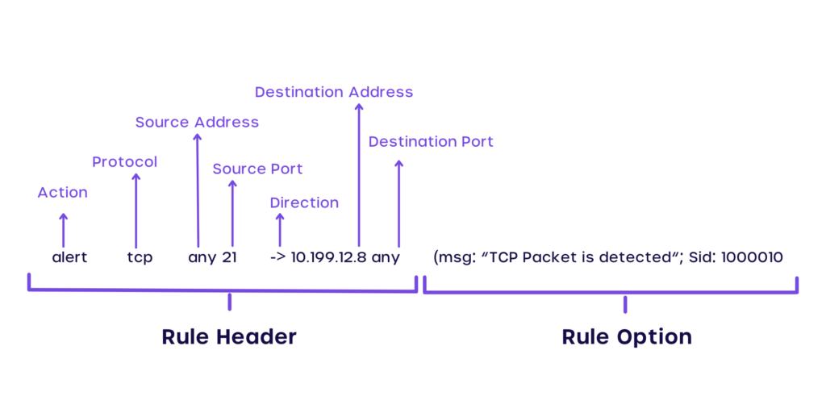

*Figure ()*

* + - Once these rules are written and stored in the database (as described in Section 4.2.3), the detection process is carried out as follows:

1. **Rule Extraction:**

* All rules are retrieved from the database using a dedicated database handler.
* For each rule retrieved, an object of the Rule class is created.
* This object encapsulates all components of the rule, including the header and the associated options.

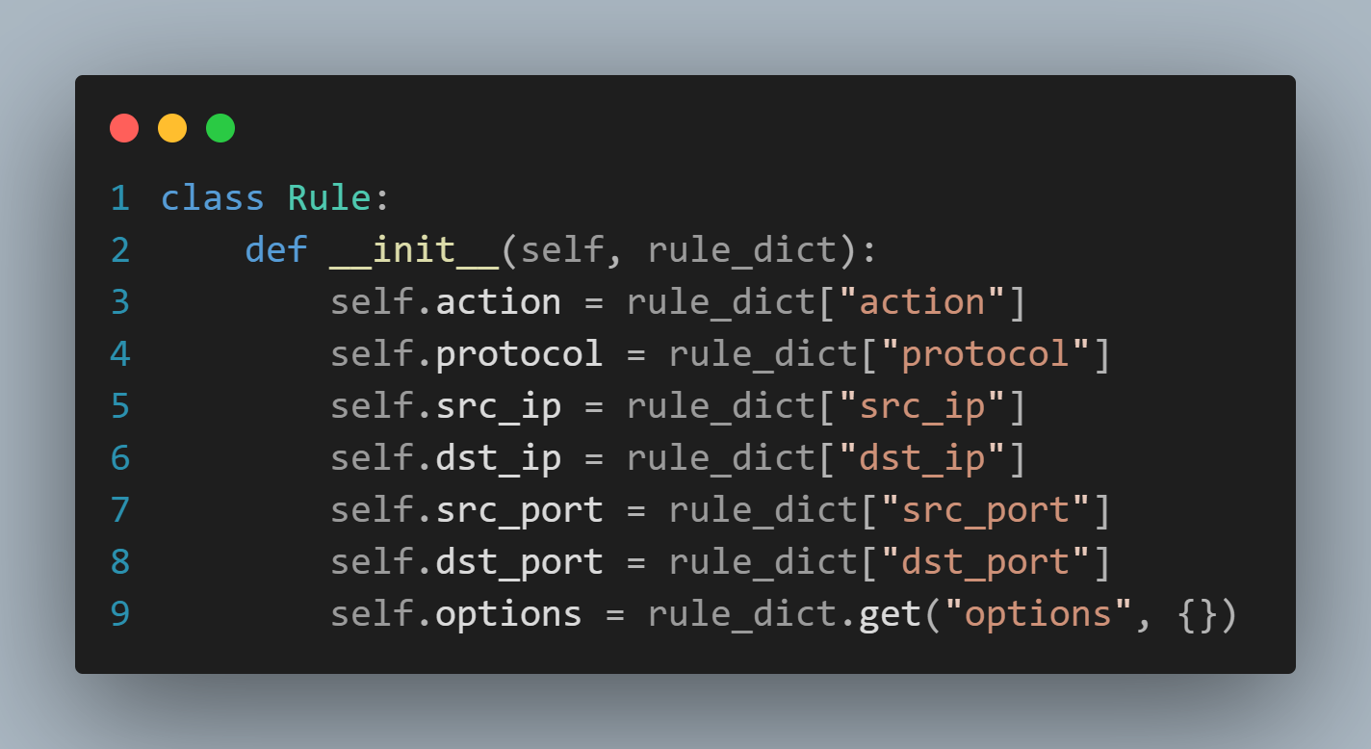

*Figure ()*

1. **Packet Matching Process:**

* Each incoming network packet is parsed into an object of the Packet class, which contains all relevant information extracted from the packet using Deep Packet Inspection (DPI). The matching process proceeds in two phases:

1. **Header Matching**

* The following header fields from the packet and the rule are compared:
  + Protocol.
  + Source IP and Port.
  + Destination IP and Port.
  + Direction (e.g., → or ↔).
* A match is considered successful only if all corresponding fields between the packet and rule header align correctly.

*Figure ()*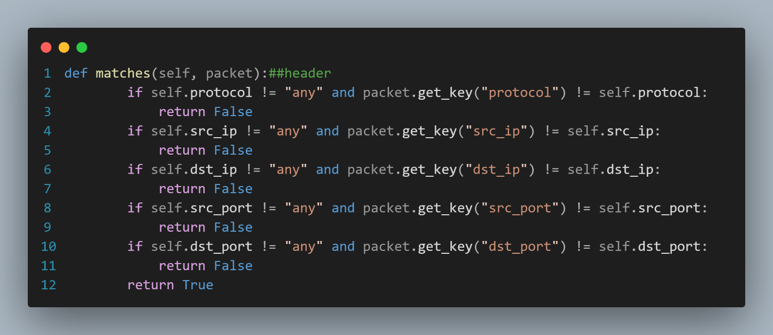

1. **Option Matching**

* After the header is matched, the system proceeds to compare the rule's options with the contents of the packet.
* Key fields checked include:
  + **content**: Searches for specific byte patterns or strings in the packet payload.
  + **pcre**: Performs regular expression matching against the payload.
  + **itype**: Used for ICMP-specific matching.
  + **threshold**: Checks if the number of matching packets exceeds a predefined count within a time interval.
  + **detection\_filter**: Applies rate-based conditions on packet detection.
* The system ensures that each of these fields, if present in the rule, must also be satisfied by the packet for the rule to be considered a match.

### 

### *Figure ()*

### *Figure ()*

### Signature Rule Matching & Concurrent Packet Processing

* + - To implement the signature-based intrusion detection mechanism effectively, the **SignatureIDS** class was developed. This class is responsible for processing packets, applying matching logic using the predefined rules, and triggering alerts or logging events when malicious behavior is detected.

### The SignatureIDS class supports both real-time detection and offline prediction (from PCAP files) using multithreading to improve performance. It integrates with the rule engine, packet parser, and database interface to provide a complete signature detection pipeline.

### *Figure ()*

### Functionalities

### A screen shot of a computer program AI-generated content may be incorrect.process\_packet(pkt, conn): Processes a single packet and checks if it matches any rule.

### *Figure ()*

### A screen shot of a computer program AI-generated content may be incorrect.detect(packets): Processes a list of Scapy packets using multithreading.

### *Figure ()*

### predict\_from\_pcap(packets): Performs detection on packets without writing to the database.

### *Figure ()*

### Anomaly-Based IDS

### Machine Learning Preparations

### Data Collection

### CIC-IDS2017

### The CIC-IDS2017 dataset is one of the most comprehensive and realistic datasets available for intrusion detection system (IDS) research. It was developed by the Canadian Institute for Cybersecurity (CIC) and includes both benign traffic and contemporary attack scenarios, making it suitable for training and evaluating anomaly-based IDS models.

* + - **Diverse Attack Types:** Includes DoS, DDoS, Brute-force, Botnet, Port Scanning, Heartbleed, Web Attacks, and Infiltration.
    - **Realistic Traffic:** Simulated in a controlled environment using real user behavior.
    - **Labelled Data:** All flows are clearly labeled as either benign or as a specific attack class.
    - **Rich Features:** More than 80 flow-based features per record, such as packet length, inter-arrival time, and header flags.
    - **Multiple Days of Traffic:** Data is organized per day, where each day corresponds to a different attack scenario.
    - High **feature dimensionality** (~80+), increasing complexity in preprocessing.
    - **Class imbalance**, with some attack types underrepresented.
    - Data volume can be large, requiring substantial computation.

### KDD’99(KDD Cup ’99)

### Groundbreaking dataset derived from DARPA 1998–99 data, originally used in the 1999 KDD Cup. It includes ~4.9 million records with 41 features and five attack classes plus normal.

### Extensive historical use – widely benchmarked in IDS research.

### Very large; suitable for testing scalability.

### Contains ~75% redundant records, leading to biased model training.

### Severe class imbalance; small classes (U2R) poorly represented.

### Noisy and outdated; it does not adequately reflect modern network behavior or attacks.

### Non-stationarity: training and test distributions differ, undermining generalization.

### NSL-KDD

### An improved version of the KDD Cup 1999 dataset, with duplicate records removed and more balanced classes. Contains 41 features covering basic, content, and traffic-related attributes. Classified into Normal, DoS, Probe, R2L, and U2R categories.

### Represents modern network protocols and attack types not available in NSL-KDD.

### Balanced statistical distributions between training and test sets.

### Rich multi-class labeling, enabling advanced classification tasks.

### Complex: many features (~42–49) require careful engineering.

### Minority class issues: some rare attack types (e.g. Worms, Shellcode) are underrepresented, causing detection difficulty.

### Requires substantial preprocessing (encoding, normalization).

|  |  |  |  |  |
| --- | --- | --- | --- | --- |
| **Dataset** | **Features** | **Classes** | **Records (Train/Test)** | **Main Challenges** |
| **KDD’99** | 41 | Normal + 4 attack types | ~494k / 311k | Duplication, imbalance, outdated attack types |
| **NSL‑KDD** | 41 | Same as KDD’99 | ~126k / 22k | Aging data; residual imbalance and noise |
| **UNSW‑NB15** | 42–49 | Normal + 9 modern attacks | 175k / 82k | Feature complexity; minority class sparsity |
| **CIC‑IDS2017** | ~80+ | Real-world attacks | Varies (days-long capture) | High dimensionality; preprocessing overhead; imbalance |

### *Table ()*

|  |  |  |  |  |
| --- | --- | --- | --- | --- |
| **Feature** | **CIC-IDS 2017** | **NSL-KDD** | **UNSW-NB15** | **KDD’99** |
| **Realistic Traffic** | ✅ | ❌ | ❌ | ❌ |
| **Modern**  **Attack Types** | ✅ | ❌ | ❌ | ❌ |
| **Labelled Data** | ✅ | ✅ | ✅ | ✅ |
| **Suitable for Deep Learning** | ✅ | ❌ | ✅ | ❌ |
| **Imbalanced Classes** | ⚠️ | ⚠️ | ✅ Balanced | ❌ Highly imbalanced |
| **Feature Richness** | ✅ 80+ flow features | ❌ Limited | ✅ Medium (~49) | ❌ Very limited |
| **Year Released** | 2017 | 2009 | 2015 | 1999 |

### 

### *Table ()*

* + - * In this project, we selected the **CIC-IDS2017** dataset as the primary source for building and evaluating our Intrusion Detection System (IDS). This decision was based on several key factors:

1. **Realistic and Modern Traffic**:

* The CIC-IDS2017 dataset was generated in a controlled environment to closely mimic real-world network behavior. It includes up-to-date attack types such as **Brute Force, DDoS, Port Scanning, Botnets**, and more, making it highly relevant to today’s security challenges.

1. **Comprehensive Feature Set**:

* It contains over **80 flow-based features** extracted using **CICFlowMeter**, which offers a detailed view of both benign and malicious traffic. This rich set of attributes supports both traditional machine learning and deep learning approaches.

1. **Labeled and Structured Format**:

* Each traffic flow in the dataset is **clearly labeled**, allowing for supervised learning models to be trained and evaluated effectively. The labels cover multiple attack categories, enabling binary and multi-class classification.

1. **Payload-Level Inspection**:

* Unlike older datasets, **CIC-IDS2017** includes **payload data**, allowing for Deep Packet Inspection (DPI) and enabling signature-based detection techniques alongside statistical analysis.

1. **Balanced Representation of Days and Attacks**:

* The dataset is organized by day, with specific attack scenarios scheduled, which allows us to **split data cleanly** into training and testing sets—improving the robustness of evaluation.

1. **Academic and Community Acceptance**:

* **CIC-IDS2017** is widely cited and used in academic research, making it a **benchmark dataset** for comparing the performance of intrusion detection techniques.

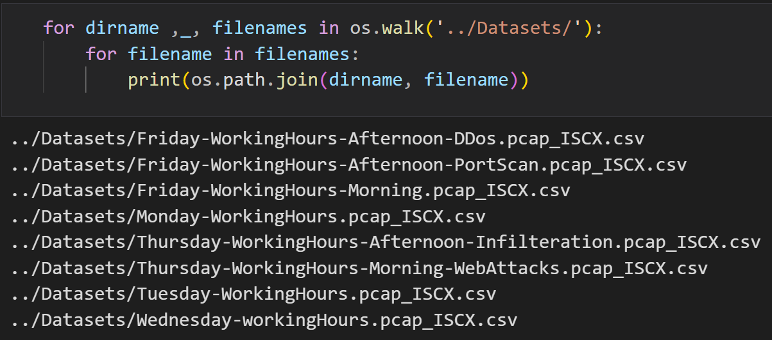

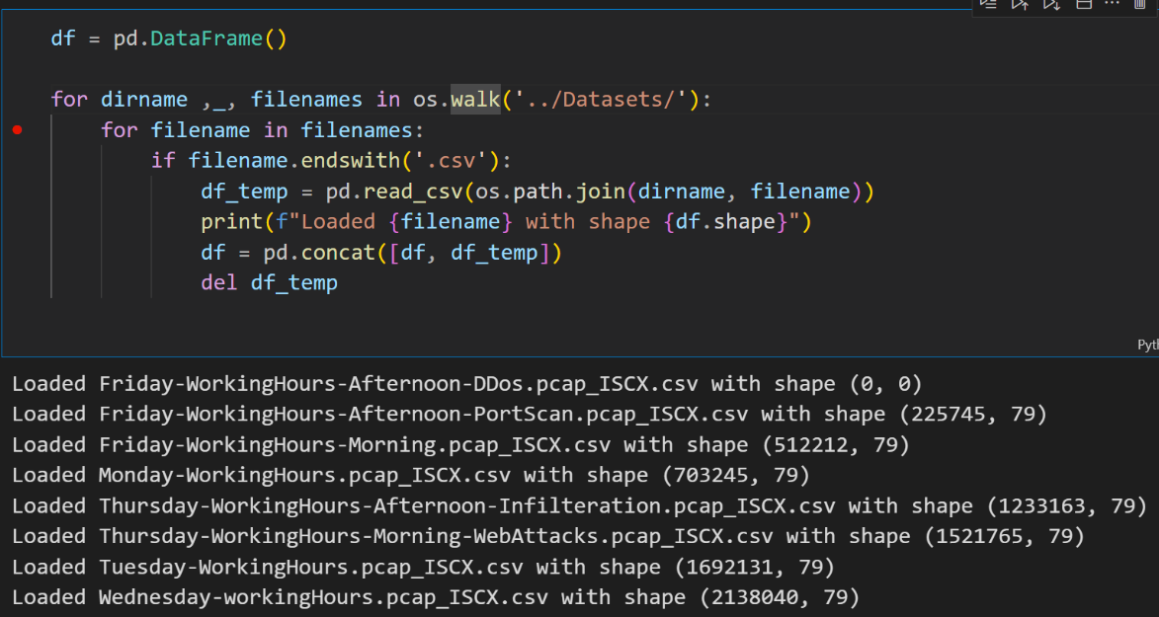*Figure ()*

*Figure ()*

### Exploratory Data Analysis (EDA)

### After collecting and organizing the CIC-IDS2017 dataset, we conducted a thorough Exploratory Data Analysis (EDA) to gain deeper insights into the structure, quality, and characteristics of the data. This step was critical to understanding the distribution of attacks, detecting anomalies in feature values, identifying data quality issues (such as missing or infinite values), and guiding the preprocessing phase. The following outlines the major observations and processes during EDA:

### Shape of the Dataset

*Figure ()*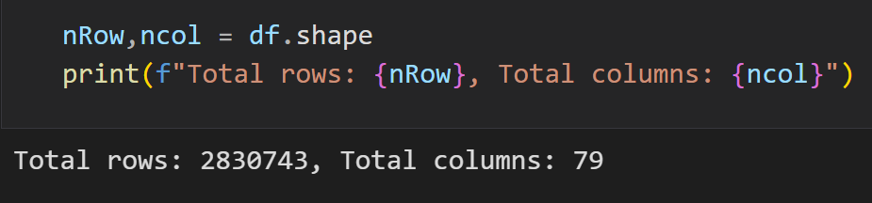

### Preview the First Few Rows

*Figure ()*

### Dataset Information Summary

*Figure ()*

### Statistical Summary

*Figure ()*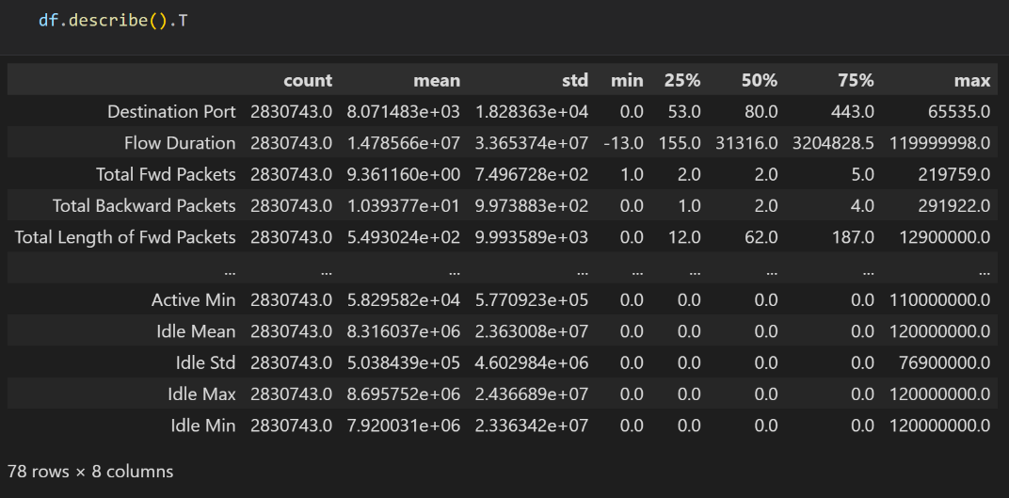

### Column Names

### 

*Figure ()*

### Label Distribution

*Figure ()*

### Data Cleaning & Preprocessing

### To ensure the dataset was ready for machine learning model training and evaluation, we performed a thorough cleaning and preprocessing process. The following steps summarize the procedures taken:

### Remove Duplicate Entries

*Figure ()*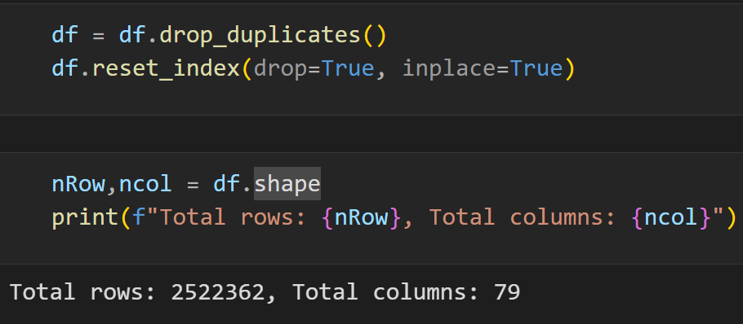

### Fix Column Names

*Figure ()*

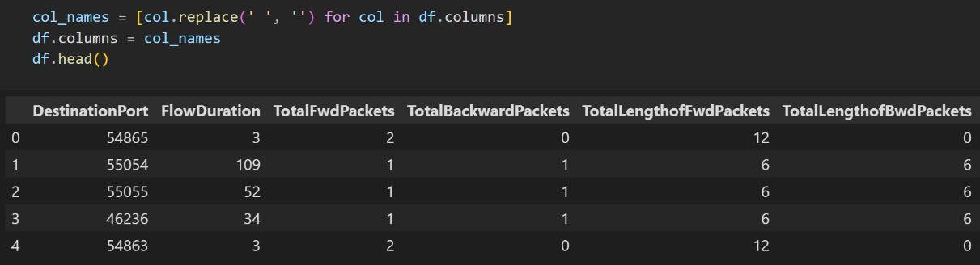

### Clean and Standardize Label Values

*Figure ()*

### Label Distribution Check

*Figure ()*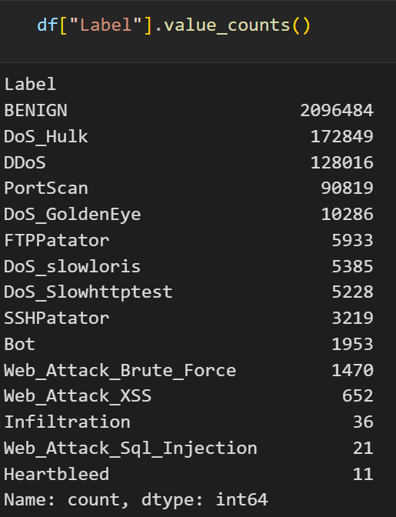

### NULL Value Detection and Removal

*Figure ()*

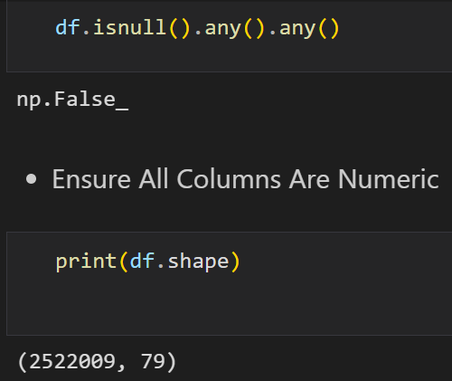

*Figure ()*

### Ensure All Features are Numeric

*Figure ()*

*Figure ()*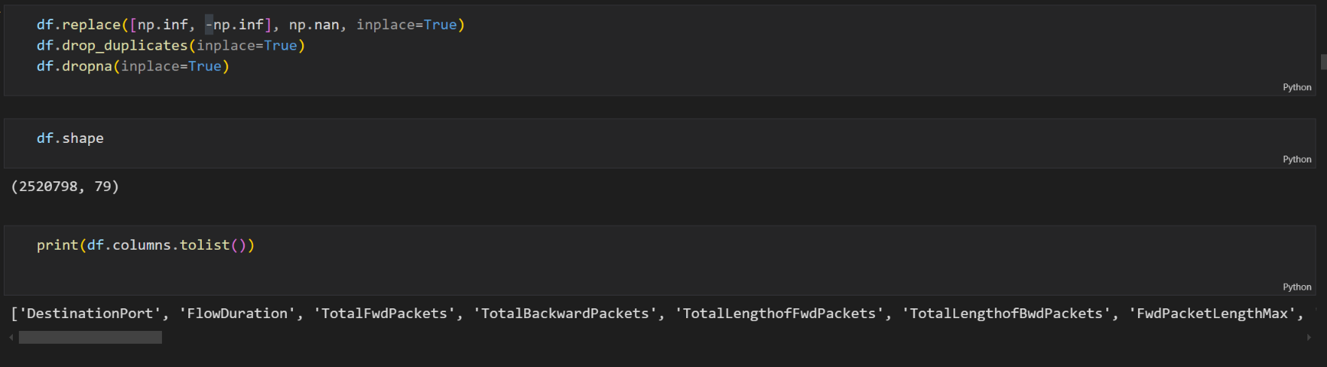

### Export Cleaned Dataset

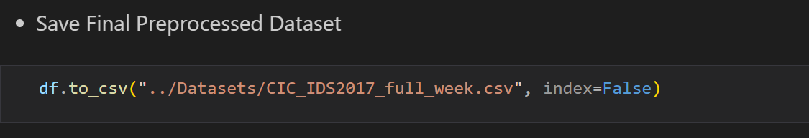

*Figure ()*

### EDA: Feature Distribution & Class Balance

-To gain deeper insights into the structure of the CIC-IDS2017 dataset, we conducted **visual Exploratory Data Analysis (EDA)** by plotting the distribution of each feature and examining the distribution of class labels (normal vs. attack types).

* Feature-Wise Distribution Analysis
  + *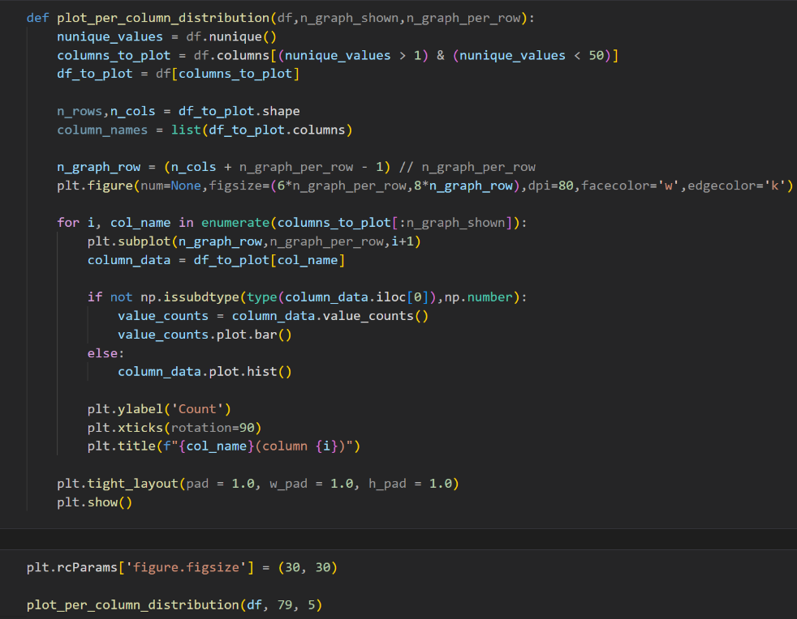*We plotted the distributions of all features with limited unique values (less than 50) to understand the spread of data. Both **histograms** and **bar plots** were used depending on the nature of the variable (numerical or categorical).

*Figure ()*

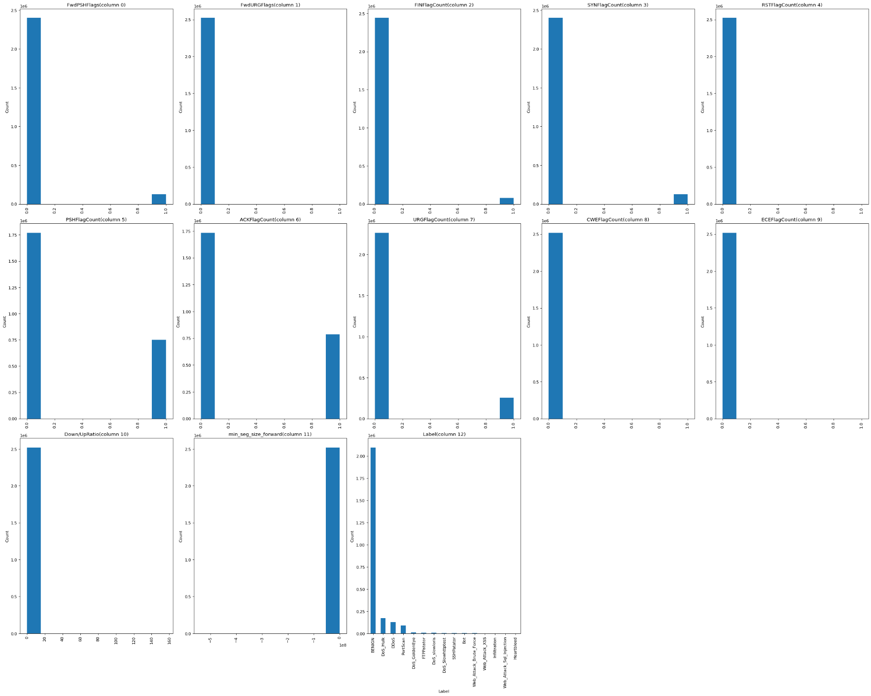

*Figure ()*

* Label Distribution Analysis
  + To assess the **class imbalance**, we visualized the distribution of the Label column using both **bar graphs** and **pie charts**.

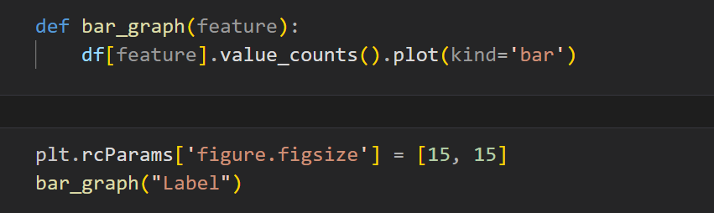

*Figure ()*

* The dataset is **highly imbalanced**, with many samples belonging to the **BENIGN** class.
* Certain attack types such as **DoS Hulk, PortScan**, and **DDoS** had significantly higher frequencies compared to others like **Heartbleed** or **Web Attack – Brute Force**.
* This imbalance can affect model performance, so appropriate **resampling** or **weighting techniques** may be required during training.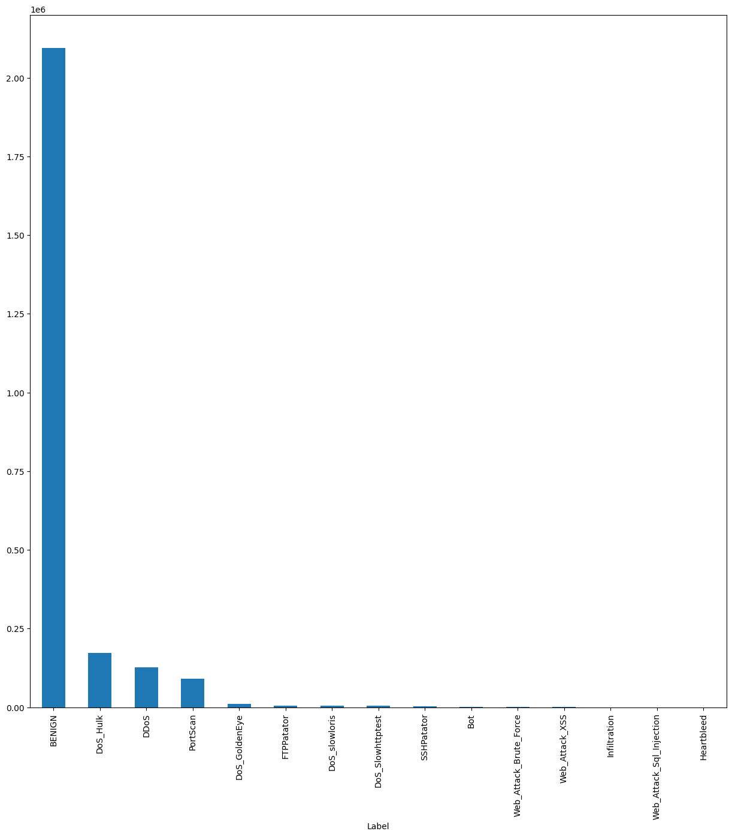

*Figure ()*

* Feature Distribution for Key Metrics
  + - To analyze specific numerical features, such as **FlowDuration**, we used a distribution plot:

*Figure ()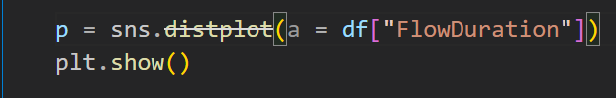*

* + - 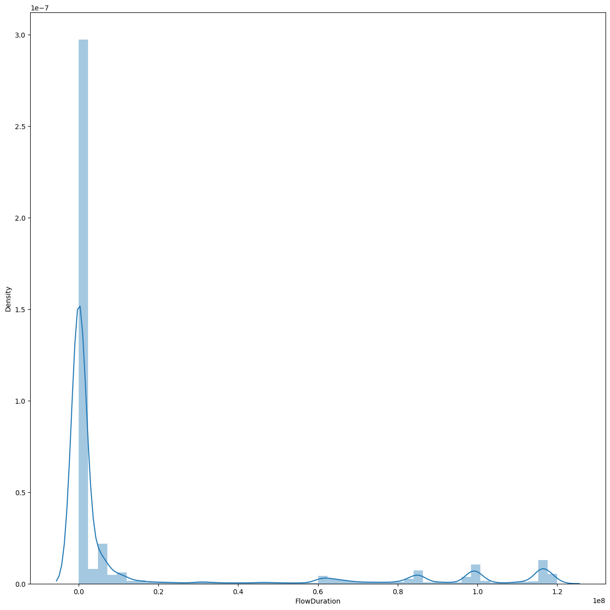This helped detect extreme values and skewness in network flow durations which could be critical indicators of attack behaviors.

*Figure ()*

* Label Distribution Pie Chart
  + - 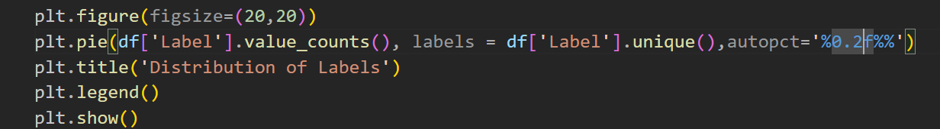 To understand the **class composition** of the CIC-IDS2017 dataset, we generated a **pie chart** showing the percentage distribution of each traffic type (normal and attack labels).

*Figure ()*

* The dataset is **dominated by a few classes**, especially **BENIGN**, **DoS Hulk**, and **PortScan**.
* 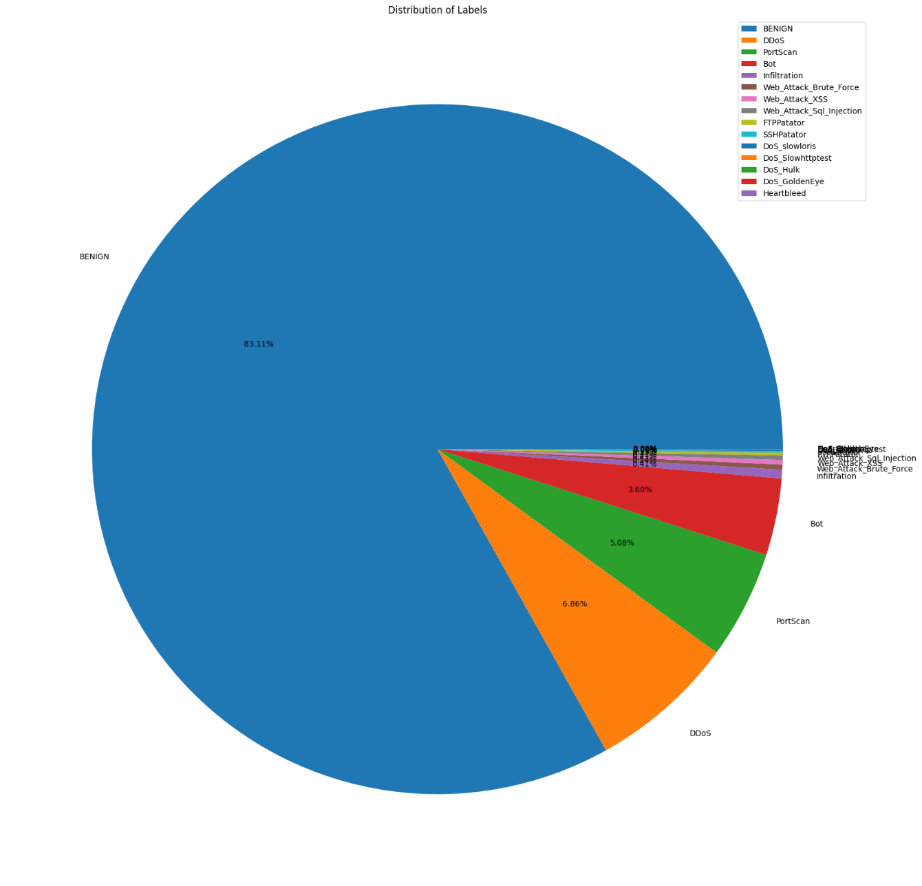Some attack types are **underrepresented** (e.g., **Heartbleed**, **Infiltration**, **Web Attack variants**).

*Figure ()*

* 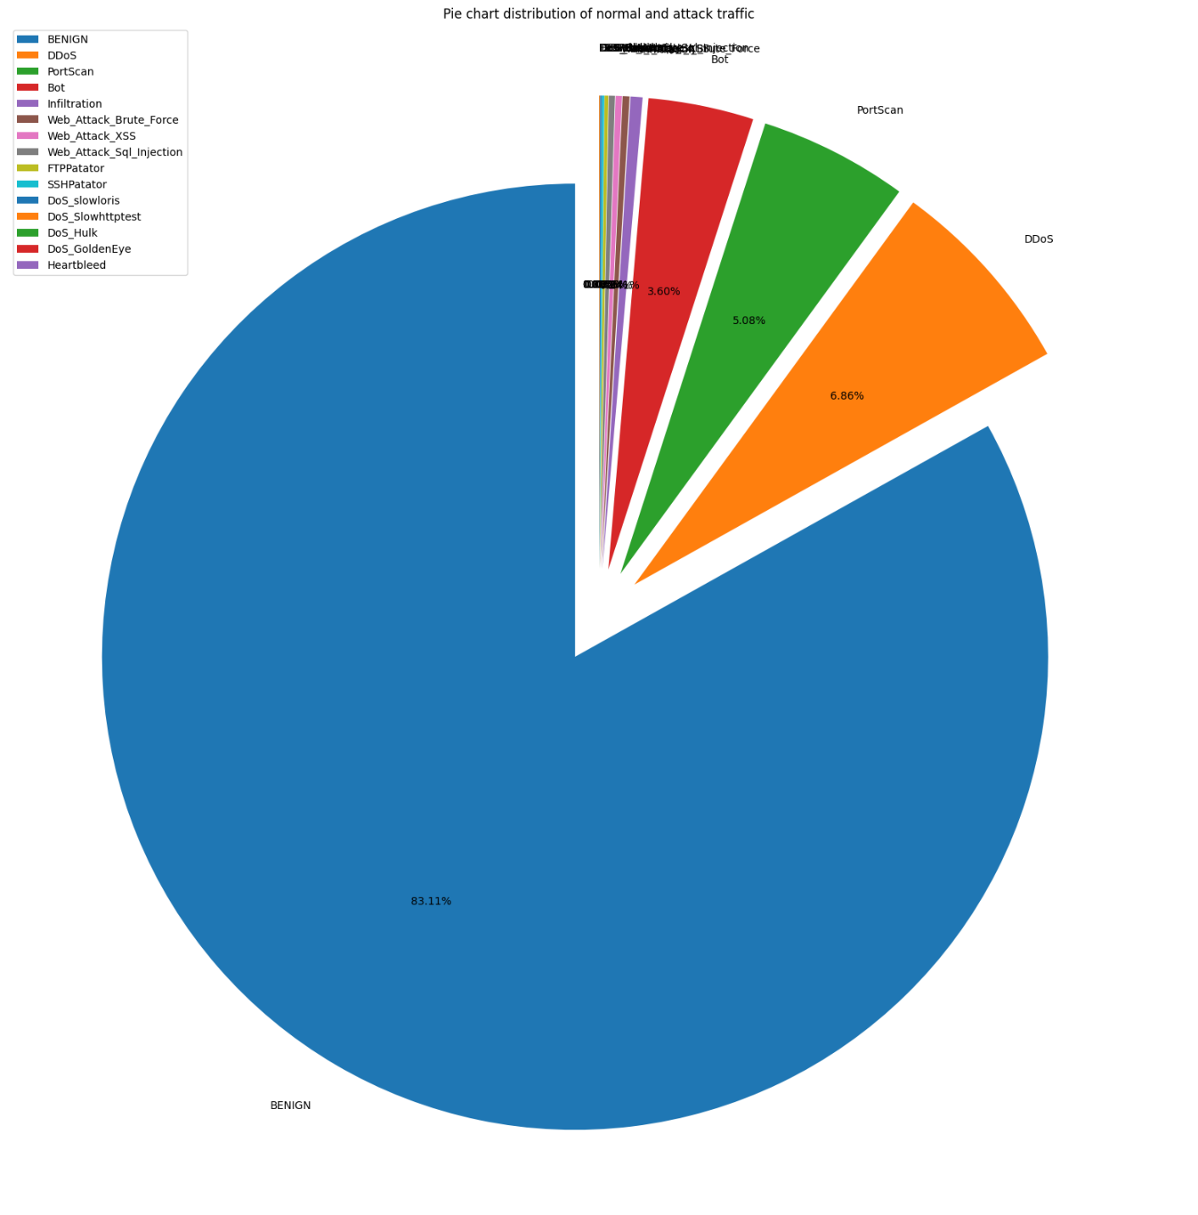This confirms the **imbalance issue** in the dataset, which may lead to **biased model predictions** if not addressed.

*Figure ()*

### Balancing the Dataset

-After performing **Exploratory Data Analysis (EDA),** it became clear that the CIC-IDS2017 dataset suffers from **class imbalance**, where certain attack types (like **BENIGN, DoS Hulk, or PortScan)** dominate the dataset, while others (like Heartbleed or Infiltration) are severely underrepresented.

-To address the class imbalance issue in the CIC-IDS2017 dataset, a systematic approach was adopted to ensure fair representation of all attack types while preventing model bias toward dominant classes. The dataset originally contains highly imbalanced label distributions, with some attacks such as **BENIGN**, **DoS\_Hulk**, **DDoS**, and **PortScan** occurring in extremely large numbers compared to rare and critical attacks like **Heartbleed** and **Infiltration**.

-**Why Balancing is Important**

* Machine learning models trained on imbalanced data tend to be **biased toward majority classes**.
* Minority classes (often the most dangerous attacks) may be **misclassified** or completely ignored.
* Balancing improves model **generalization** and **fairness** across all classes.
  + - * Dataset Before Balancing

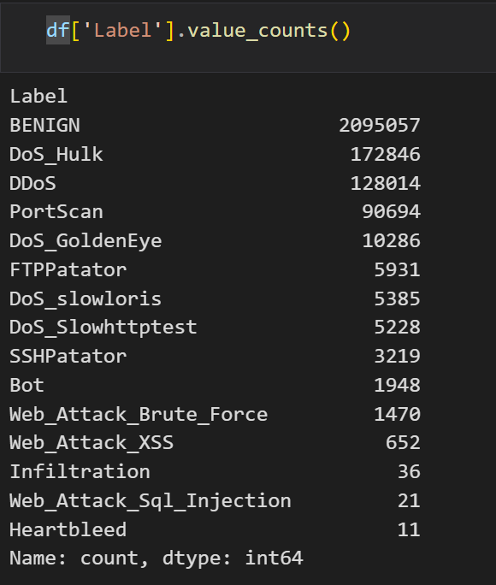

*Figure ()*

* + - * Label Filtering and Limiting

**Retained in full:** We kept all instances of the rare and underrepresented classes such as: **DoS\_GoldenEye, FTPPatator, DoS\_slowloris, DoS\_Slowhttptest, SSHPatator, Bot, Web\_Attack\_Brute\_Force, Web\_Attack\_XSS, Web\_Attack\_Sql\_Injection, Infiltration, Heartbleed**

**Downsampled (limited):** The most dominant labels were truncated to the top 50,000 samples each to prevent overrepresentation. These include: **BENIGN, DoS\_Hulk, DDoS, PortScan.**

A new balanced DataFrame (result\_df) was then created by combining the full rare classes with the limited samples of dominant classes and shuffling them randomly.

*Figure ()*

*Figure ()*

*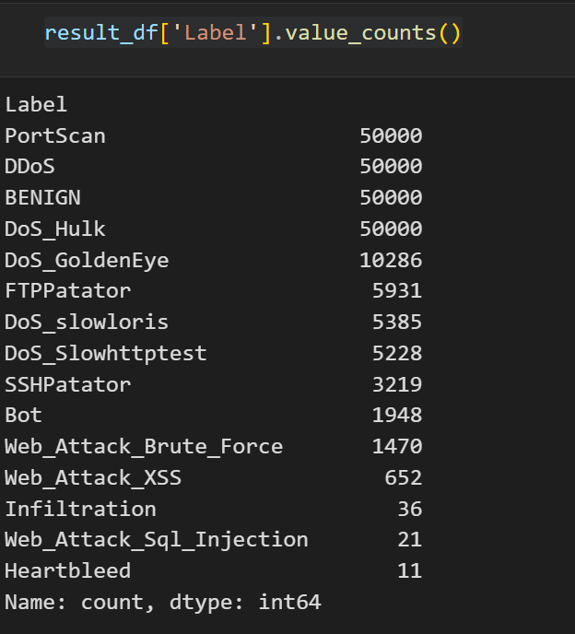*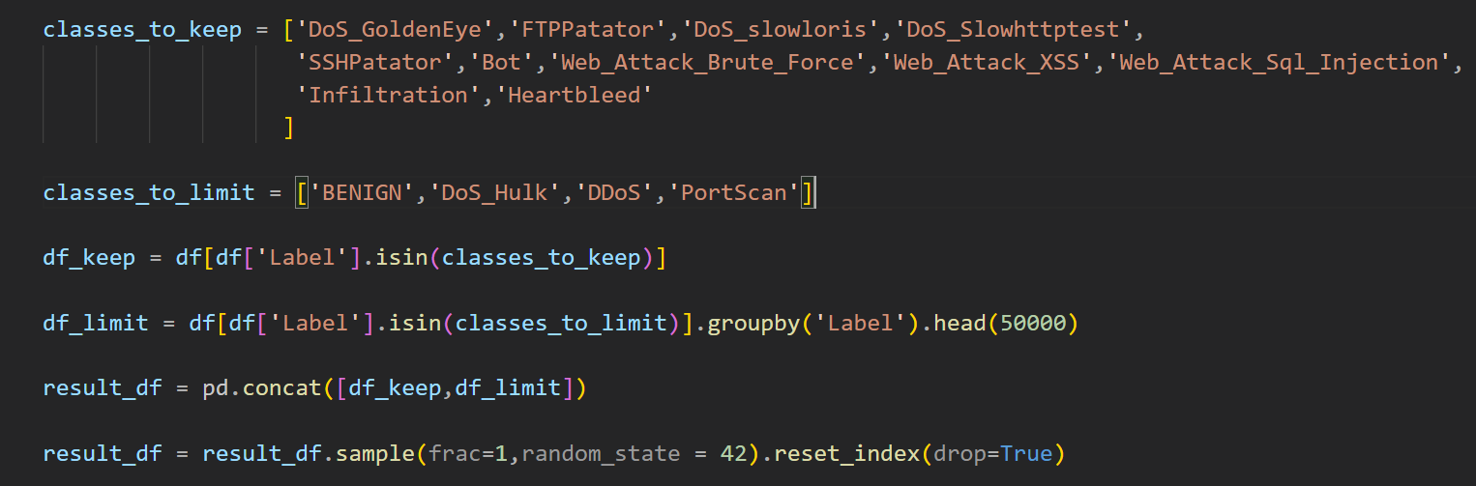

* + - * Oversampling Rare Classes

Even after filtering, some attack types such as Heartbleed and Infiltration remained severely underrepresented. To mitigate this, we applied manual **oversampling** by replicating each of these rare classes 30 times. This increased their presence in the training data and allowed the model to learn better patterns from them.

*Figure ()*

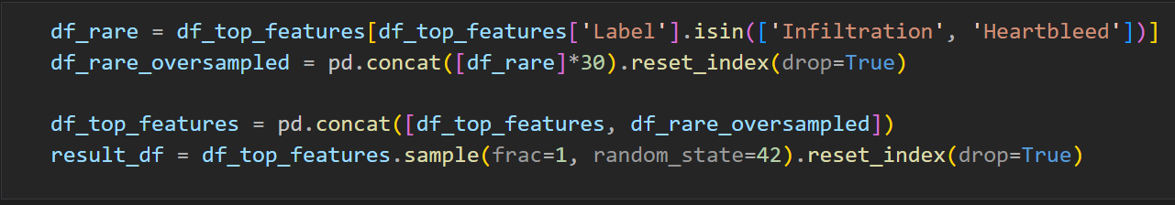

* + - * Attack Type Mapping and Normalization
* To simplify classification and group semantically similar attacks, we introduced a mapping (**attack\_map)** that consolidated specific attack types under general categories. For instance:
* **DoS\_Hulk, DoS\_GoldenEye, DoS\_slowloris → DoS**
* **Web\_Attack\_XSS, Web\_Attack\_Brute\_Force → Web\_Attack**
* **FTPPatator, SSHPatator → Brute\_Force**
* This mapping was applied using the. map **()** function to overwrite the Label column with normalized attack families.

*Figure ()*

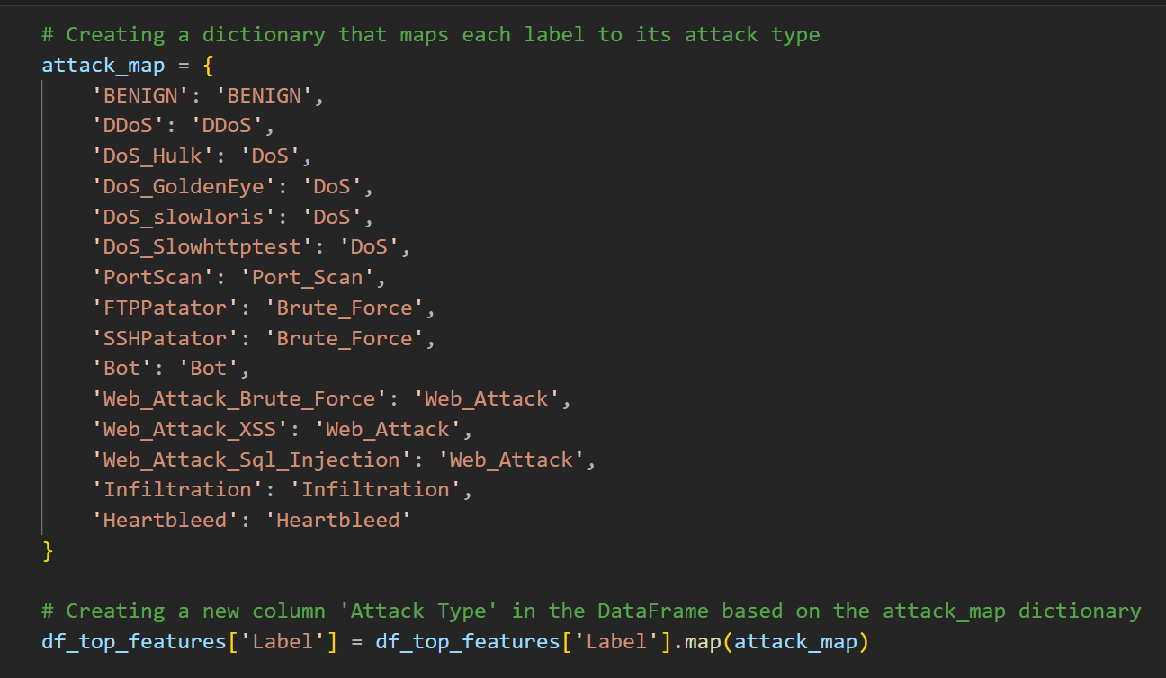

* + - * Visualizing the Balanced Label Distribution
* A pie chart was plotted to visualize the class distribution post-balancing. This helped ensure that no class excessively dominates the dataset and that rare attacks are adequately represented for meaningful model training and evaluation.
  + - * Final Dataset Preparation

The resulting dataset (**result\_df**) was shuffled and stored with a clean distribution of attack types, suitable for training robust and fair classification models.

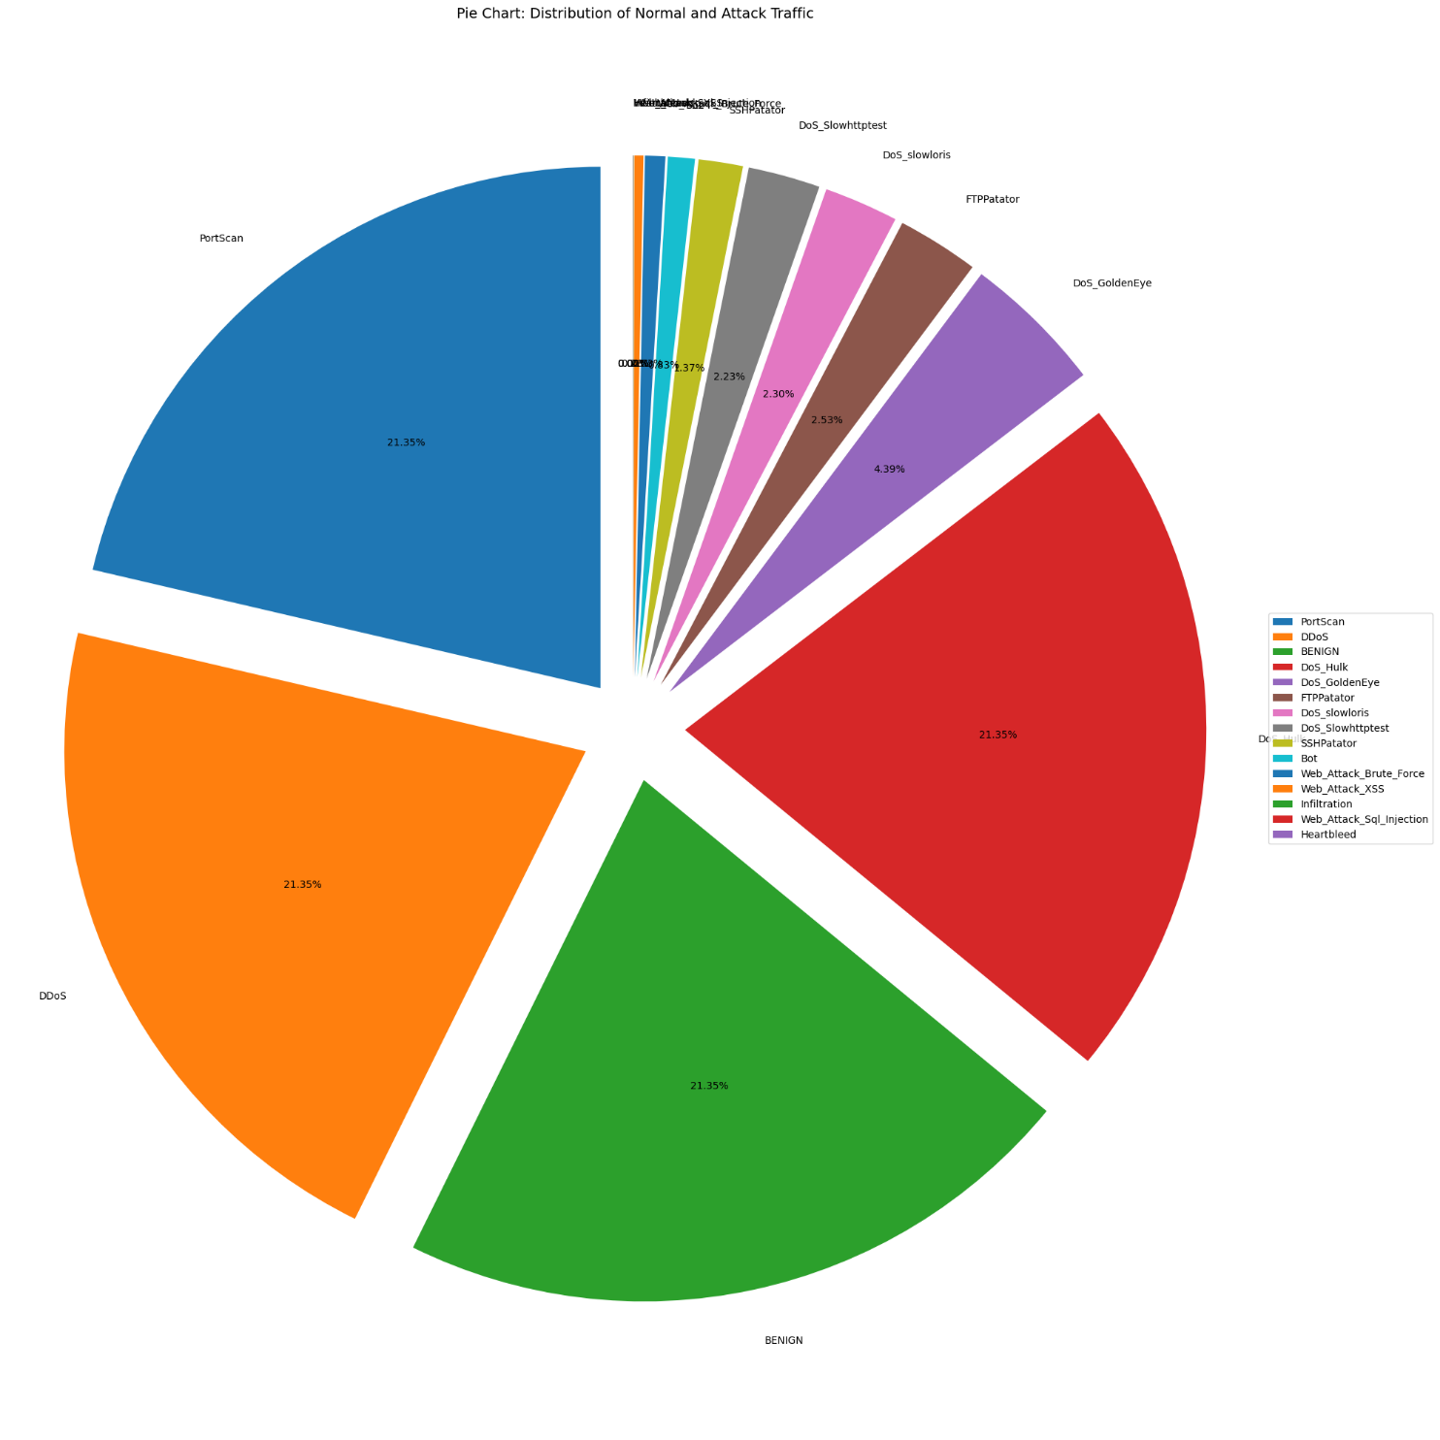

*Figure ()*

### Label Encoding

- To make the target variable suitable for machine learning models, especially those that only accept numerical inputs, the categorical labels (attack types) were converted into numerical forms using **Label Encoding**.

* The **LabelEncoder** from **sklearn.preprocessing** was applied to the '**Label**' column.
* A dictionary was generated to store the mapping between the original attack names and their corresponding numerical codes.
* The encoder was saved using **joblib** for reuse during model inference to ensure consistent label mapping.
* **{'BENIGN': np.int64(0), 'Bot': np.int64(1), 'Brute\_Force': np.int64(2), 'DDoS': np.int64(3), 'DoS': np.int64(4), 'Heartbleed': np.int64(5), 'Infiltration': np.int64(6), 'Port\_Scan': np.int64(7), 'Web\_Attack': np.int64(8)}.**

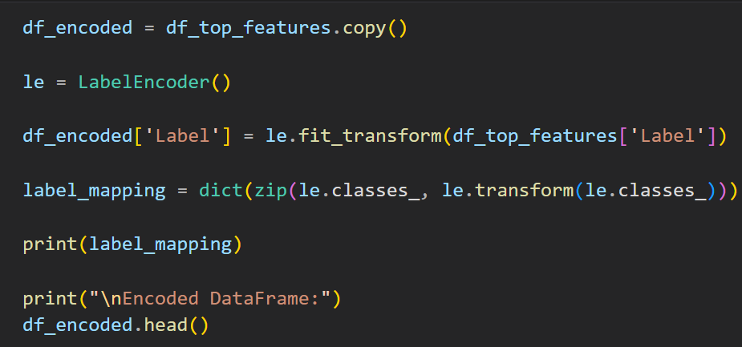

*Figure ()*

### Correlation Analysis

- To gain deeper insights into the relationship between the features and the target variable (Label), a **correlation heatmap** was generated. This step aims to identify the most relevant features based on their statistical correlation with the class’s output.

- A **Pearson correlation matrix** was calculated using the encoded dataset (**df\_encoded**), where all features and the target label were numerical.

- A **correlation threshold** of 0.1 was applied to filter out features that have little to no linear relationship with the target variable.

- Only the features whose absolute correlation value with the label exceeded 0.1 were included in the heatmap.

- This analysis helps identify **highly correlated features** that are more likely to influence the classification outcome.

- Features that show **strong positive or negative correlation** with the label are valuable for training efficient and accurate models.

- This also aids in **reducing redundancy** and **selecting informative features**, which improves both performance and interpretability.

- The filtered correlation matrix was visualized using a **Seaborn heatmap** with a diverging color palette, making it easier to distinguish between positive and negative correlations.

- Each cell in the matrix shows the correlation value (ranging from -1 to +1), where:

**- +1** indicates a strong positive correlation.

**- -1** indicates a strong negative correlation.

**- 0** indicates no correlation.



*Figure ()*

### Feature Selection using Random Forest

### - After performing data preprocessing and balancing, it became essential to reduce the dimensionality of the dataset by selecting only the most relevant features for model training. Feature selection helps improve model performance, training speed, and generalization. For this purpose, the Random Forest Classifier was used to evaluate feature importance.

- Steps Followed:

* **Splitting the Dataset:**
* The dataset was divided into input features X and target labels y.
* A train-test split was applied using an 80/20 ratio to ensure model evaluation on unseen data.

*Figure ()*

* **Training the Random Forest Model:**
* A **Random Forest Classifier** was trained using 100 estimators (trees) with a fixed random seed.
* 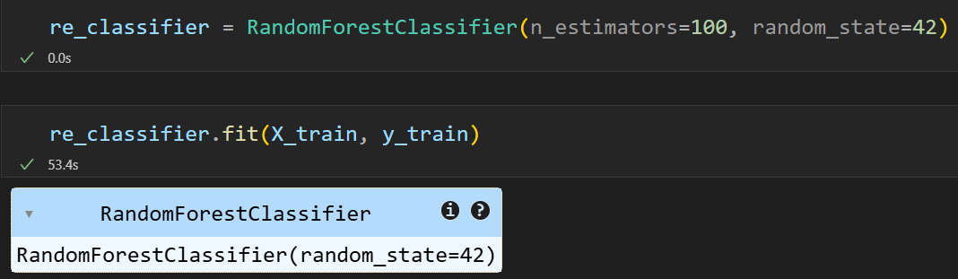The classifier’s built-in. **feature importances\_** attribute was used to compute the importance of each feature.

*Figure ()*

* **Extracting and Ranking Feature Importances:**
* Feature importance values were extracted and stored in a DataFrame.
* The features were sorted in descending order based on their importance scores.
* **Selecting the Top 20 Features:**
* The top 20 most important features were selected for further analysis and model training.
* 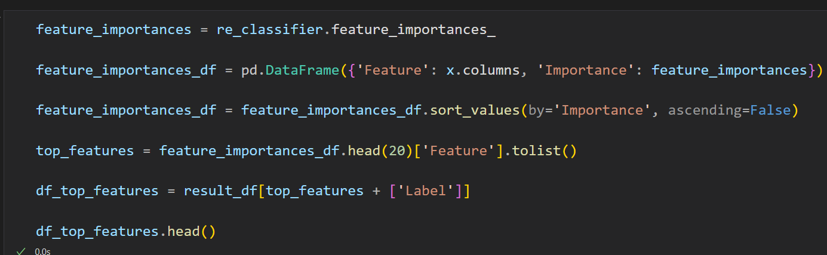A reduced dataset **df\_top\_features** was created using these selected features and the label column.

*Figure ()*

* **Visualization:**
* Bar charts and horizontal plots were used to visualize the importance of values clearly.

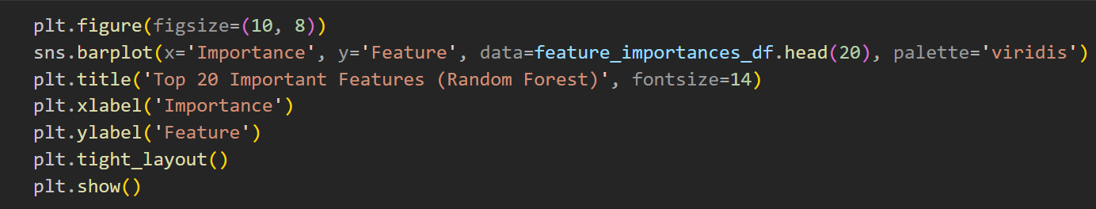

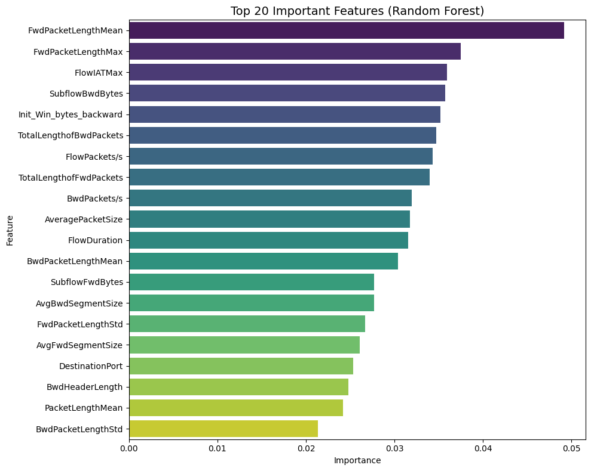 *Figure ()*

*Figure ()*

- This step was essential to ensure that the models only use the most relevant input attributes, thus reducing overfitting and improving detection accuracy. These selected features were later used in training both the anomaly-based and signature-based IDS components.

### Splitting the Data into Features and Labels

### - After completing the preprocessing, cleaning, balancing, and feature selection stages, we proceeded to split the dataset into features (X) and labels (y) in preparation for training and evaluation of the machine learning models.

- Steps Followed:

* **Separating Features and Labels:**
* The target column (**Label**) was separated from the dataset.
* **X** contains all the features (input variables).
* **y** contains the corresponding labels (output classes).
* **Train-Test Split:**
* The dataset was split into training and testing sets using an **80/20** ratio.
* The **stratify=y** parameter ensures that the class distribution in both training and test sets remains balanced and consistent with the original dataset.
* The **random\_state=42** was set to ensure reproducibility of results.

*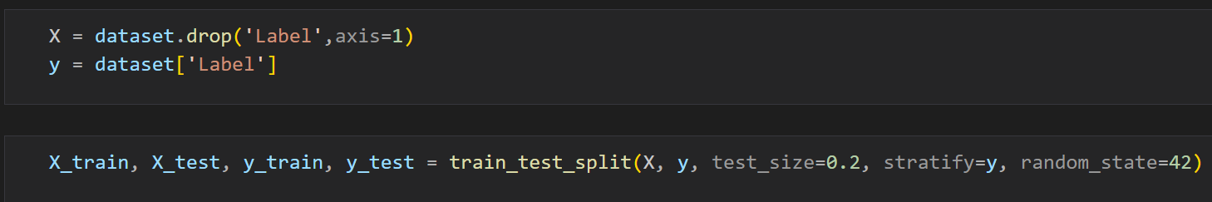*

*Figure ()*

### Feature Scaling

### - After splitting the dataset into training and testing sets, feature scaling was applied to normalize the feature values and improve the performance of the machine learning models.

- Why Feature Scaling?

* Many machine learning algorithms are sensitive to the range and scale of input features, especially those based on distance (e.g., **KNN, SVM, Neural Networks**). Features with larger magnitudes may dominate others, leading to biased model behavior. To address this, we used Min-Max Scaling, which transforms all feature values into a range between **0** and **1**.

- Steps Followed:

* **Min-Max Scaling:**
* The **MinMaxScaler** from **sklearn.preprocessing** was used.
* The scaler was fitted only on the training set to avoid data leakage.
* The same scaler was then used to transform both training and testing sets.
* **Converted to DataFrame:**
* The scaled arrays were converted back to DataFrame format to retain feature names and ease debugging or inspection.
* **Saving the Scaler:**
* The fitted scaler object was saved using **joblib** to ensure consistent scaling during real-time inference or deployment.

*Figure ()*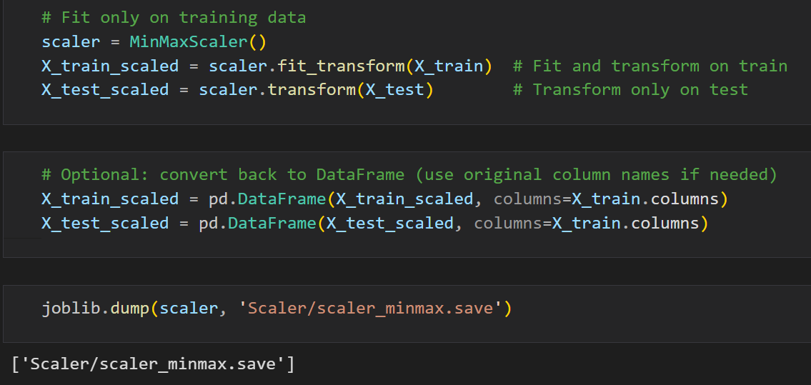

### Exporting Data:

* The scaled and original features and labels were exported to .csv files for backup and testing purposes.

*Figure ()*

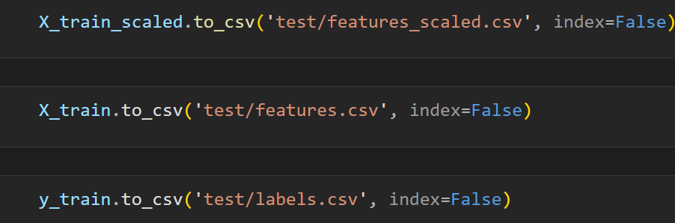

### Validation:

* 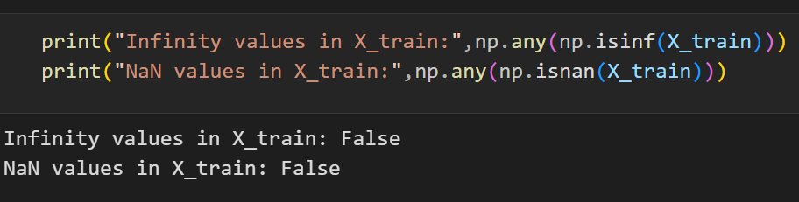Checked for **NaN** or Inf values in the dataset to ensure data integrity before feeding into models.

*Figure ()*

### Memory Management:

* Unused large variables were set to None to free memory space during the training pipeline.

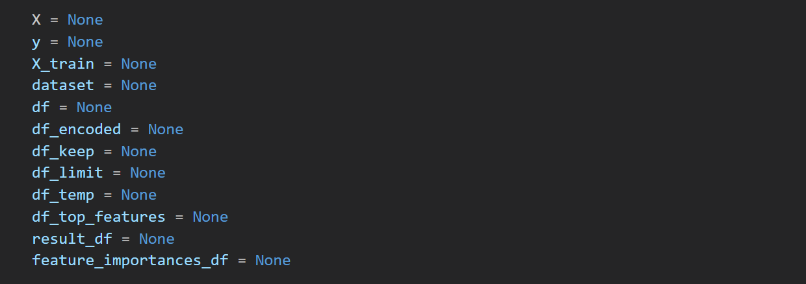

*Figure ()*

### Model Development

### Model Creating

### Stacking Classifier

### To improve the robustness and performance of our Intrusion Detection System (IDS), we implemented an ensemble learning technique called Stacking, which combines multiple machine learning classifiers and uses a meta-model to produce the final prediction.

### We use it to detect the Known (pre-Trained) labels only.

* + - **Stacking Model Architecture:**
      * The stacking classifier consists of the following base learners:
        + **Decision Tree** – Criterion: Entropy, Max Depth: 4:

is a supervised learning model that splits the data based on feature values to form a tree-like structure of decisions. Each node splits the dataset using a condition that best separates the classes.

*Figure ()*

**In the model, the **criterion is "entropy"**, which uses **Information Gain** to choose the best split:

**Max Depth = 4** restricts the tree from growing too deep, which:

Prevents overfitting.

Forces the model to learn general patterns.

Makes it faster and interpretable.

**Why it’s useful in IDS:**

Good for capturing **simple decision rules**.

Handles both numerical and categorical features.

Fast to train and test on.

* + - * + **Logistic Regression:**

Logistic Regression is a **linear classifier** that models the **probability** of a class using the **sigmoid function**:

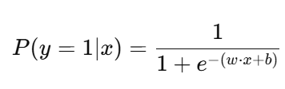

*Figure ()*

In It outputs a value between 0 and 1, which is **thresholded** to make class predictions.

**Max Depth = 4** restricts the tree from growing too deep, which:

Prevents overfitting.

Forces the model to learn general patterns.

Makes it faster and interpretable.

**Why it’s useful in IDS:**

Simple and fast.

Good for linearly separable attack types.

Works well as a baseline and provides probability outputs, which is important in stacking.

* + - * + **K-Nearest Neighbors (KNN)** – Neighbors: 3

KNN is an **instance-based** (or lazy) learning algorithm.

For a new sample, it:

Finds the **k=3 closest points** in the training set.

Predicts the label by **majority vote**.

Distance metric: usually **Euclidean**.

**Why it’s useful in IDS:**

Effective when **similar attacks cluster** together in feature space.

Captures **local patterns** missed by other classifiers.

Non-parametric: doesn't make assumptions about data distribution.

* + - * + **CatBoost Classifier** (Boosting Algorithm)

**CatBoost** is a **gradient boosting** algorithm developed by Yandex. It builds an ensemble of **decision trees**, each correcting the errors of the previous ones.

For a new sample, it:

iterations=100: Number of trees.

learning\_rate=0.1: Controls how much each tree contributes.

depth=6: Controls tree complexity.

**What makes CatBoost special:**

Efficient with **categorical features** (even if not present here).

Handles **imbalanced data** better.

Uses **ordered boosting** to reduce overfitting.

**Why it’s useful in IDS:**

Strong overall accuracy.

Excellent at modeling **non-linear relationships** between features.

Boosting is often the **best standalone classifier** for structured/tabular data like network features.

* + - * The **meta-model** (final estimator) used is a **Random Forest Classifier** with 100 estimators

Each of the 4 base models makes **individual predictions** on the input features.

These predictions (or class probabilities) are then **used as new features**.

The **meta-model (Random Forest)** learns from these to produce the final prediction.

**Why Random Forest is used as meta-model:**

Robust to overfitting.

Aggregates decisions from multiple trees.

Handles non-linear patterns in the **meta-feature space** (outputs of base learners).

* + - **Why Use Stacking in IDS:**
      * Each base learner contributes diverse perspectives:
      * Linear (LogReg), Local (KNN), Tree-based logic (DT), Ensemble power (CatBoost).
      * The final estimator learns how to trust each base model depending on the situation.
      * 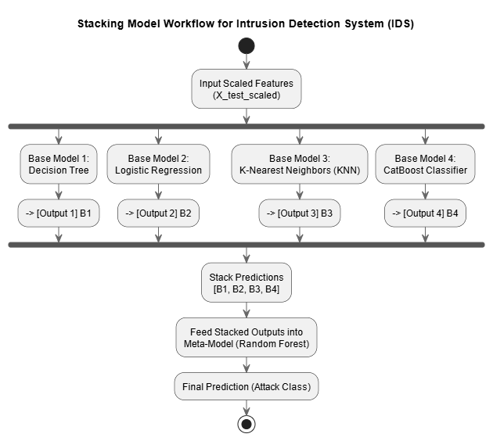This leads to higher accuracy, robustness, and generalization, which are critical in detecting both known and unknown attacks.

*Figure ()*

### Model Training

* 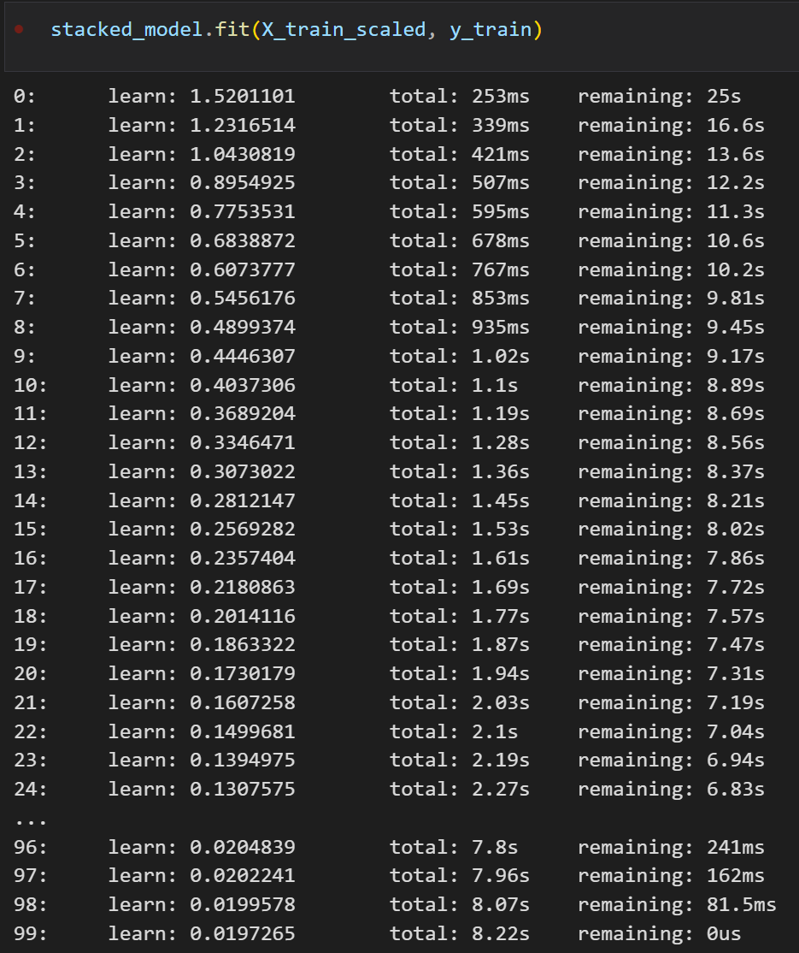The model was trained on the **scaled training data (X\_train\_scaled, y\_train)** using 5-fold cross-validation (cv=5) to ensure a balanced and generalizable model.Linear (LogReg), Local (KNN), Tree-based logic (DT), Ensemble power (CatBoost).

*Figure ()*

### Model Prediction

*Figure ()*

### Model Evaluation Metrics:

* 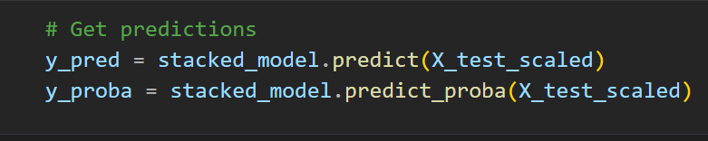 The trained model was evaluated on the **test set** (X\_test\_scaled, y\_test) using the following performance metrics:

1. **Accuracy**
   * **Definition**: The ratio of correctly predicted samples to the total number of samples.
   * **Purpose**: Gives an overall sense of how often the model is correct.
   * **Limitation**: Not reliable alone in imbalanced datasets (e.g., where "BENIGN" is much more frequent than attacks).
   * **Formula**:

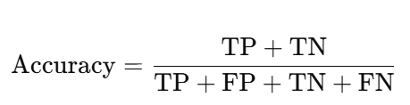

*Figure ()*

1. **Precision (Weighted)**
   * **Definition**: How many of the predicted positive samples are correct, averaged across all classes, weighted by support (number of samples).
   * **Formula (for each class)**:

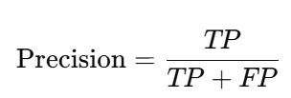

*Figure ()*

* + **Weighted Average**:

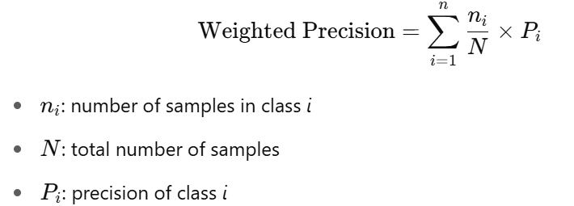

*Figure ()*

* + **Purpose**: Indicates how *precise* the model is when labeling something as a certain attack. Critical for minimizing **false alarms**.

1. **Recall (Weighted)**
   * **Definition**: Measures how well the model captures *all actual instances* of each class.
   * **Formula (for each class)**:

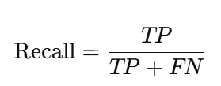

*Figure ()*

* + **Weighted Average**:  
    Like precision but using recall.
  + **Purpose**: Essential for **detecting all attack types**, especially important in intrusion detection to avoid missing real threats.

1. **F1 Score (Weighted)**
   * **Definition**: The harmonic mean of precision and recall, giving a balance between them.
   * 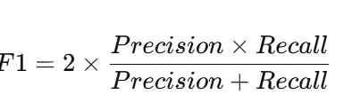**Formula**:

*Figure ()*

* + **Weighted Average**: Averages F1 across all classes, weighted by class size.
  + **Purpose**: Balanced view of performance, especially useful for **imbalanced datasets** where some classes are underrepresented.

1. **F1 Score (Macro)**
   * **Definition**: Average of F1 scores for all classes, **without considering class imbalance**.
   * **Formula**:



*Figure ()*

* + **Purpose**: Evaluates the model’s ability to treat **all classes equally**, regardless of their frequency. Useful when rare attack types of matter as much as frequent ones.

1. **ROC AUC Score (OvR - One vs Rest)**
   * **Definition**: Measures the model's ability to distinguish between classes.
   * **How it works**:
     + For each class, treat it as "positive" and the rest as "negative" (One-vs-Rest).
     + Plot the ROC curve and calculate the **Area Under Curve (AUC)**.
     + Average the AUC values (weighted or macro).
   * **Purpose**: Gives insight into the **probabilistic separability** of classes. Higher AUC indicates better discrimination between attack types and benign traffic.

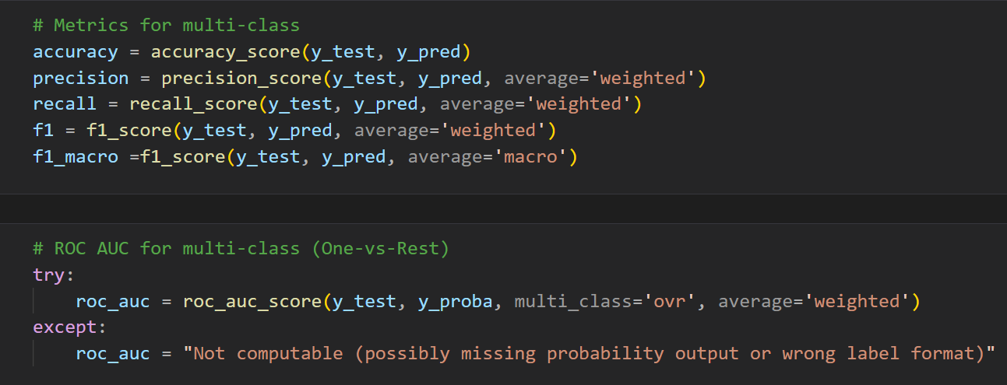

*Figure ()*

* **Results:**
* The model achieved the following performance:

|  |  |
| --- | --- |
| **Metric** | **Score** |
| **Accuracy** | 0.9972410865874364\*100 = 99.7241% |
| **Precision (Weighted)** | 0.9972764667822465\*100 = 99.7276% |
| **Recall (Weighted)** | 0.9972410865874364\*100 = 99.7241% |
| **F1 Score (Weighted)** | 0.9972502096897812\*100 = 99.7250% |
| **F1 Score (Macro)** | 0.9929805115023242\*100 = 99.2981%   |  | | --- | |  | |
| **ROC AUC Score** | 0.999956591477652\*100 = 99.9957% |

* These values indicate **exceptionally high performance** of the stacked IDS model across all key metrics — showing both strong general accuracy and good balance between precision and recall, even across multiple classes.
* **Classification Report:**
  + A detailed classification report was generated showing per-class precision, recall, and F1-score.
* **Confusion Matrix:**
  + A confusion matrix was plotted to visualize the performance across different classes. It helps identify which classes are more likely to be misclassified and provides insight into class-wise mode

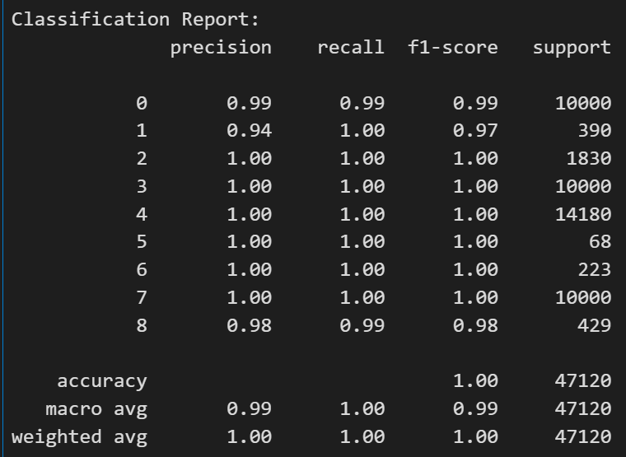

*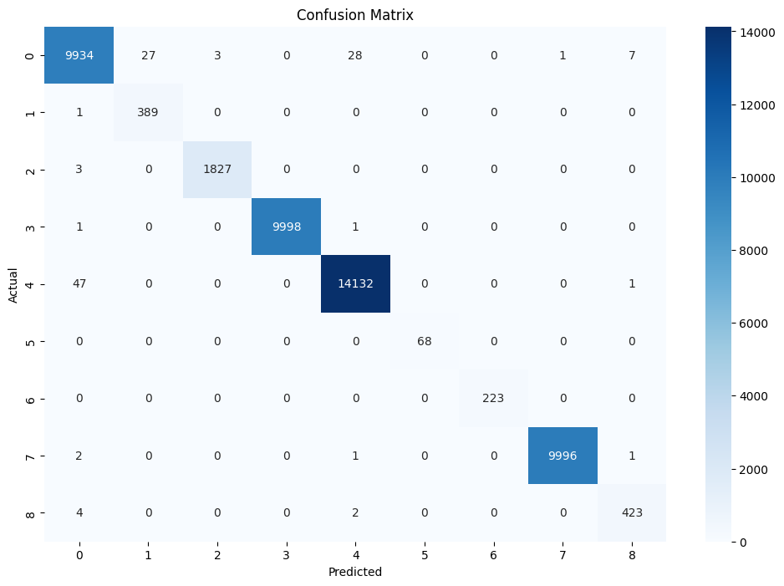Figure ()*

*Figure ()*

### Anomaly Detection (Unknown Attacks)

### To enhance the system's capability of detecting unknown or zero-day attacks, we implemented an anomaly-based detection module using the Isolation Forest algorithm. The key idea is to model what *normal (benign)* traffic looks like and then identify any data points that significantly deviate from this norm as *potential anomalies*.

### Steps:

### Extract Only Benign Traffic:

### We transformed the class label "BENIGN" using the previously saved LabelEncoder.

### Using the encoded label, we filtered the X\_train\_scaled DataFrame to extract only benign records (X\_benign).

### This dataset is assumed to represent normal network behavior.

*Figure ()*

### Train Isolation Forest:

### We used IsolationForest from sklearn.ensemble to train on X\_benign.

### Parameters used:

### n\_estimators=100: Number of trees in the forest.

### contamination=0.05: An estimate of the expected proportion of outliers (this helps in scoring).

### random\_state=42: For reproducibility.

*Figure ()*

### Save the Model:

### The trained model is saved using joblib to be used later in live or offline prediction mode.

### This anomaly detector can be used to flag suspicious traffic not seen during training or not part of the labeled classes (e.g., new types of attacks).

### It works well in combination with the signature-based and ML-based classifiers to form a hybrid IDS system.

*Figure ()*

### Hybrid Detection Method (Stacking + Isolation Forest)

### To build a more robust and intelligent IDS, we designed a hybrid detection system that leverages the strengths of both supervised learning and unsupervised anomaly detection. Specifically, we combined a Stacking Classifier with an Isolation Forest to detect both known and unknown (zero-day) attacks.

### Components of the Hybrid System:

### Stacking Classifier (Supervised Learning):

### Trained on labeled attack and benign data.

### It consists of multiple base classifiers (e.g., Decision Tree, Logistic Regression, KNN, CatBoost).

### A meta-model (Random Forest) aggregates predictions from the base classifiers.

### Handles known attack types with high accuracy.

### Predicts both class label and confidence/probability.

### Isolation Forest (Unsupervised Learning):

### Trained only in BENIGN traffic.

### Learning the patterns of normal behavior.

### Flags anything that deviates as anomalous.

### Effective in detecting new/unknown/zero-day attacks.

### Flow-Based Feature Extraction

### In our proposed Intrusion Detection System (IDS), we developed a custom Flow class designed to extract meaningful flow-level features from raw packet data.

### This process is crucial for transforming low-level network traffic into structured input suitable for machine learning models.

### Flow Construction:

### Network packets are grouped into *flows* using a 5-tuple key:

### Source IP

### Destination IP

### Source Port

### Destination Port

### Protocol

### The grouping is bidirectional meaning forward, and reverse traffic are combined to represent a complete communication session. This grouping allows for a more comprehensive analysis of each flow’s behavior.

### 

### *Figure ()*

### *Figure ()*

### Feature Extraction:

### Once the flows are formed, we extract 20 handcrafted features for each flow. These features were selected based on their relevance to distinguishing between benign and malicious behavior. The extracted features include:

### Statistical metrics: e.g., mean and standard deviation of packet lengths.

### Traffic direction: separate calculations for forward and backward streams.

### Temporal properties: such as inter-arrival times and flow duration.

### Protocol-related attributes: like header lengths, segment sizes, and initial window sizes.

### The full list of features includes:

* **FwdPacketLengthMean, FwdPacketLengthMax, FlowIATMax**
* **SubflowBwdBytes, Init\_Win\_bytes\_backward, TotalLengthofBwdPackets**
* **FlowPackets/s, TotalLengthofFwdPackets, BwdPackets/s**
* **AveragePacketSize, FlowDuration, BwdPacketLengthMean**
* **SubflowFwdBytes, AvgBwdSegmentSize, FwdPacketLengthStd**
* **AvgFwdSegmentSize, DestinationPort, BwdHeaderLength**
* **PacketLengthMean, BwdPacketLengthStd**

|  |  |  |  |
| --- | --- | --- | --- |
| **NO** | **Feature Name** | **Description** | **Calculation Method** |
| **1** | **FwdPacketLengthMean** | **Average length of forward direction packets** | **np.mean(fwd\_sizes)** |
| **2** | |  | | --- | | **FwdPacketLengthMax** |  |  | | --- | |  | | **Maximum length among all forward packets** | **np.max(fwd\_sizes)** |
| **3** | **FlowIATMax** | **Maximum inter-arrival time between packets in the flow** | **max (fwd\_times + bwd\_times)** |
| **4** | **SubflowBwdBytes** | |  | | --- | |  |  |  | | --- | |  |   **Total bytes transferred in the backward subflow** | **sum(bwd\_sizes)** |
| **5** | **Init\_Win\_bytes\_backward** | **Initial TCP window size from the first backward packet** | **Extracted from first backward packet:**  **pkt.get\_window\_size()** |
| **6** | **TotalLengthofBwdPackets** | **Total byte length of all backward packets** | **sum(bwd\_sizes)** |
| **7** | **FlowPackets/s** | **Number of packets per second in the flow** | **(len(fwd\_sizes) + len(bwd\_sizes)) / flow\_duration** |
| **8** | **TotalLengthofFwdPackets** | |  | | --- | |  |   **Total byte length of all forward packets** | **sum(fwd\_sizes)** |
| **9** | **BwdPackets/s** | **Number of backward packets per second** | **len(bwd\_sizes) / flow\_duration**   |  | | --- | |  | |
| **10** | **AveragePacketSize** | **Average size of all packets in the flow** | **np.mean(fwd\_sizes + bwd\_sizes)** |
| **11** | **FlowDuration** | **Total duration of the flow**   |  | | --- | |  | | **flow\_end - flow\_start** |
| **12** | **BwdPacketLengthMean** | **Average length of backward packets** | **np.mean(bwd\_sizes)** |
| **13** | **SubflowFwdBytes** | |  | | --- | |  |   **Total bytes transferred in the forward subflow** | **sum(fwd\_sizes)** |
| **14** | **AvgBwdSegmentSize** | **Average segment size of backward packets** | **np.mean(bwd\_seg\_size)** |
| **15** | **FwdPacketLengthStd** | **Standard deviation of forward packet lengths**   |  | | --- | |  | | **np.std(fwd\_sizes)** |
| **16** | **AvgFwdSegmentSize** | **Average segment size of forward packets**   |  | | --- | |  | | **np.mean(fwd\_seg\_size)** |
| **17** | **DestinationPort** | **Destination port number from the first packet**   |  | | --- | |  | | **pkt.dst\_port** |
| **18** | **BwdHeaderLength** | **Total length of headers in backward packets**   |  | | --- | |  | | **sum(header\_length for each backward packet)** |
| **19** | **PacketLengthMean** | **Mean of all packet lengths in both directions**   |  | | --- | |  | | **np.mean(fwd\_sizes + bwd\_sizes)** |
| **20** | **BwdPacketLengthStd** | |  | | --- | |  |   **Standard deviation of backward packet lengths** | **np.std(bwd\_sizes)** |

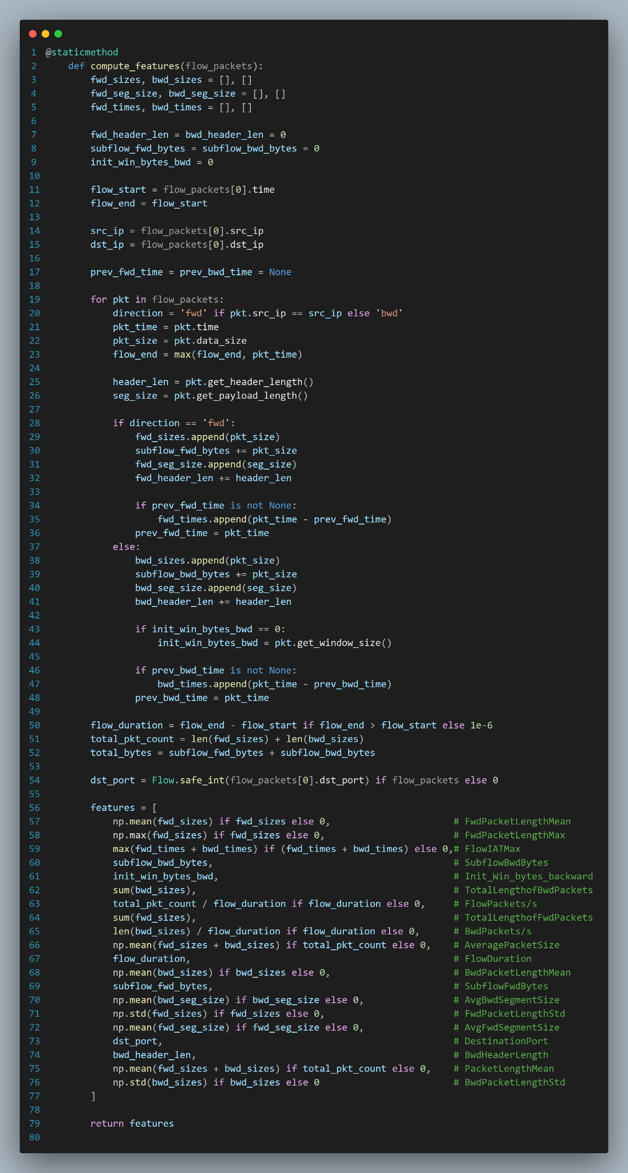

*Figure ()*

### Purpose and Integration:

### These features serve as the input for both:

### The stacked classification model (used to detect known attacks).

### The Isolation Forest is an anomaly detector (used to detect unknown threats based on deviations from benign traffic patterns).

### The design ensures compatibility with the models trained earlier using the CIC-IDS2017 dataset, thereby allowing seamless inference in real-time environments.

### Real-Time Readiness:

### The Flow class is optimized for use in real-time scenarios, enabling it to process packets and extract features efficiently without relying on third-party flow processors.

### Anomaly-Based Intrusion Detection System

* + - * To implement an intelligent anomaly-based intrusion detection mechanism, the **AnomalyIDS** class was developed. This class plays a critical role in identifying both **known attack types** using supervised learning and **unknown/zero-day attacks** using unsupervised anomaly detection techniques.
      * It combines both supervised learning and unsupervised anomaly detection techniques to achieve high accuracy in identifying known attacks and flexibility in detecting unknown threats.
      * The **AnomalyIDS** class operates by extracting features from packet flows, normalizing them using a pre-fitted scaler, and then passing them through a hybrid detection pipeline. It integrates seamlessly with the database (for logging and alerting), the custom Packet and Flow classes (for feature extraction), and supports parallel flow processing using multithreading for real-time performance.
      * The AnomalyIDS class integrates two machine learning models:

### The stacked classification model (used to detect known attacks).

### The Isolation Forest is an anomaly detector (used to detect unknown threats based on deviations from benign traffic patterns).

### By combining both models, the class enhances the detection capabilities of the IDS, providing:

### High precision for known threats, and

### Flexibility and adaptability for detecting novel attacks.

*Figure ()*

### The AnomalyIDS Class perform the following:

### Flow Processing: Groups raw packets into flows and extracts statistical features per flow.

### Feature Scaling: Uses a saved MinMaxScaler to normalize features before prediction.

### Anomaly Scoring: Computes an anomaly score using Isolation Forest; detects unseen behaviors.

### Classification: For normal flows, uses a trained stacking model to classify known attacks.

### Logging & Alerting: Records suspicious activity into a structured SQLite database.

**Batch Prediction:** Supports prediction from CSV files to test or validate model behavior offline.

### Functionalities:

### process\_flow(flow\_item, conn)

### Processes a single bidirectional flow of packets:

### Extracts 20 handcrafted statistical features using the Flow class.

### Scales the features using a MinMaxScaler.

### Detects anomalies using the IsolationForest model.

### If not anomalous, classifies the traffic using the StackingClassifier.

### If the result is an attack (not “BENIGN”), it logs and raises an alert in the database.

*Figure ()*

### detect(scapy\_packets,threads=10)

### Accepts a list of Scapy packets and performs the following:

### Converts packets into Packet objects.

### Group them into flows using a 5-tuple connection key.

### Detects and classifies traffic in parallel using thread pools.

### Updates the total number of flows and detection status.

*Figure ()*

### predict\_from\_CSV(csv\_path)

### Allows offline prediction and evaluation using a structured CSV file:

### Reads the input features and scales them.

### Applies the hybrid anomaly model.

### Returns predictions and summary statistics (e.g., counts of benign, attack, and unknown).

*Figure ()*

### Output & Alert Handling:

### If an attack is detected (either known or unknown), a new Log and Alert record is created.

### Each alert includes metadata such as timestamp, source IP, destination IP, protocol, and attack type.

### The alert is stored in a local SQLite database for later visualization or response.

*Figure ()*

### if the rule matched with Packet or Detecting Anomalous

* + - * **it would do two things**:

### Alerting:

### To ensure proper tracking and response to detected threats, the Alert class was implemented as a key component of the intrusion detection system. This class is responsible for storing alert information into a persistent database and retrieving it when needed. It enables both anomaly-based and signature-based detection modules to log alerts in a unified format.

*Figure ()*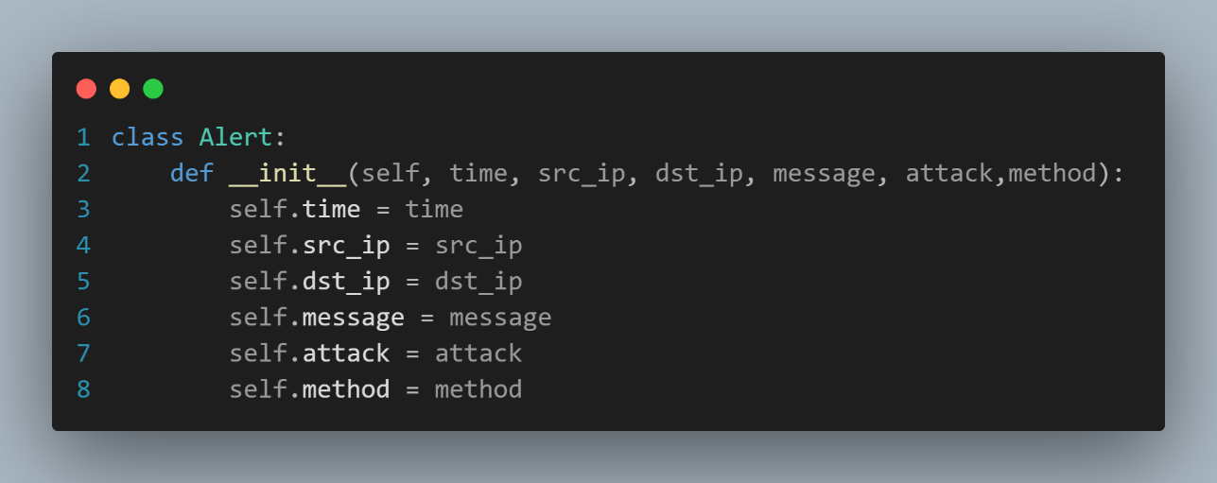

### A screen shot of a computer AI-generated content may be incorrect.Inserts the current alert instance into the alerts table within the SQLite database. It ensures that all key fields are captured and committed to storage for later analysis or UI display.

### *Figure ()*

### Retrieves all existing alerts from the database, reconstructs them into Alert objects, and returns them in a list. This is particularly useful for reporting, visualization in dashboards, or audit purposes.

### *Figure ()*

### Integration in the IDS Pipeline:

### Used by both the AnomalyIDS and SignatureIDS classes after successful attack detection.

### Allows consistent and modular handling of alerts across different detection techniques.

### Supports future extension such as email notifications, SMS, or SIEM integration.

*

### *Figure ()*

### Logging:

### The Log class is responsible for recording and retrieving logging events related to the Intrusion Detection System (IDS).

### These events capture important details about network activities, including suspicious or malicious traffic, and store them in a persistent database table (logs).

### 

### *Figure ()*

### Inserts the log entry into the logs table of the SQLite database using the provided connection.

### 

*Figure ()*

### Retrieves all stored logs from the logs table and returns them as a list of Log objects for further analysis or display.

### *Figure ()*

### Integration:

### Works closely with both AnomalyIDS and SignatureIDS systems.

### An event called whenever (especially an alert or detection) needs to be persistently recorded.

### The stored data supports system auditing, dashboard visualization, and forensic analysis.

### *Figure ()*

### AlertAnalyzer Class

* + - * The **AlertAnalyzer** class is a simple analytical utility designed to process and extract insights from a list of alert objects (instances of the Alert class). It provides statistical summaries such as identifying the most frequent source and destination IPs that triggered alerts. This helps administrators understand the most common offenders and targets in the network, assisting in further investigation and mitigation.
      * This class is typically used in the **admin dashboard or backend analytics module** to highlight common sources of attacks and potential targets, allowing network admins to identify patterns or possible compromised devices.

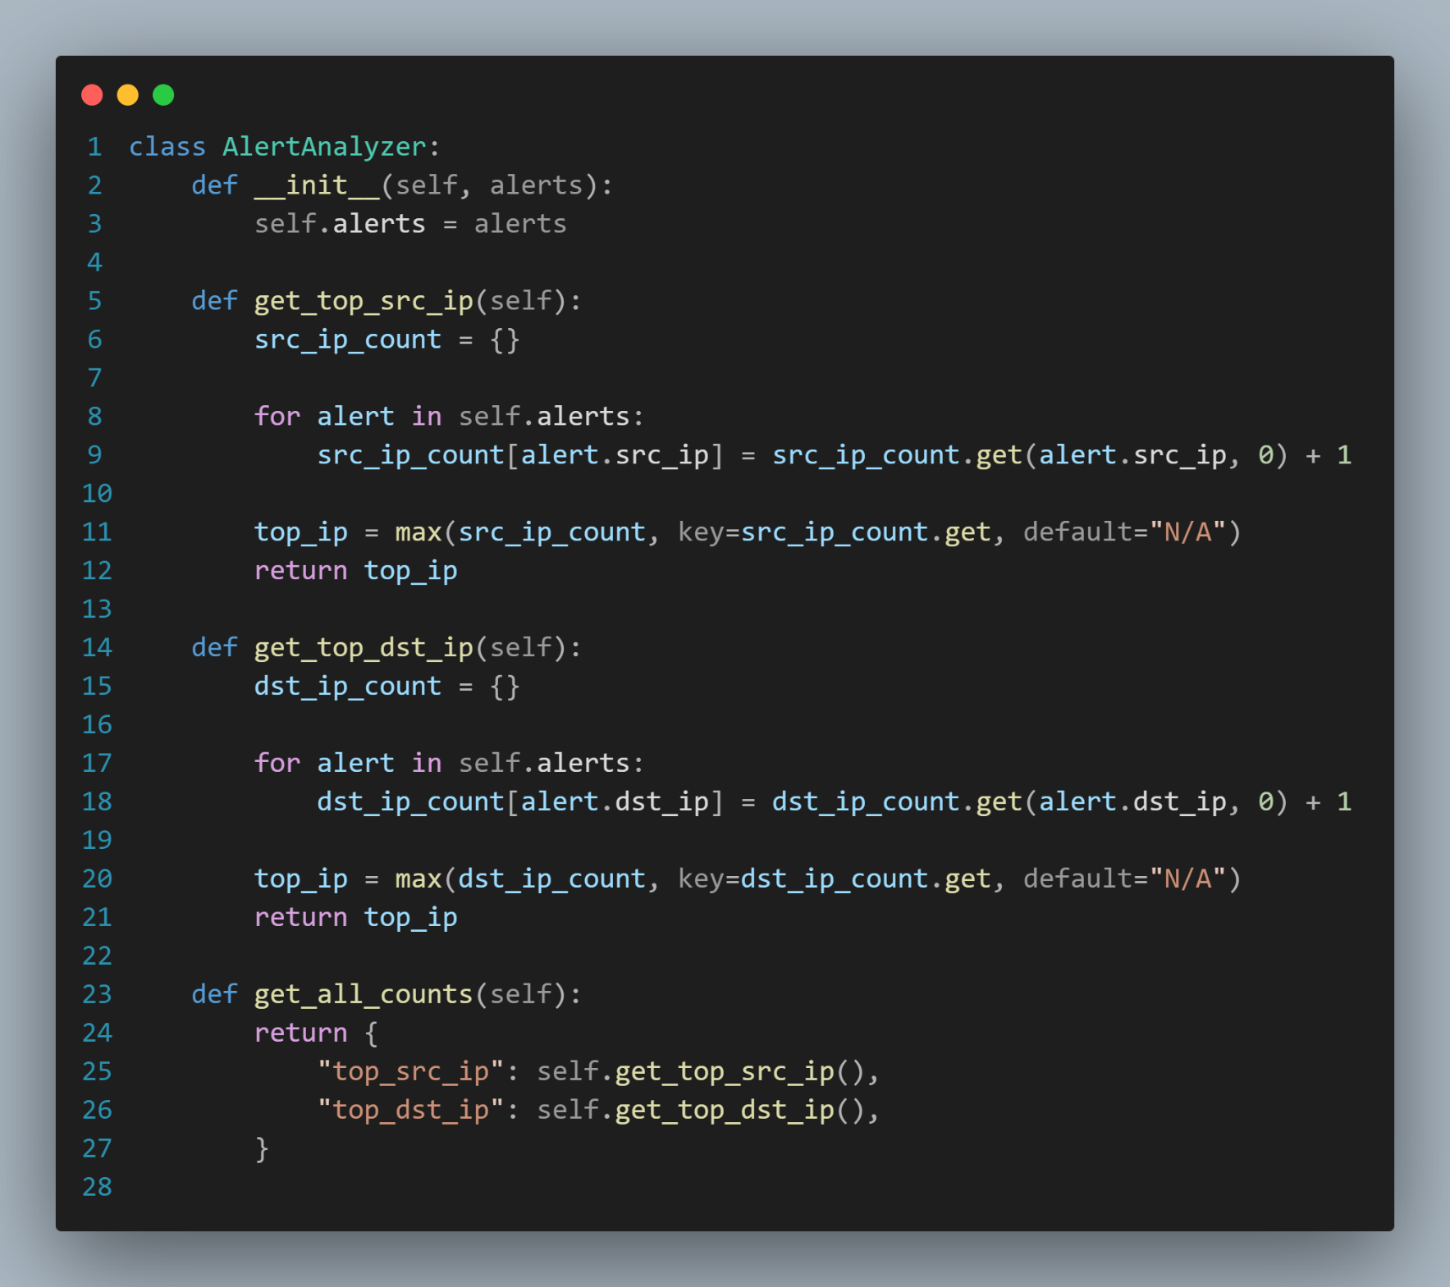

### *Figure ()*

* + - * **Integration Pipeline:**

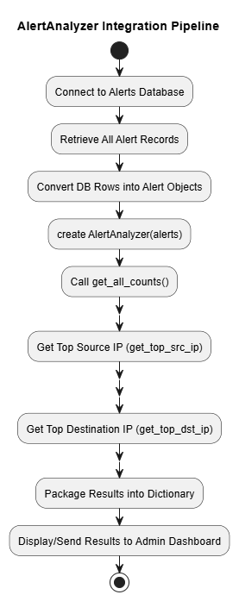

### 

### 

### *Figure ()*

### To ensure proper tracking and response to detected threats, the Alert class was implemented as a key component of the intrusion detection system. This class is responsible for storing alert information into a persistent database and retrieving it when needed. It enables both anomaly-based and signature-based detection modules to log alerts in a unified format.

### Full Stack Integration & Web Dashboard (Flask Application)

* + - * All the previous it was into the core, how Matching done and what happen if matched. Now we have reached the last point, which is how we will display all this to the admin.
      * We used it for visualizing and using the UI Flask framework.
      * Flask is a lightweight and flexible Python web framework used for building web applications. It is classified as a micro-framework because it provides the essentials for web development without imposing too many restrictions or dependencies. Flask is known for its simplicity, ease of use, and extensibility, making it a popular choice for both small and large projects.
      * The Flask-based web system serves as the central interface for monitoring, controlling, and analyzing the behavior of the hybrid Intrusion Detection System (IDS). It combines both Signature-Based and Anomaly-Based detection mechanisms with an interactive dashboard for real-time visibility.
      * **Install FLASK:**

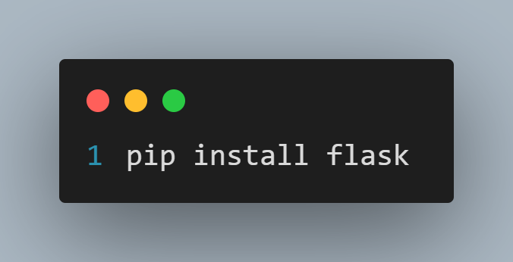

*Figure ()*

* + - * **Import FLASK:**

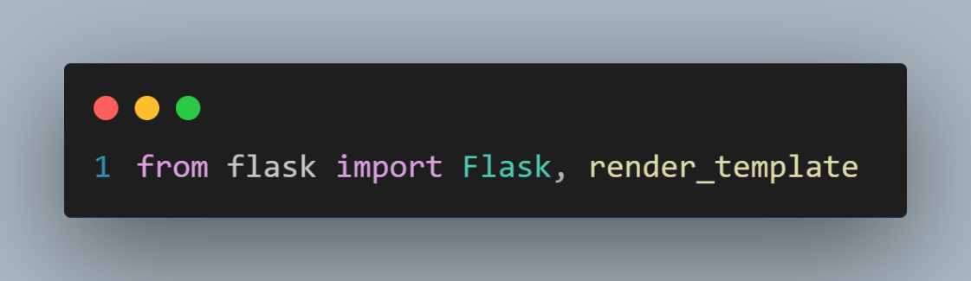

*Figure ()*

* + - * **Create a name for the Application:**

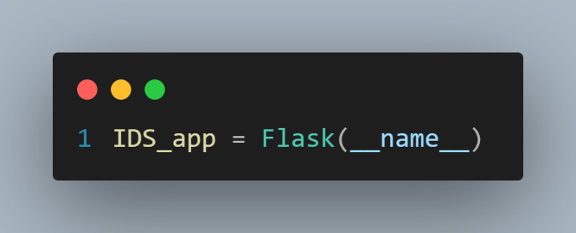

*Figure ()*

* + - * **Implement The Front-End Pages with HTMl, CSS & JS:**

1. **Creating Partial Templates**
   1. 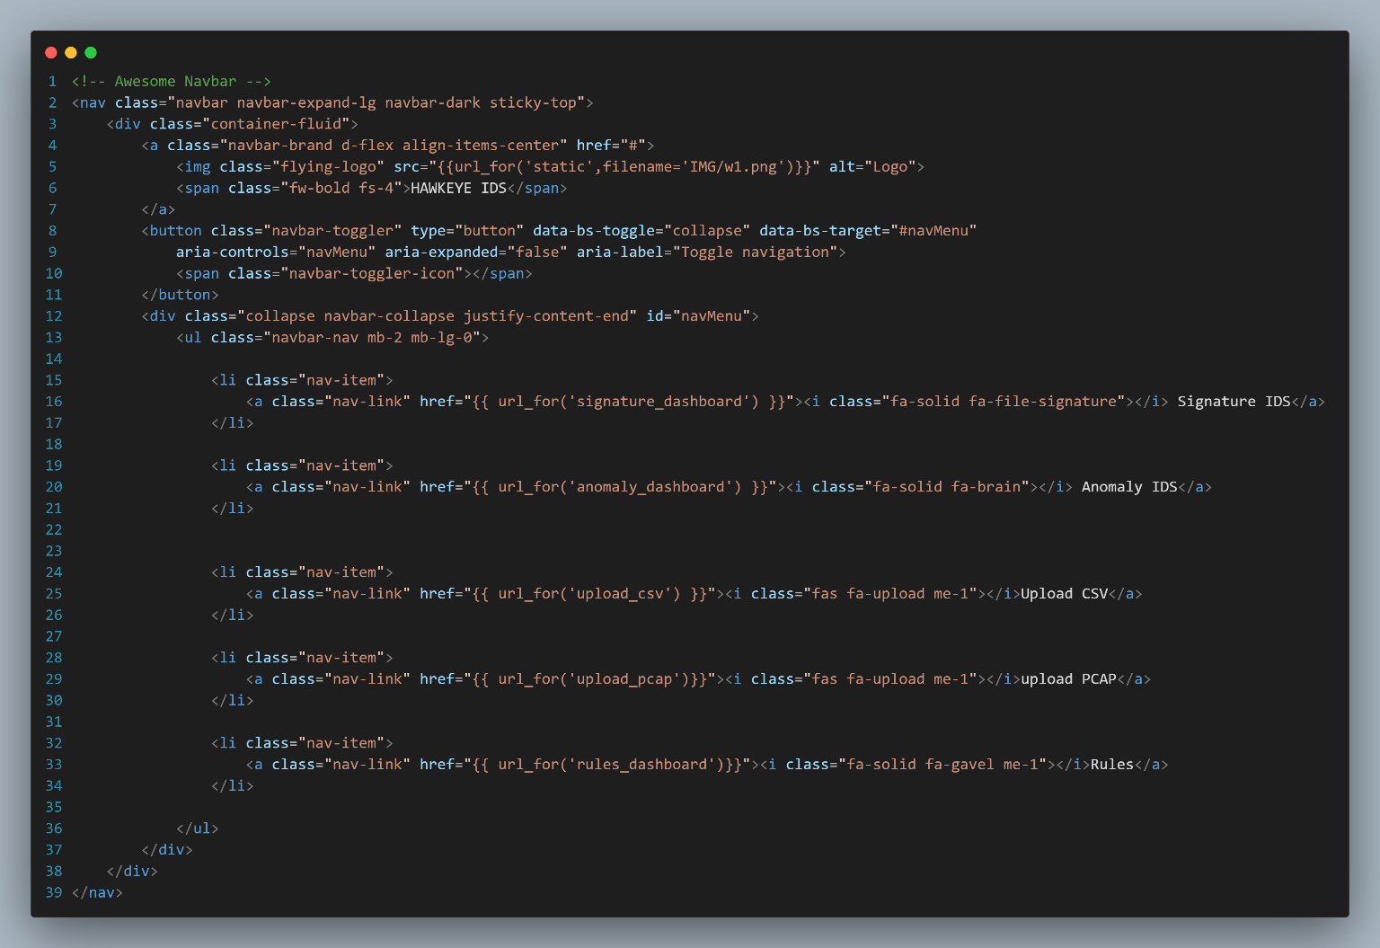**Navbar**

*Figure ()*

* 1. **Footer**

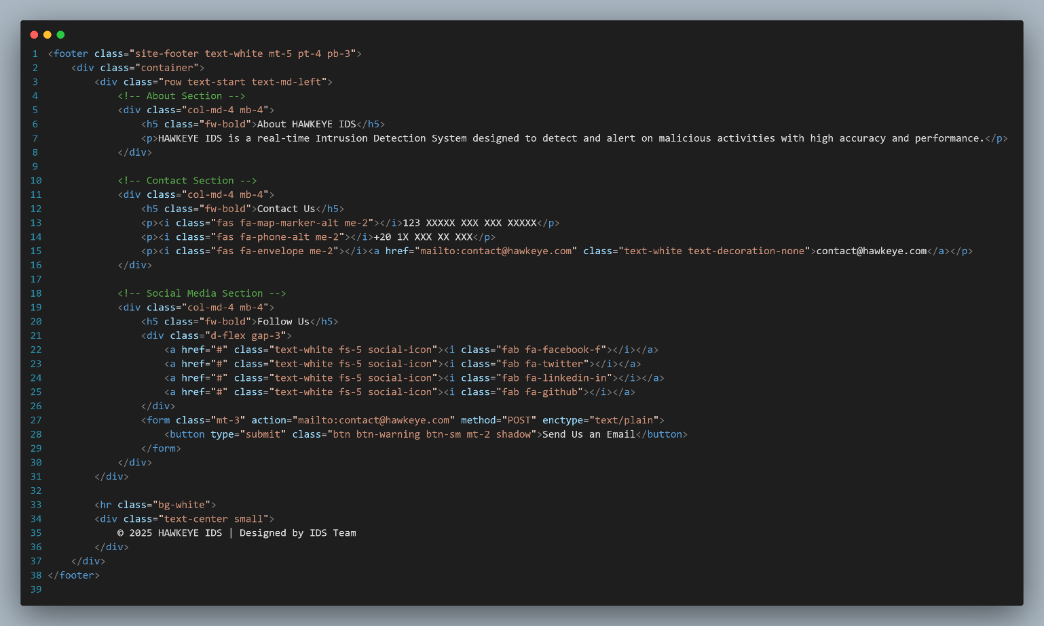

*Figure ()*

1. **Create A Base.html**

* 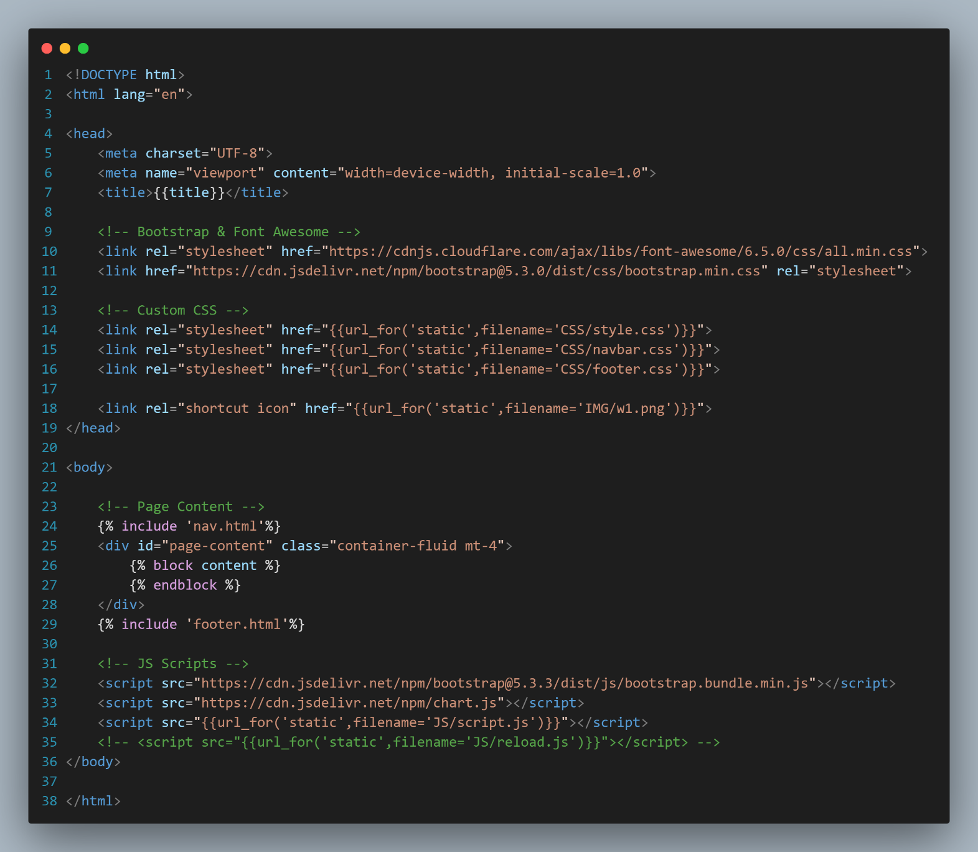defines the main layout of the Flask-based Intrusion Detection System (IDS) dashboard. It is a reusable and responsive structure that loads dynamic content based on Flask routes, and ensures consistency across all pages using Bootstrap, custom style sheets, and partial templates

*Figure ()*

1. **Create HTML Code for each page to display its content and use Base.html into it.**
   1. **CSV.html.**
   2. **PCAP.html.**
   3. **Index.html.**
   4. **Anomaly.html.**
   5. **Rules.html.**

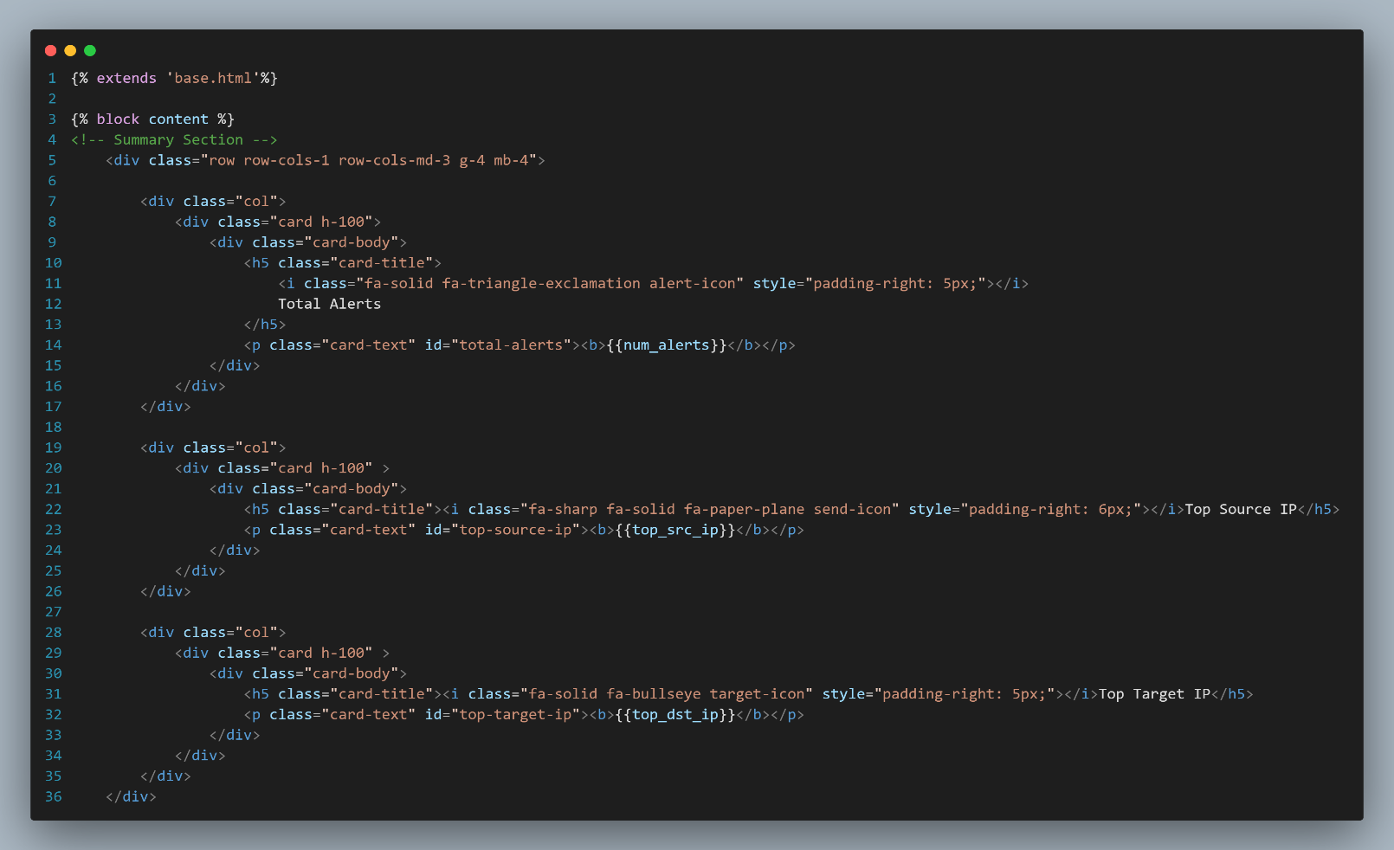*Figure ()*

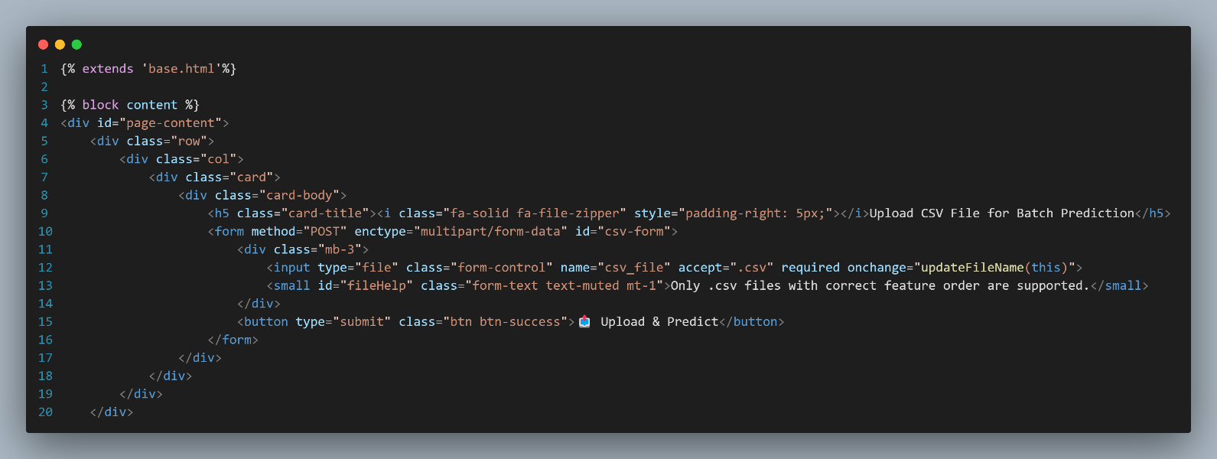*Figure ()*

*Figure ()*

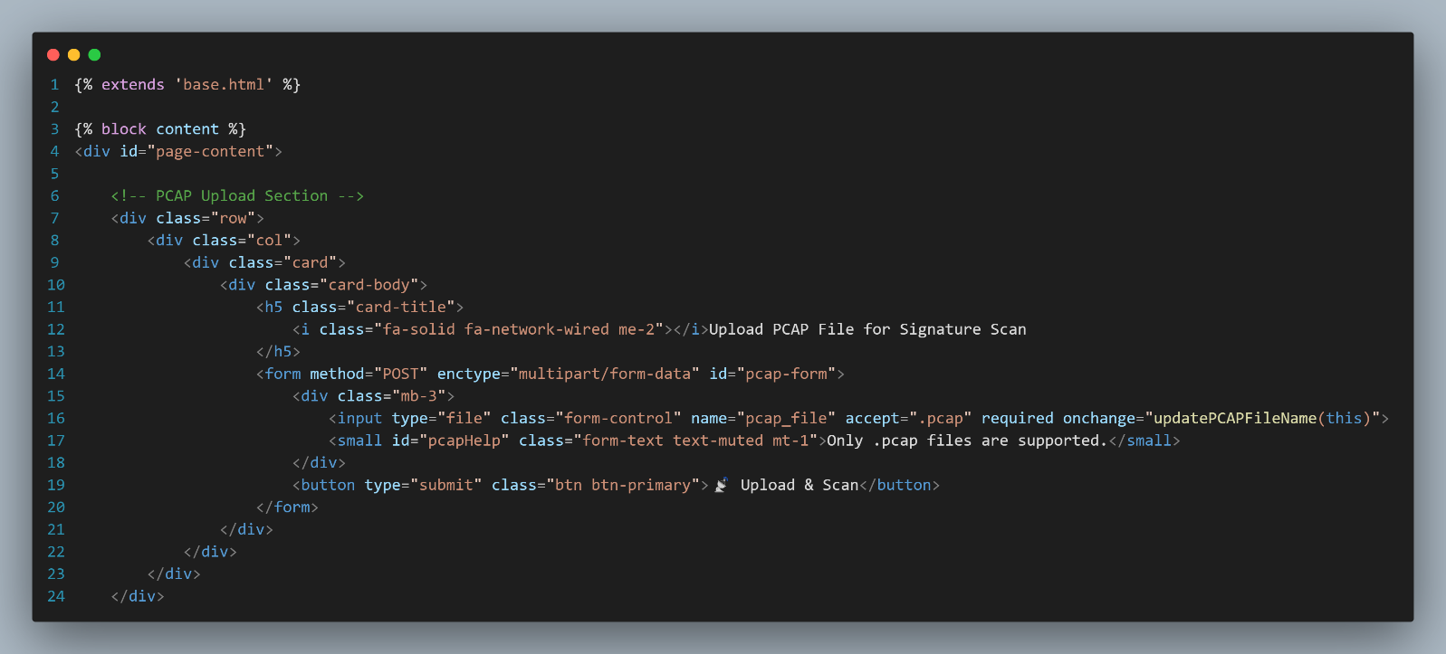

1. **We use Jinja2, the default Flask templating engine to:**
   * + - To take the Alerts, Logs and Rules from the Flask and display it onto the HTML Page we use Jinja2 Syntax.
       - Jinja2 Syntax is a powerful and widely used templating engine for Python. It is commonly used on web **frameworks like**Flask**and**Django**to generate dynamic** HTML**,** XML**, or other markup formats.** Jinja2 **allows you to embed Python-like expressions and control structures**
     1. Inject variables.
     2. Serve routes dynamically.
     3. Include partial templates for reusability.

### 

### *Figure ()*

1. Write the **CSS(Bootstrab)** for the **HTML** File to give styling for the Page**.**

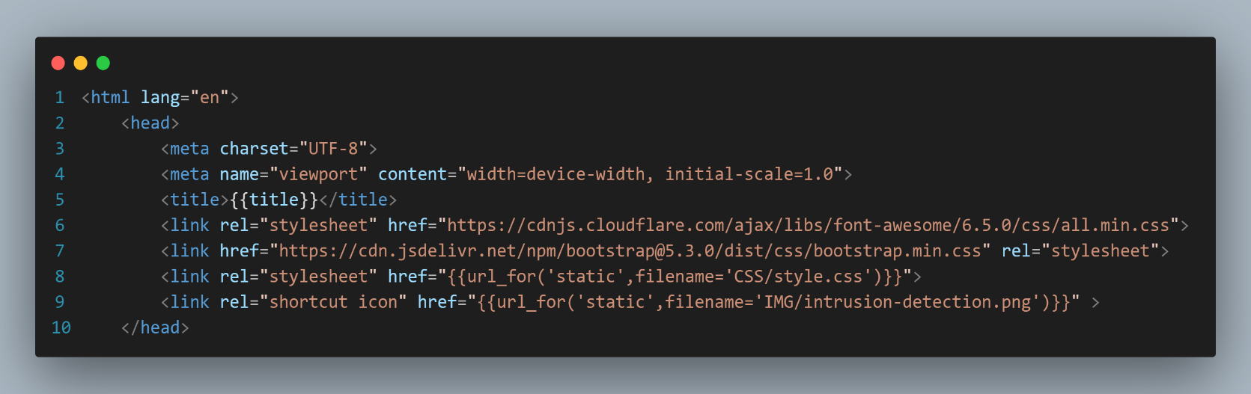

*Figure ()*

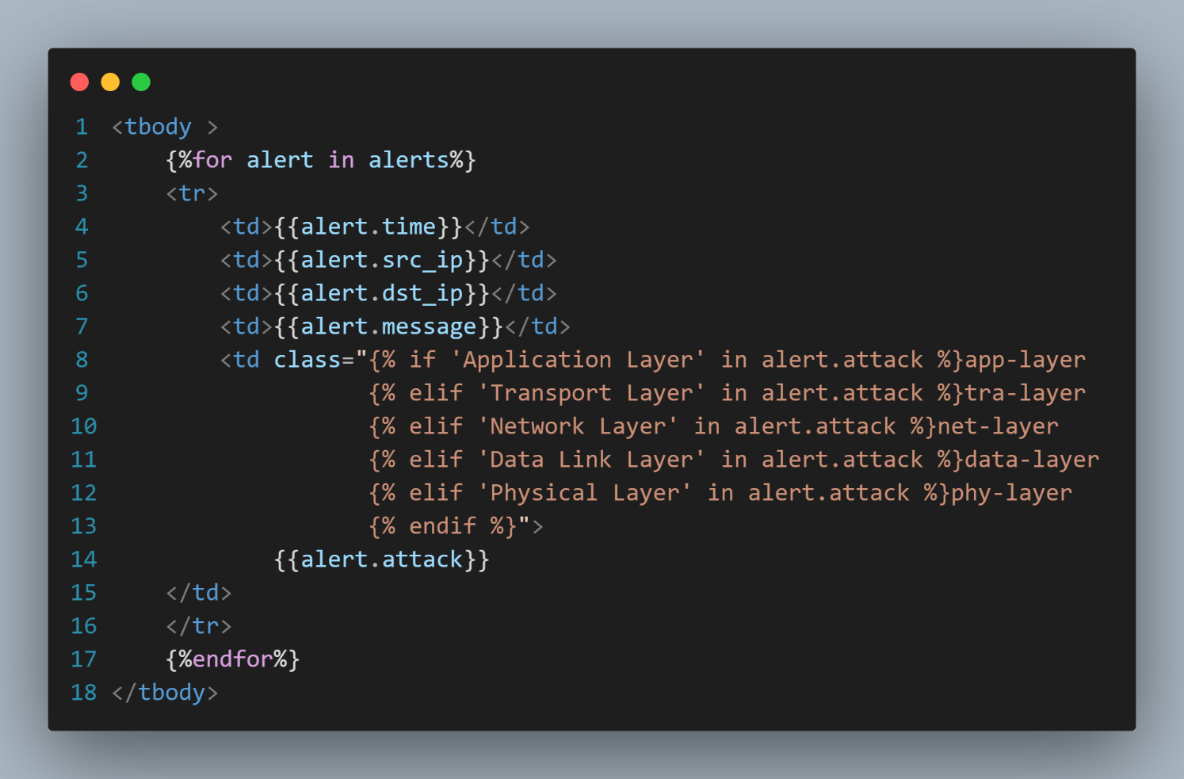

*Figure ()*

1. Write the **JS** for the **HTML** File to add flexibility to the web page**.**

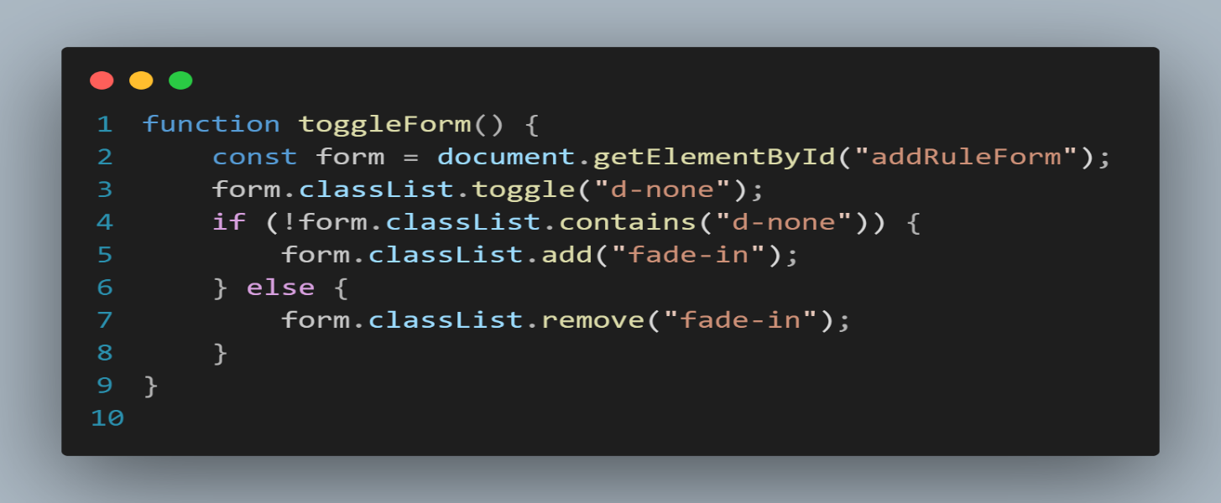

*Figure ()*

* + - * **Implement The Controller of the System:**

1. **Implement the Routes of each Page.**
   1. **Siganture-Based IDS.**

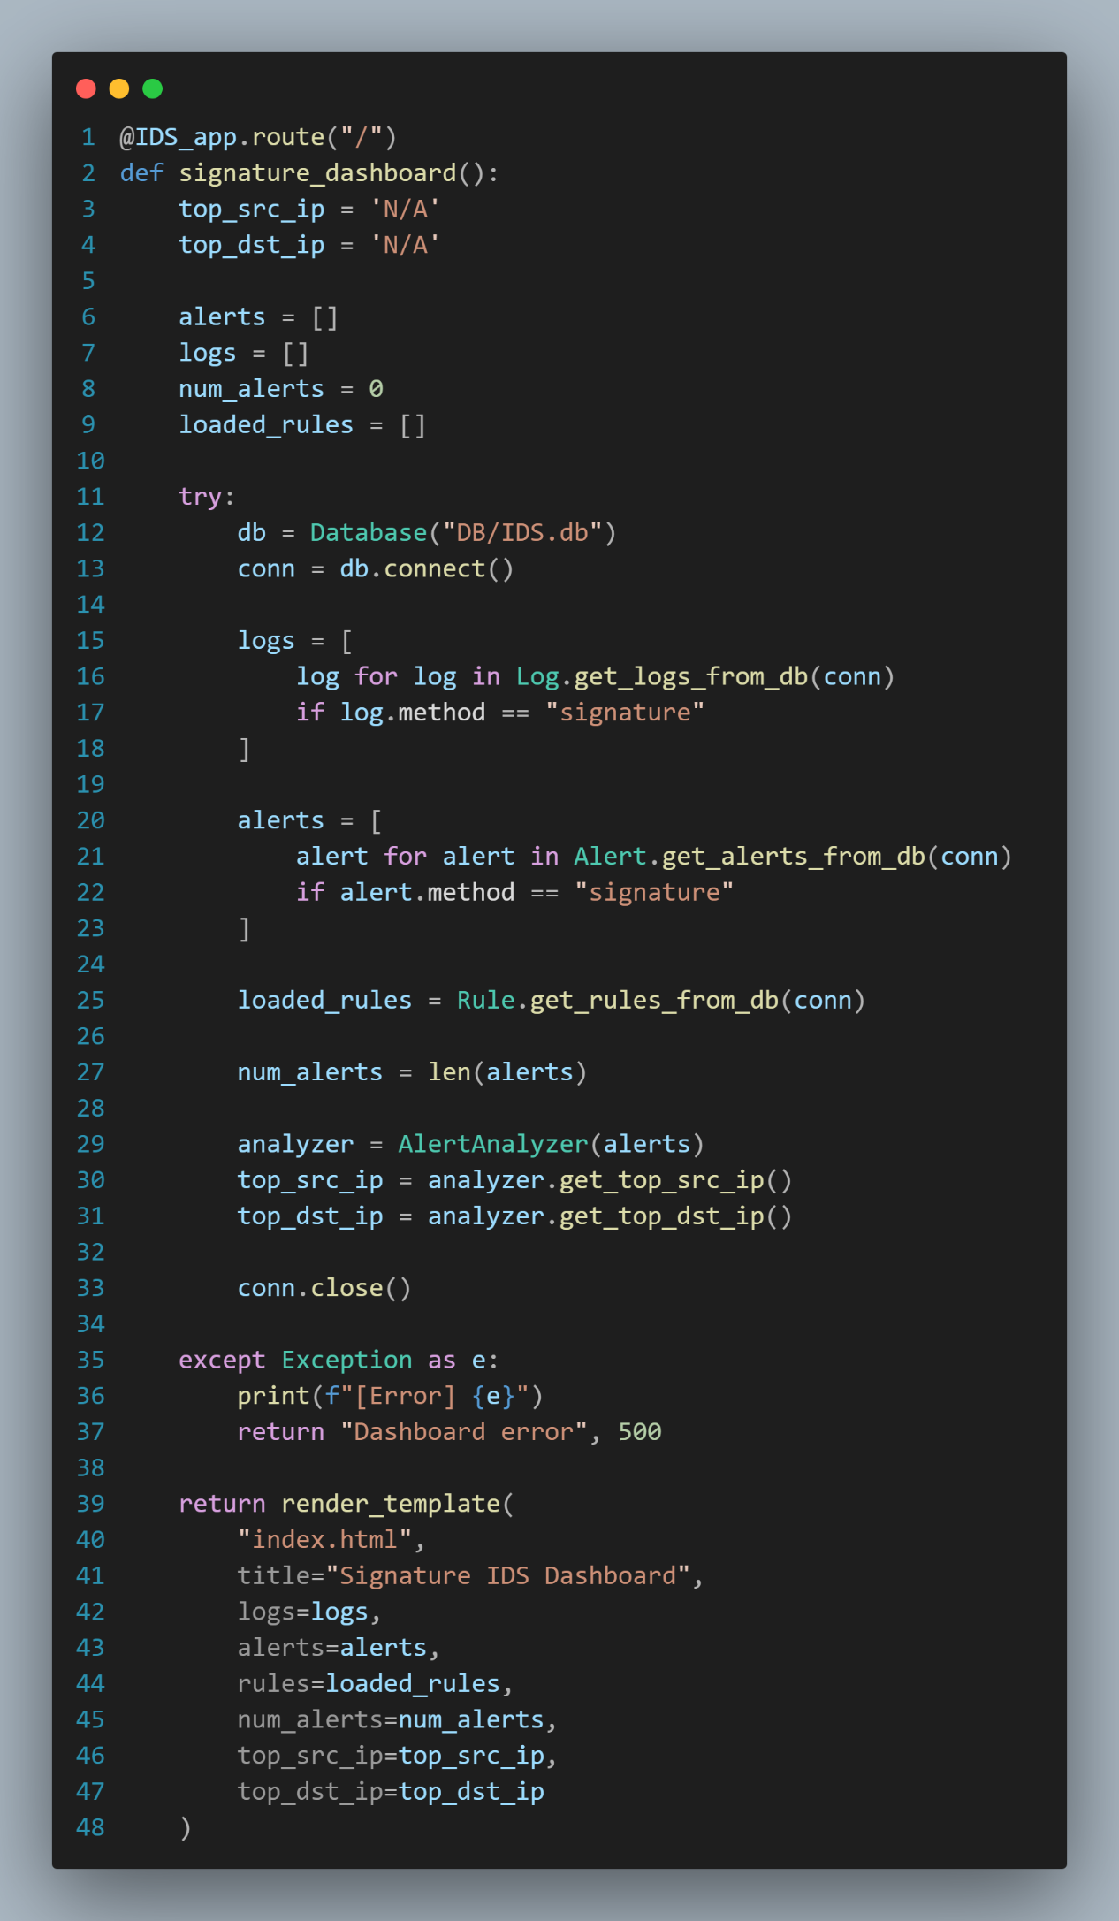

*Figure ()*

* 1. **Anomaly-Based IDS.**

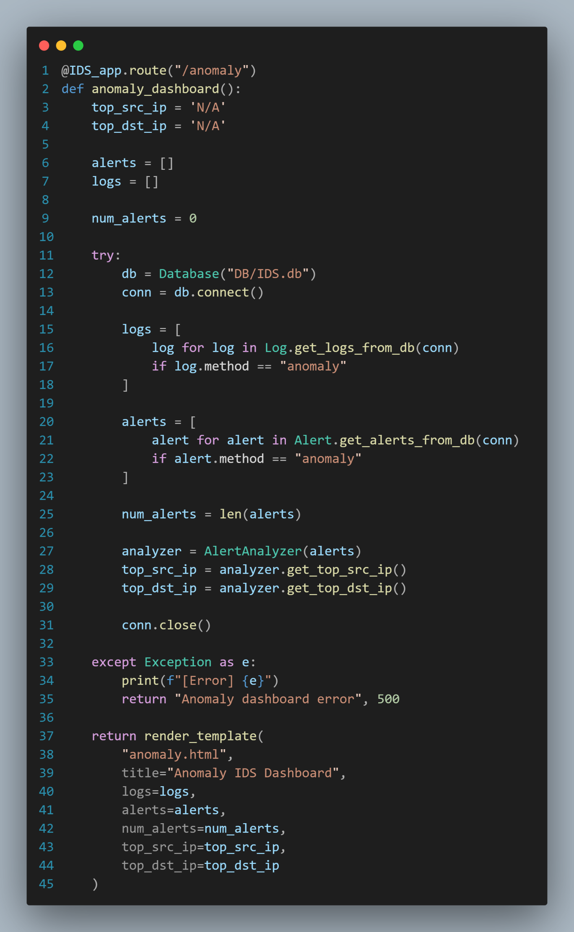

*Figure ()*

* 1. **Scanning PCAP Files.**

*Figure ()*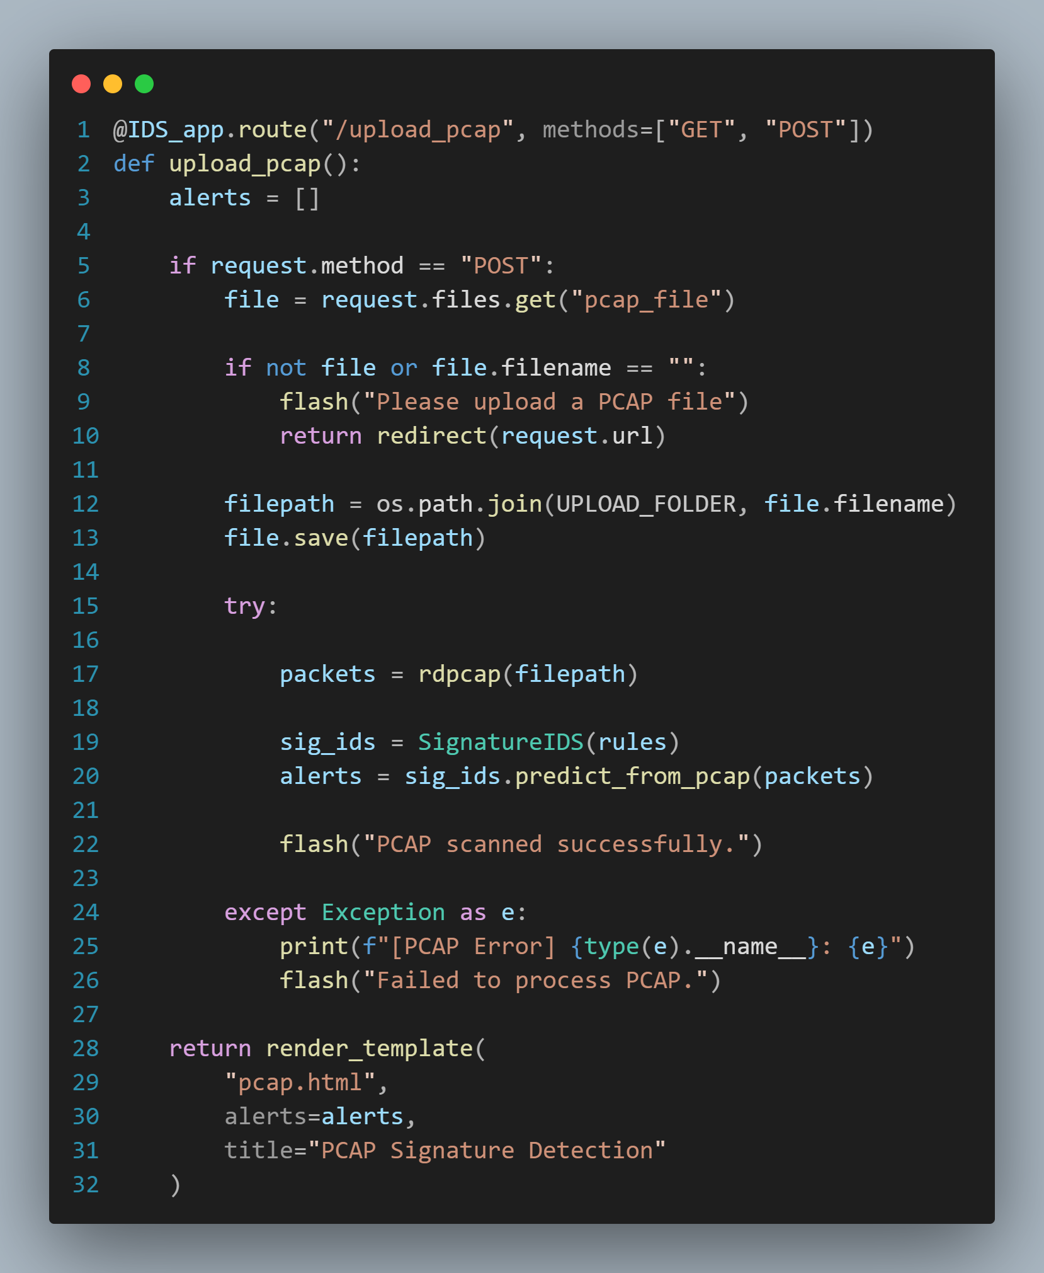

* 1. 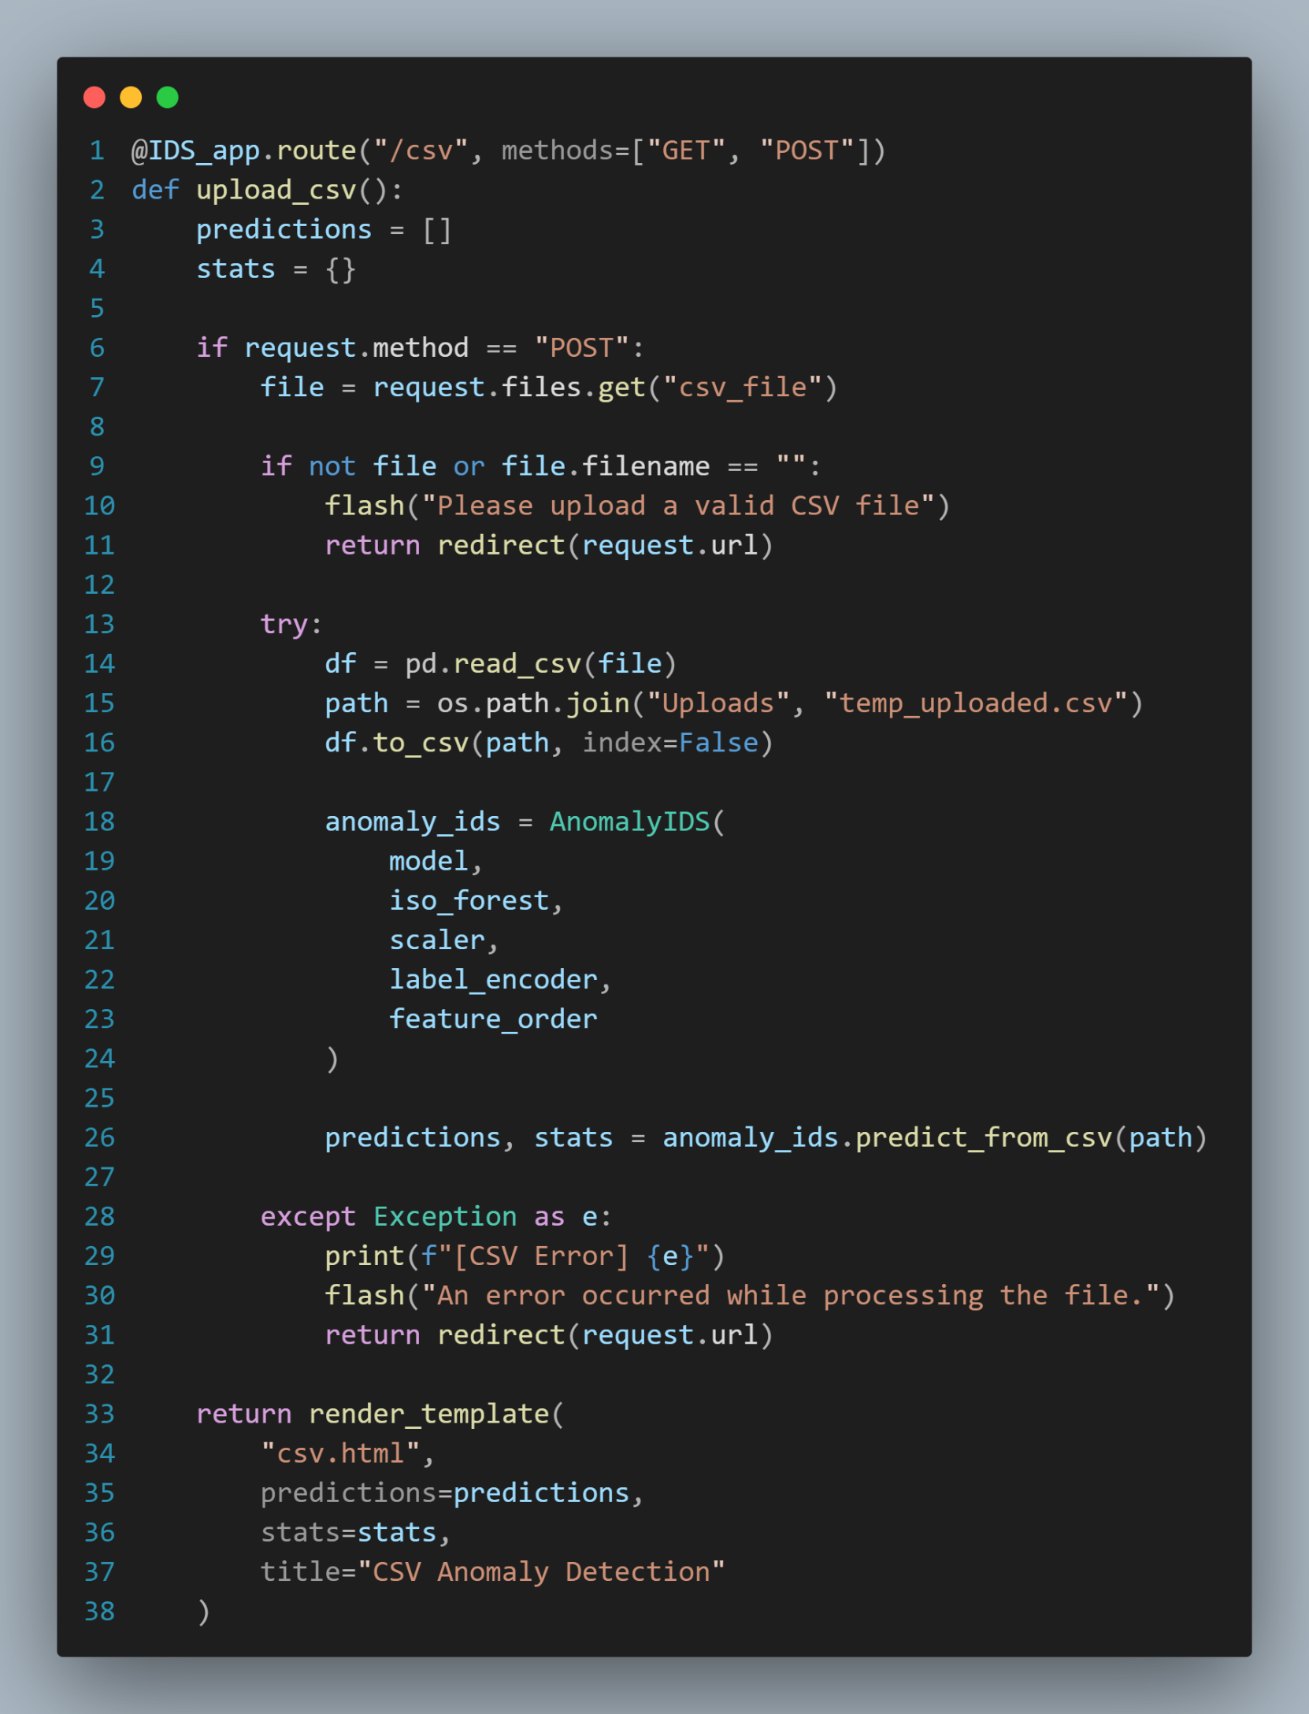**Scanning CSV Files.**

*Figure ()*

* 1. **Display Rules.**

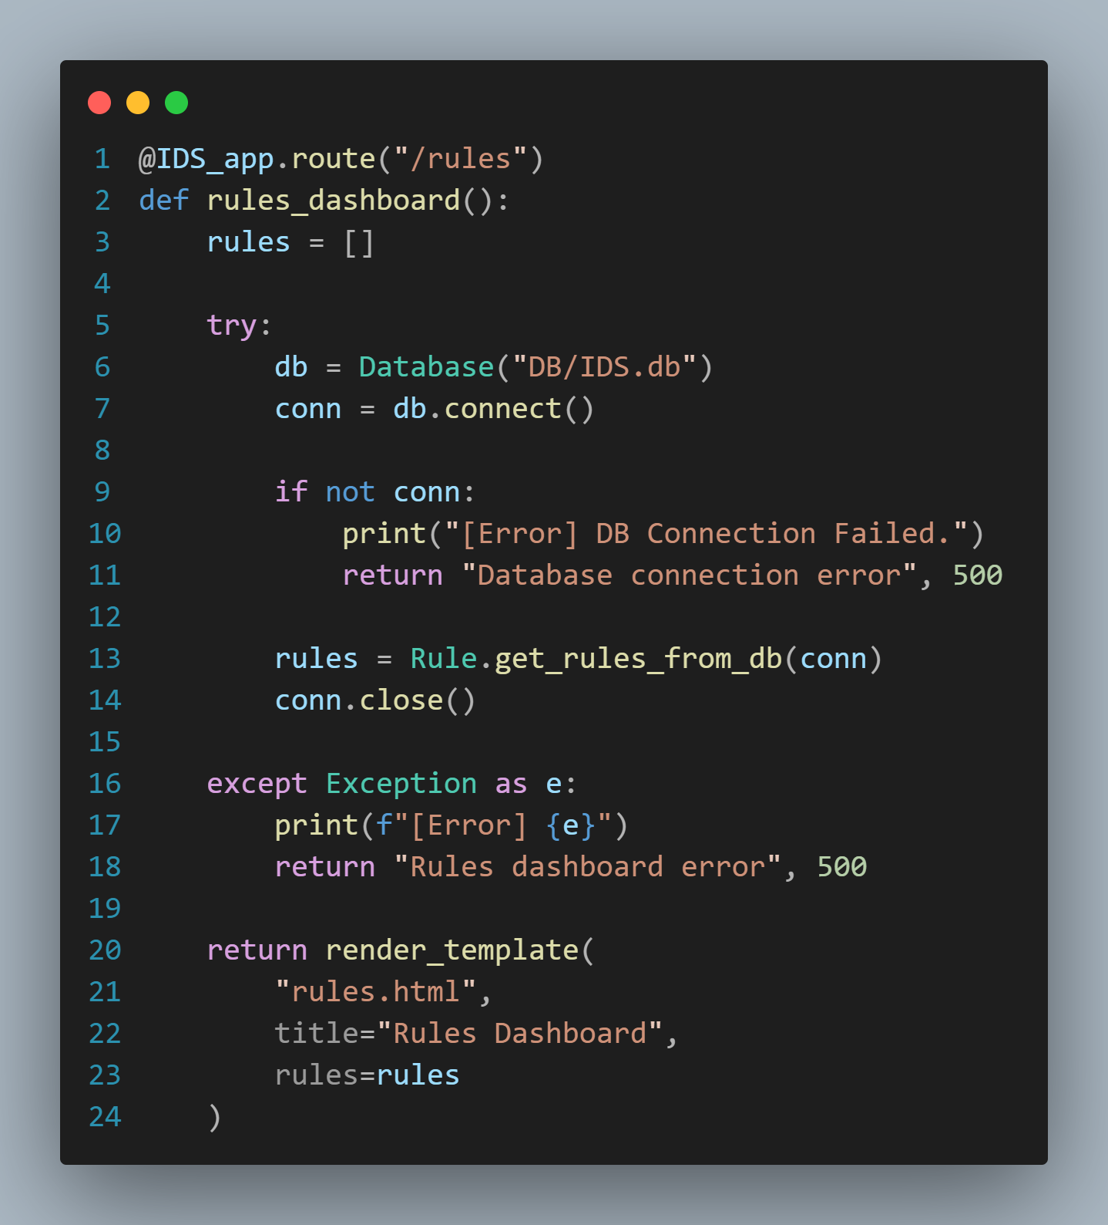

*Figure ()*

1. **Connect to the database.**

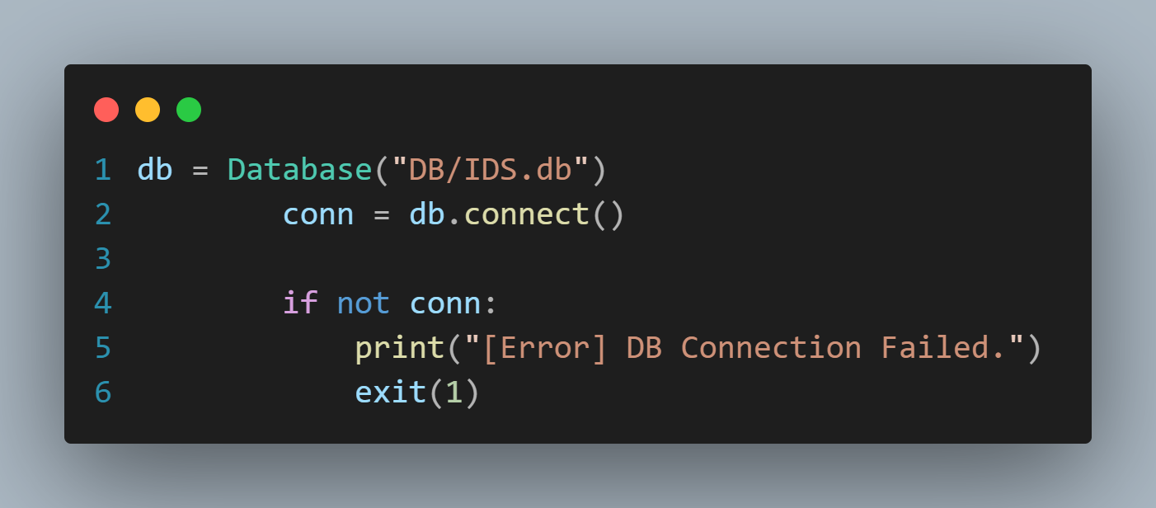

*Figure ()*

1. **Load a sample test. PCAP File to act as a real time traffic.**

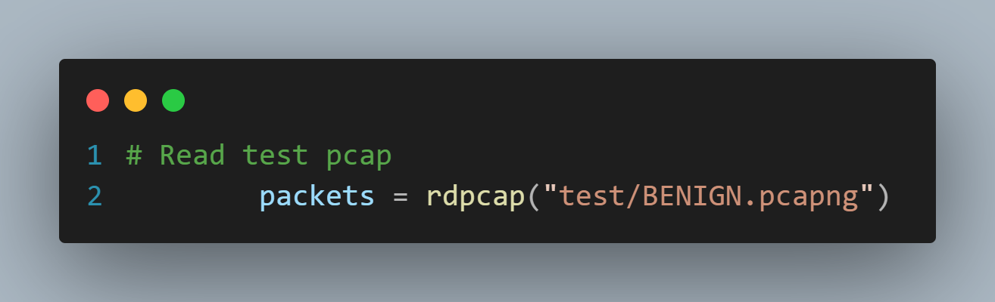

*Figure ()*

1. **Load the Signatures rules.**

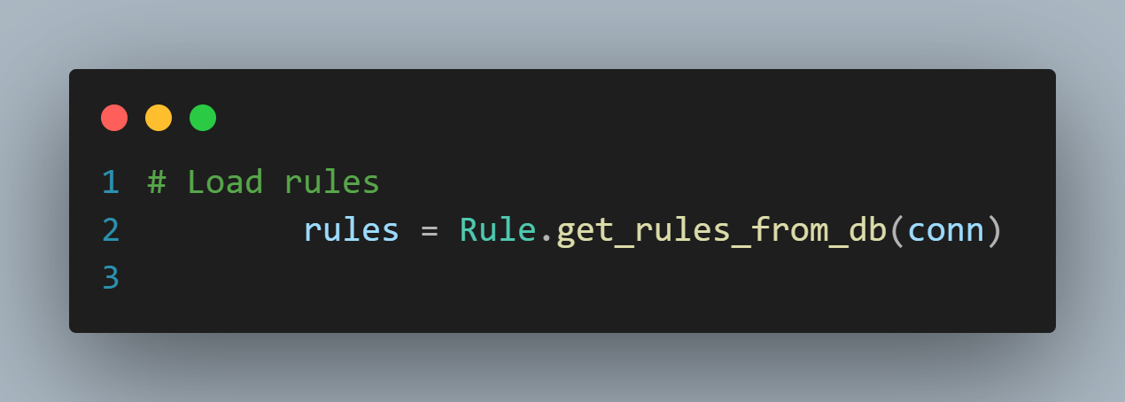

*Figure ()*

1. **Model Integration**

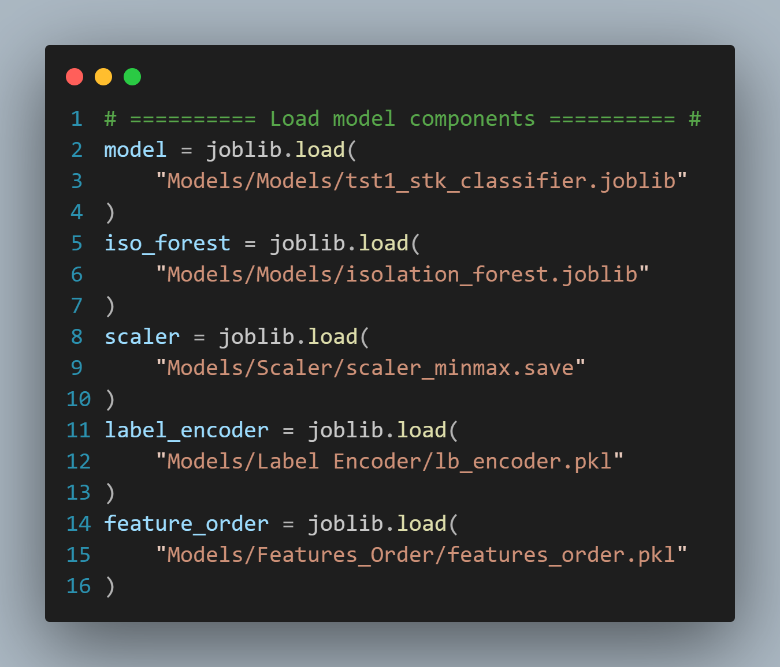

*Figure ()*

1. **Launch:**
   * 1. **Signature-Based IDS in the background thread.**

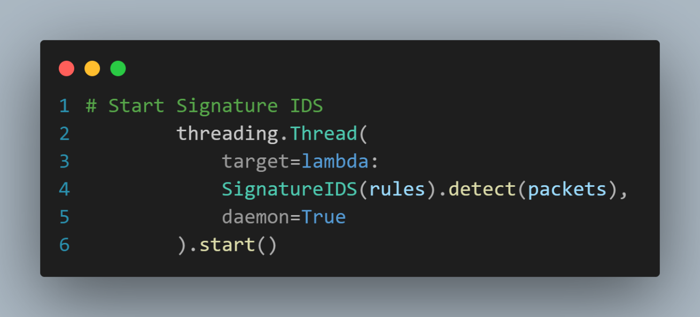

*Figure ()*

* + 1. **Anomaly-Based IDS in a parallel thread.**

*Figure ()*

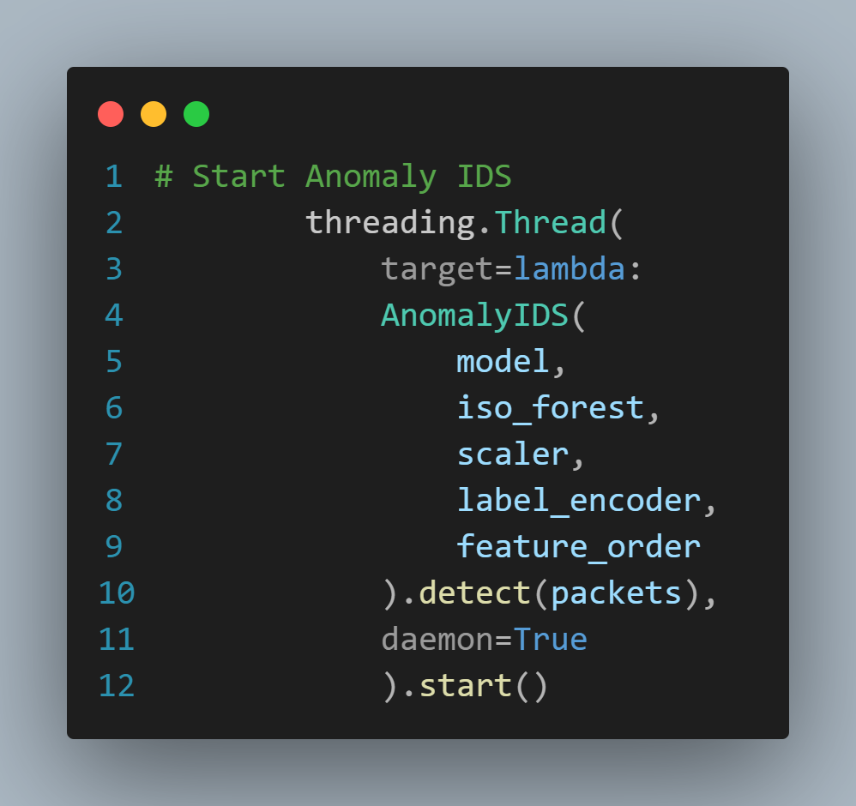

1. **Start the Flask Server**

*Figure ()*

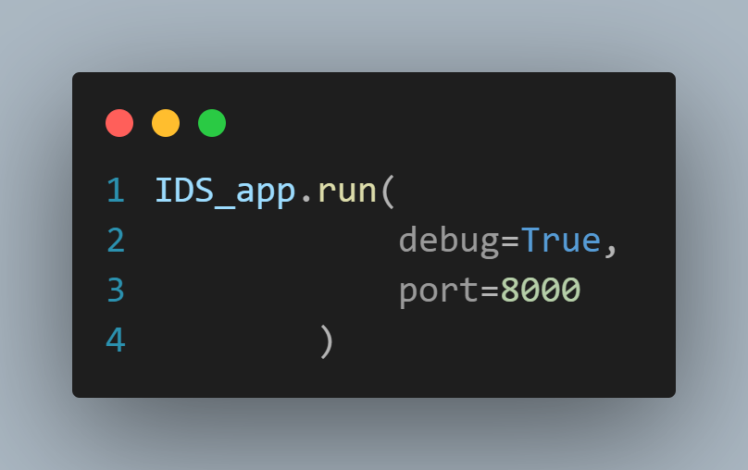

## - The Pipeline of the UI:

*Figure ()*

## Testing & Evaluation

* + - * This presents the testing methodology and performance evaluation of the developed **Intrusion Detection System (IDS)**, which integrates both Signature-based detection and Anomaly-based detection techniques.
      * The aim is to ensure the system functions correctly, detects intrusions accurately, and maintains performance under different operational conditions.

### Model Testing

* + - * After training our **hybrid Anomaly Intrusion Detection System (IDS)** composed of a **Stacking Model and Isolation Forest (IF)**, we conducted comprehensive testing using multiple approaches to evaluate its accuracy, generalization, and robustness.

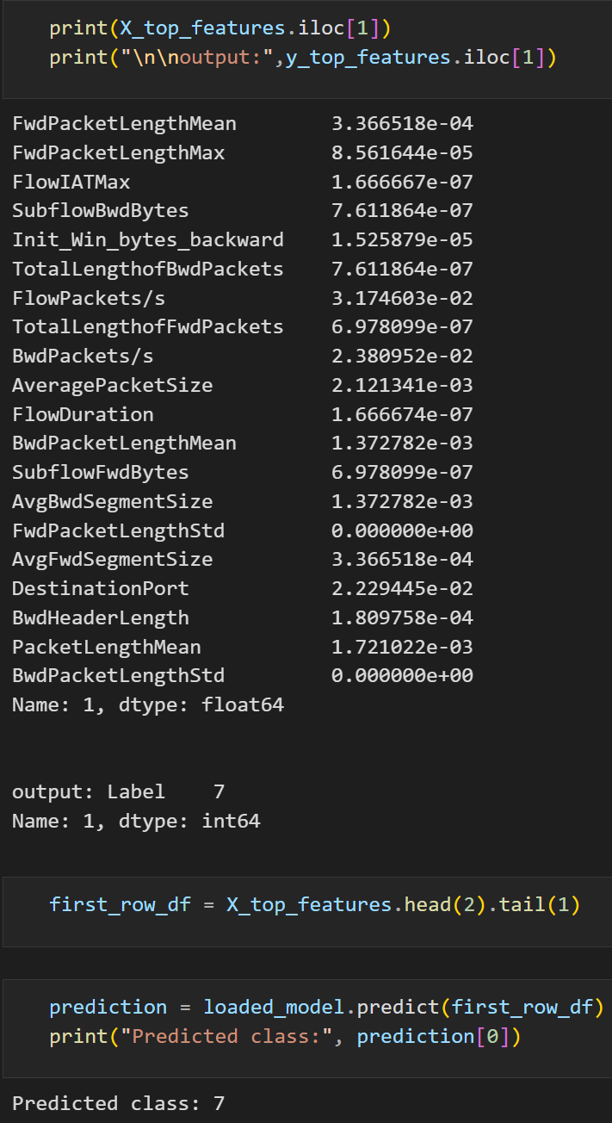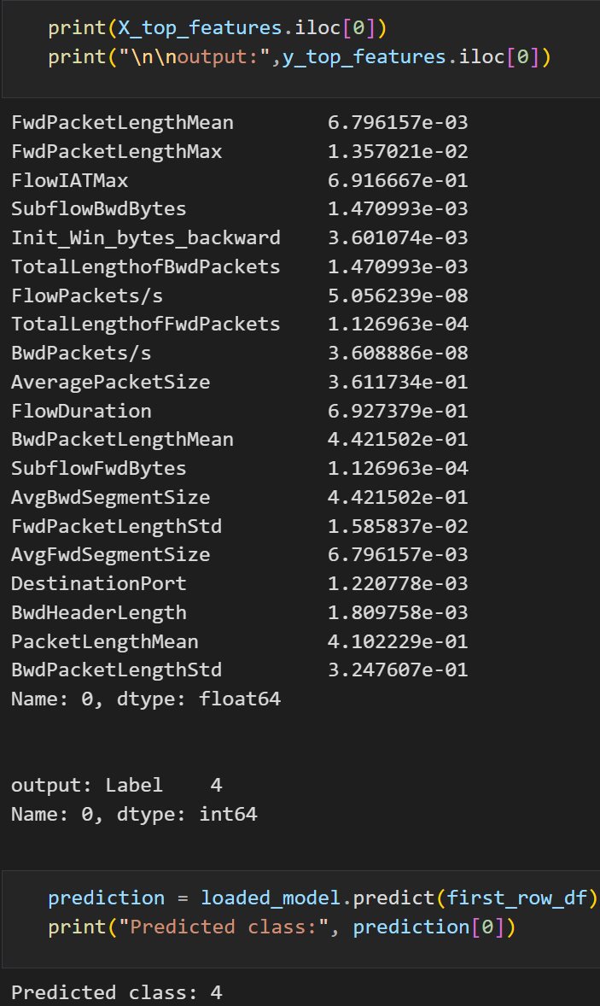

*Figure () Figure ()*

* + - * After this we apply live testing mechanism by entering the values of the features and make the prediction.

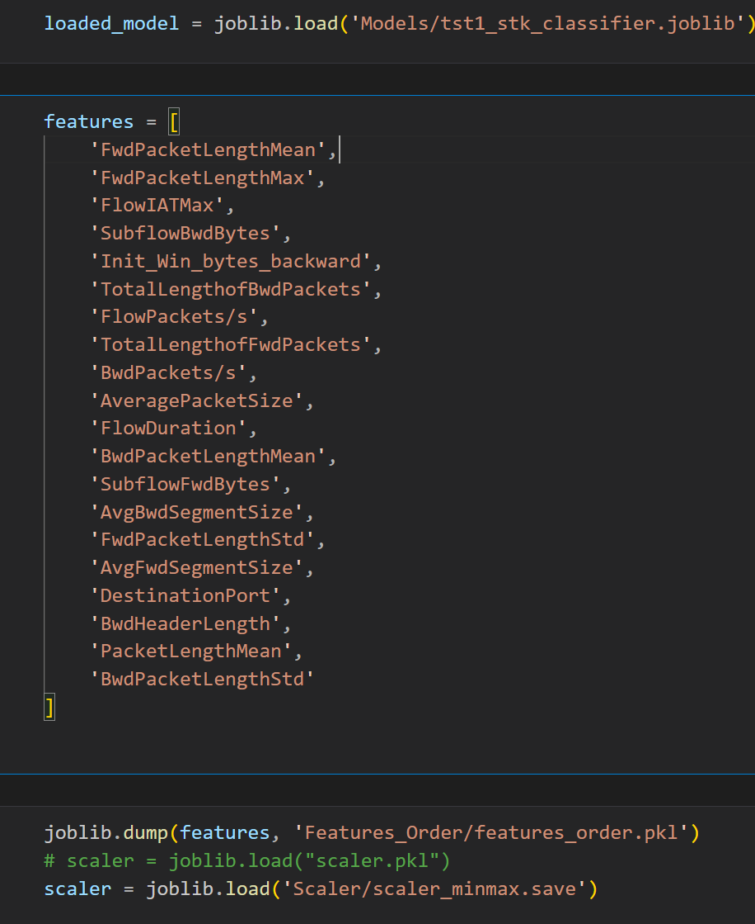

*Figure ()*

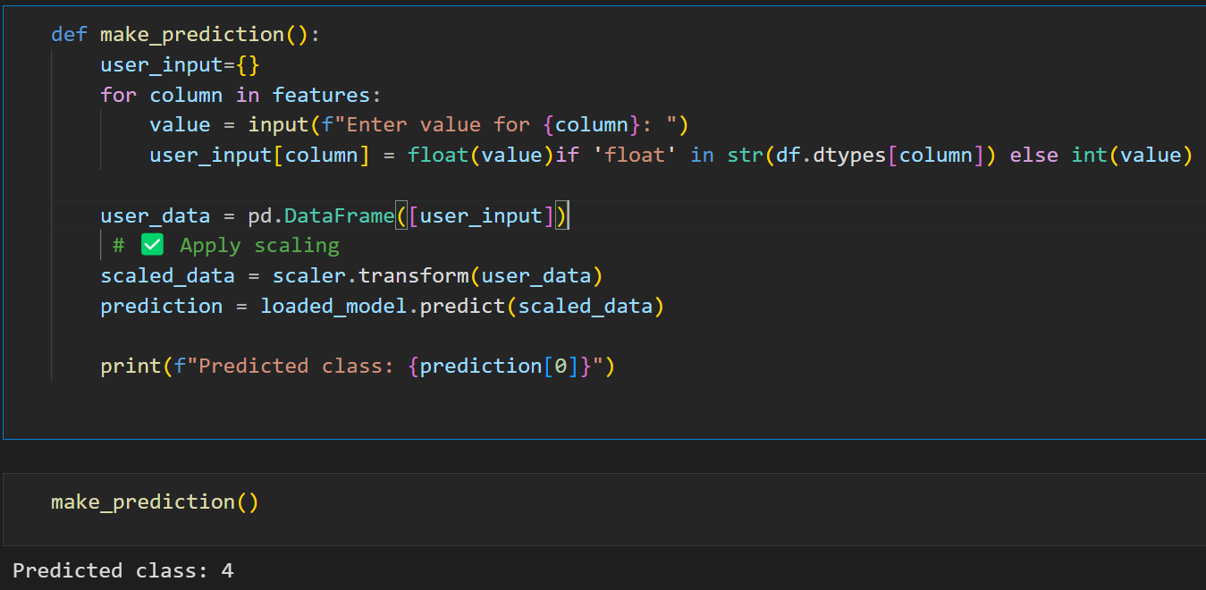

### *Figure ()*

### DPI (Deep Packet Inspection) Testing

* + - * To ensure that the **Packet DPI Class** Already working as it needed.

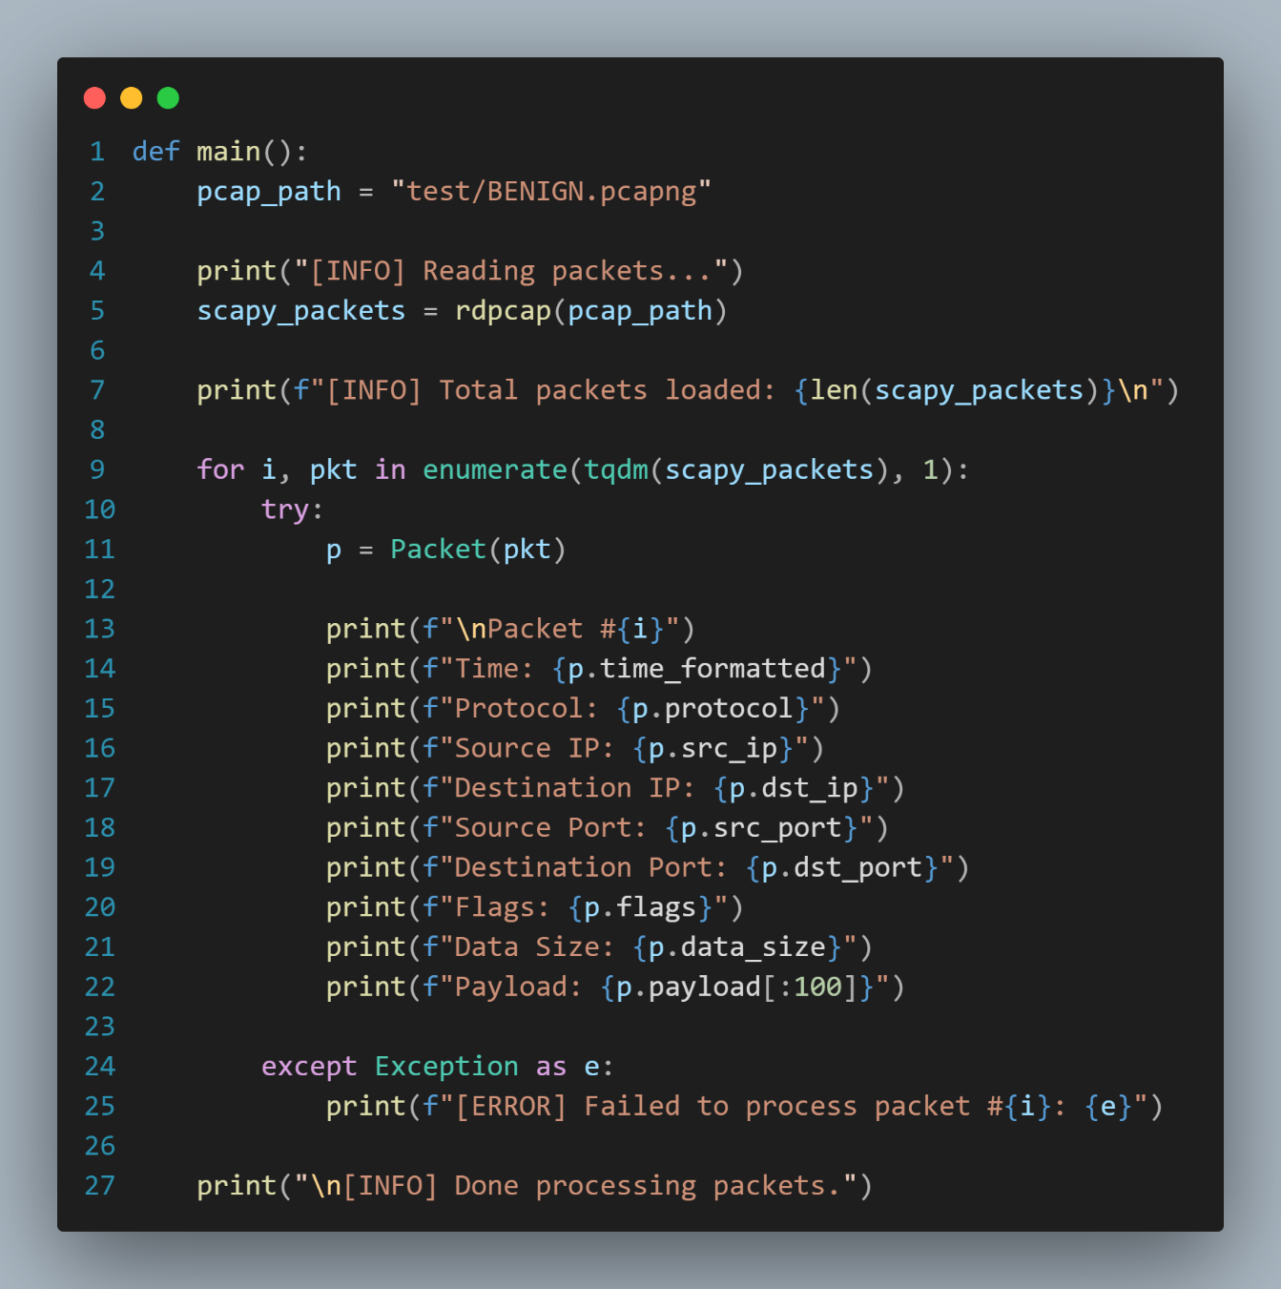

*Figure ()*

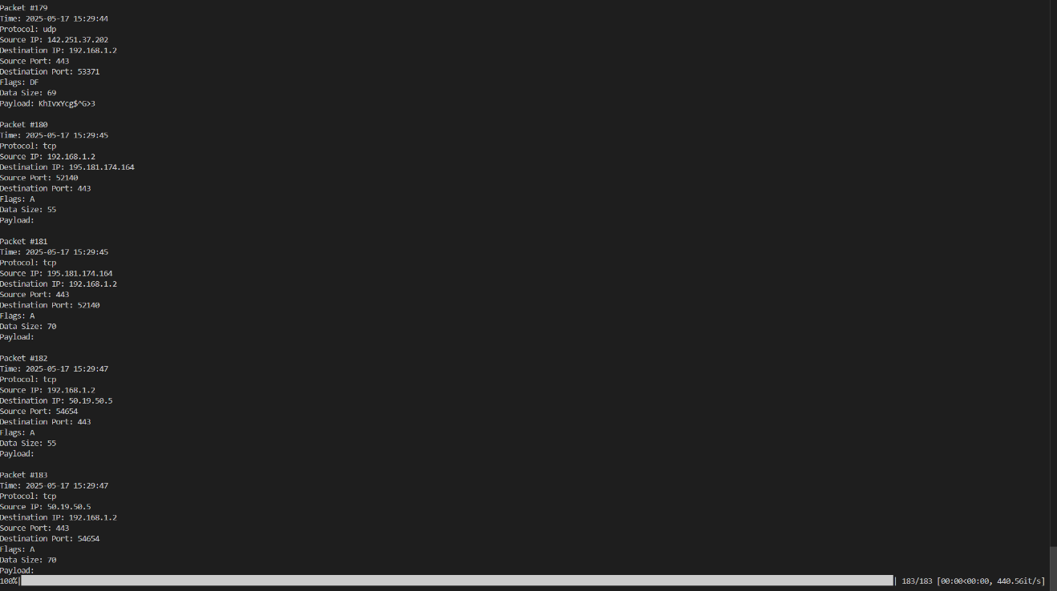

### *Figure ()*

### Extracting Flow Features

### *Figure ()*

### Performance Evaluation

* + - * To We evaluated the performance of the **Anomaly-Based Detection** model using standard classification metrics. The results show high detection, accuracy and robustness:
      * Interpretation:

High Accuracy and ROC AUC indicate excellent discrimination between normal and Malicious traffic.

The Macro F1 score suggests the model performs consistently across all classes, even if some classes have fewer samples.

| **Metric** | **Value (%)** |
| --- | --- |
| **Accuracy** | **99.72%** |
| **Precision (Weighted)** | **99.73%** |
| **Recall (Weighted)** | **99.72%** |
| **F1 Score (Weighted)** | **99.72%** |
| **F1 Score (Macro)** | **99.29%** |
| **ROC AUC Score** | **99.99%** |

### Real-Time Detection Testing

* + - * A **PCAP** file (e.g., **httpslowloris.pcac**) was loaded into the system.
      * Both **SignatureIDS** and **AnomalyIDS** were executed **concurrently** using multithreading.
      * The system generated alerts **in real-time** and stored them in the **SQLite** database.
      * Results:

Alerts were generated instantly after detecting suspicious flows.

Flows were classified correctly based on rules or anomaly thresholds.

Multithreading ensured quick processing even for large packet volumes.

* + - * 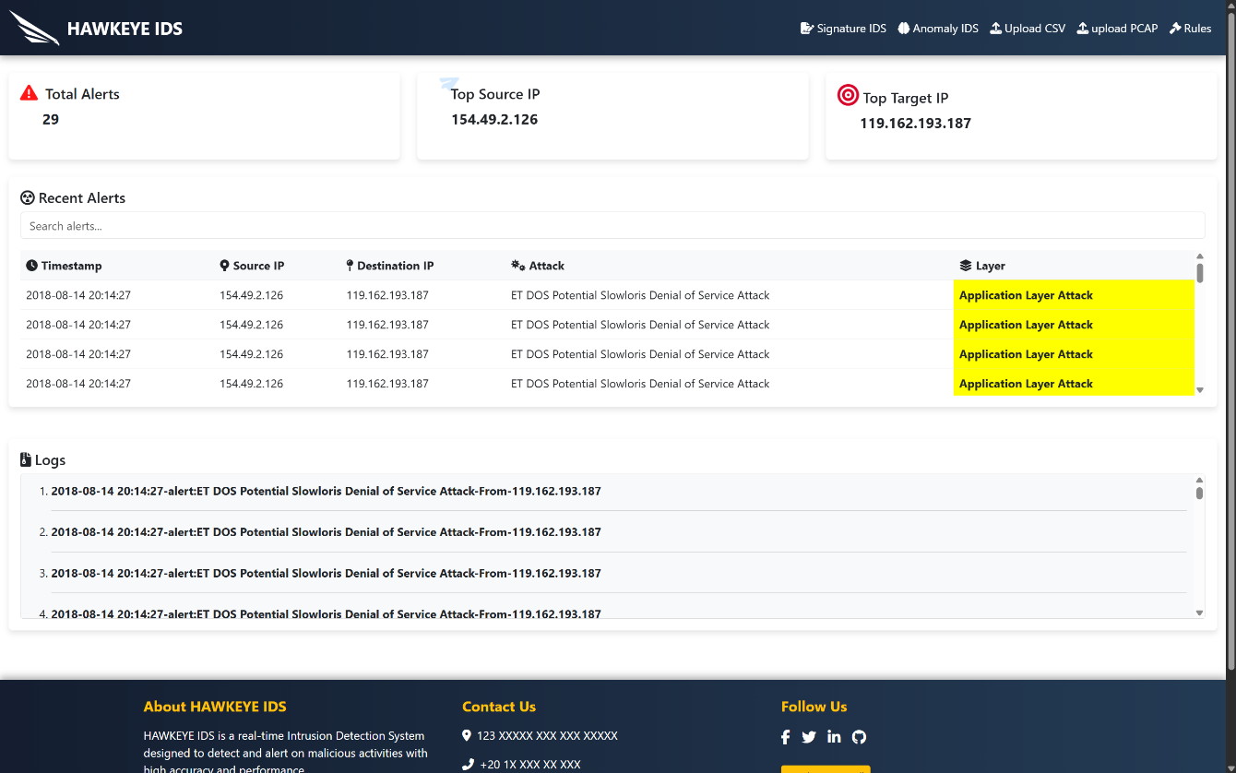For Signature-Based IDS:

*Figure ()*

* + - * 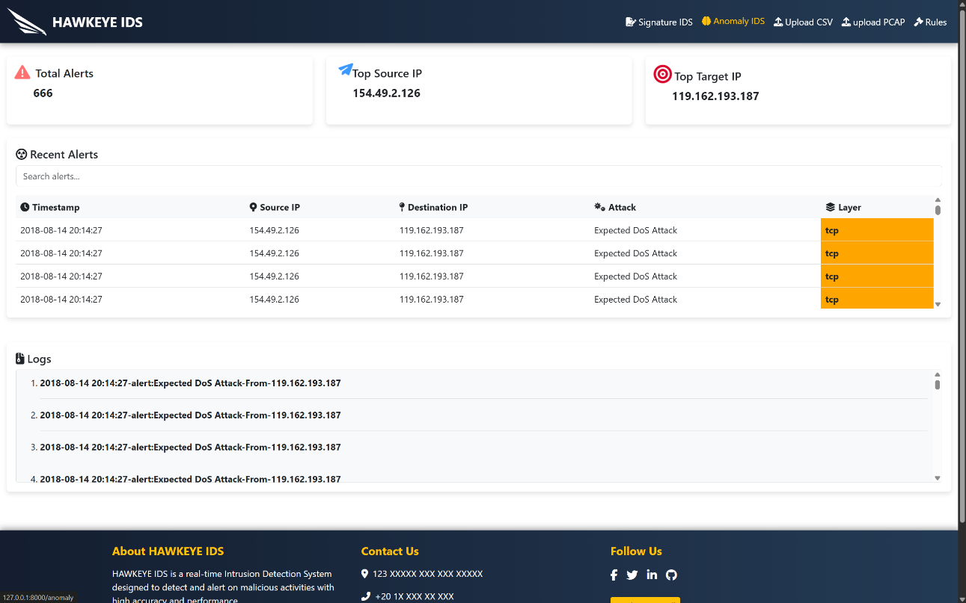For the Anomaly-Based IDS:

*Figure ()*

### PCAP File Scanning

* + - * 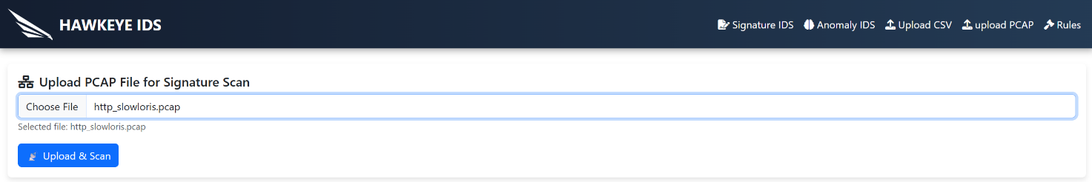By Selecting a file that is already infected with specific attack such as:**HTTPSlowloris**:

*Figure ()*

* + - * By clicking Upload and scan it will process the file throw the Signature IDS and detect what attack in this file if it exist.
      * 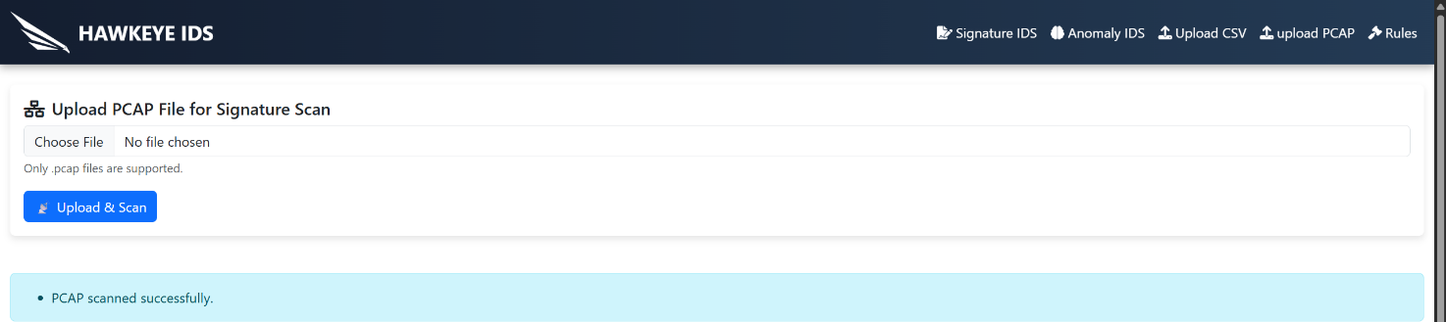Results:

*Figure ()*

*Figure ()*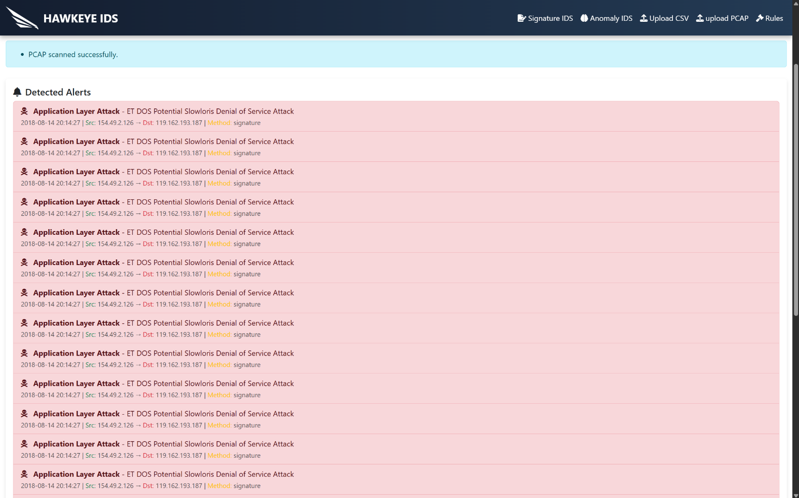

### CSV File Prediction

### By Selecting a file that is already infected with specific attack such as: HTTPSlowloris or here in the anomaly detection now we can detect the Unknown attacks:

* + - * 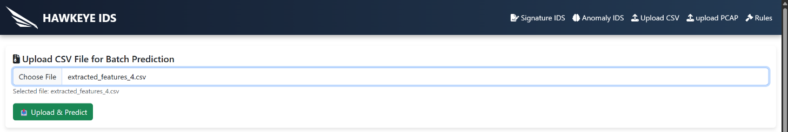By clicking Upload and scan it will process the file throw the Anomaly IDS and detect what attack in this file if it exist.

*Figure ()*

* + - * 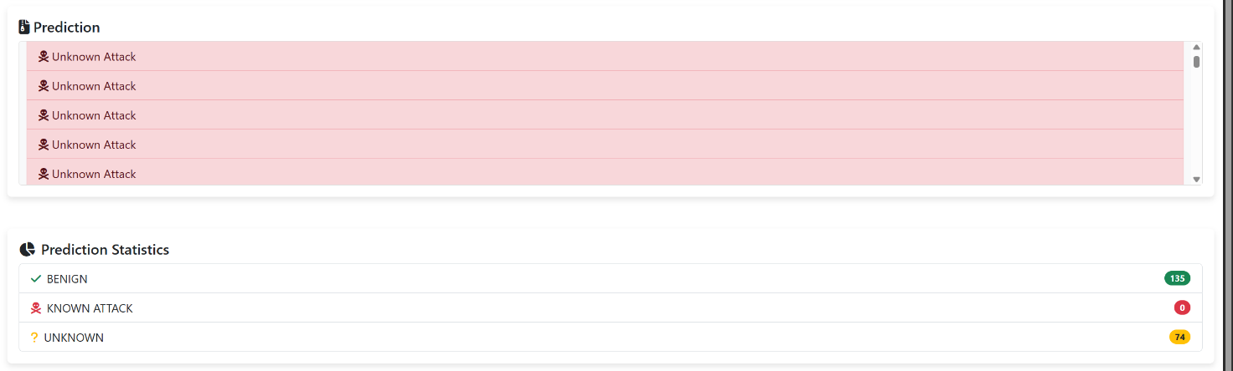Results:

*Figure ()*

### A screenshot of a computer AI-generated content may be incorrect.Display the Rules to Admin

*Figure ()*

### Adding Rules throw the Dashboard

### A close up of a blue and white line AI-generated content may be incorrect.By Clicking Add New Rule it will display the Form of adding new rule:

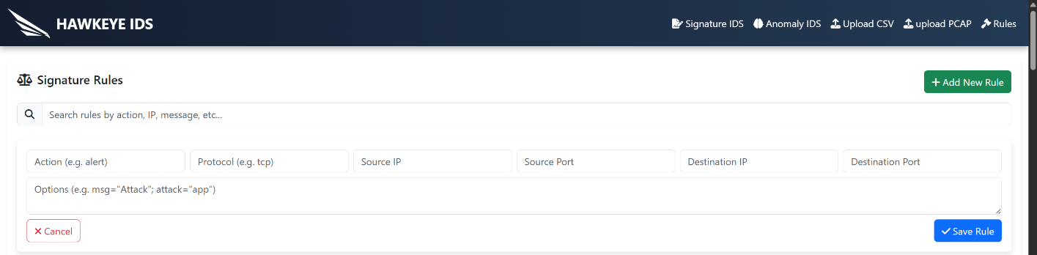*Figure ()*

*Figure ()*

### Limitations

* + - * While the system performed well in most scenarios, a few limitations were noted:
* **False Positives**: The Isolation Forest occasionally flagged rare benign traffic as malicious due to unfamiliar patterns.
* **Signature Limitation**: New or zero-day attacks are not detected by **SignatureIDS** unless rules are updated.
* **Threshold Sensitivity**: The anomaly detection threshold required fine-tuning to avoid misclassification.
* **Feature Dependence**: Anomaly model heavily depends on correct feature extraction; malformed packets may reduce accuracy.

## Technologies and Tools

### Front-End & UI

### Flask.

### HTML.

### CSS.

### Bootstrap.

### Java Script.

### 

## 

### Database

### DB SQLite

### A green logo with a black background AI-generated content may be incorrect.DPI

### Scapy

### Programming Language

### Python

### 1200px-Visual_Studio_Code_1 35_icon svgTools

### VS Code.

### 

### DB SQLite Browser.

### Snort Logo

### Snort.

### suricata logo

### Suricata.

### Github LogoGit/GitHub.

### 

### A close up of a logo AI-generated content may be incorrect.Lucid

# 

# Chapter 6 Conclusions and Future Work

## Conclusions

* + - * Based on the test cases outlined in **Chapter 4: Signature IDS**, the **Signature-Based Intrusion Detection System (IDS)** has successfully achieved its objectives and addressed the problem statement defined at the beginning of this documentation. The following key accomplishments demonstrate the system's effectiveness:

## Core Functionalities:

## Successfully detected known threats by matching network traffic against a database of predefined attack signatures.

## Provided real-time alerts for suspicious activities, enabling timely responses to potential security breaches.

## Demonstrated high accuracy in identifying and mitigating attacks such as malware, phishing, and denial-of-service (DoS) attempts.

## The Advanced Capabilities:

## Integrated a rule-based engine to dynamically update and manage signature databases, ensuring the system remains effective against evolving threats.

## Supported log analysis to provide administrators with detailed insights into network traffic and attack patterns.

## Offered a user-friendly interface for monitoring and managing alerts, enhancing the usability of the system.

## Validation of Success:

## The system passed all test cases, confirming its ability to meet the specified requirements.

## It effectively addressed the problem statement by providing a reliable and efficient solution for detecting known threats in network environments.

* + - * **In summary,** the Signature-Based IDS has been validated as a robust and effective tool for enhancing network security. It fulfills its intended purpose by offering a dependable mechanism for identifying and responding to known cyber threats, thereby safeguarding critical assets and data.

## Suggestions and Future Work

* + - * Based on There are a lot of features and possible enhancements that could be useful for future maintenance and updates to the current version of this project.
      * A list of these features and enhancements that we would like to add to enrich the system in the future.
      * While the current implementation of the **Hybrid Intrusion Detection System (IDS)** successfully combines **Signature-Based** and **Anomaly-Based** detection techniques to provide robust security, there are several enhancements and future directions that can further improve its effectiveness and scalability. Below is a list of potential improvements and additions:
* **Continue Deep Research about Anomaly-Based IDS Techniques.**
* **Search for Suitable Datasets:**
* To build and train the IDS system, high-quality datasets are essential. Research and experiment with the following datasets:
  + - **CICIDS2017:** 
      * Labeled traffic, including various types of attacks (e.g., DDoS, brute force).
      * It contains realistic and diverse traffic features**.**
    - **UNSW-NB15:** 
      * Includes modern attack types and a rich variety of features for statistical and ML analysis.
    - **NSL-KDD:**
      * An improved version of KDD Cup 99 for benchmarking.
    - **TON\_IoT Datasets:** 
      * Focuses on IoT-related threats with both network and log data.
    - **CTU-13 Dataset:** 
      * Provides labeled botnet traffic alongside normal and background traffic.
    - **Malware Traffic Analysis Repository:** 
      * Real-world malicious traffic captures for anomaly testing.
        + **Enhanced Detection Capabilities**:

**Full Anomaly Detection Implementation**: Implement all steps of the anomaly detection process, including data preprocessing, feature extraction, model training, and real-time anomaly detection, to ensure a comprehensive and robust solution.

* + - * + **Scalability and Performance Optimization:**

**Distributed Architecture**: Implement a distributed IDS architecture to handle large-scale networks and high traffic volumes efficiently.

**Parallel Processing:** Use parallel processing techniques to speed up packet analysis and reduce latency in threat detection.

**Add more Signatures to the DB.**

* + - * + **User Experience and Management:**

**Improved Dashboard**: Develop a more intuitive and interactive dashboard for administrators to monitor alerts, analyze trends, and manage system configurations.

* + - * + **Support for Encrypted Traffic**:
* **SSL/TLS Decryption**: Add support for decrypting and inspecting encrypted traffic (e.g., **HTTPS**) to detect threats hidden within encrypted communications.
* **Behavioral Analysis for Encrypted Traffic:** Develop behavioral analysis techniques to identify anomalies in encrypted traffic without decryption.

- **By implementing these enhancements,** the Hybrid IDS can evolve into a more advanced, scalable, and user-friendly solution, capable of addressing the ever-changing landscape of cybersecurity threats. These improvements will ensure that the system remains a critical component of modern network security infrastructure.

# 

# References

## References

## [1] Fortinet, “What is the CIA Triad and Why is it important?” Fortinet, 2023. <https://www.fortinet.com/resources/cyberglossary/cia-triad>

## [2] P. Rawat, “Common Security Attacks in the OSI Layer Model,” InfoSec Train, Jan. 25, 2023.

## <https://www.infosectrain.com/blog/common-security-attacks-in-the-osi-layer-model/>

## [3] D. Robinette, “What are the Two Main Types of Intrusion Detection Systems?” Stamus networks.com, 2023.

## <https://www.stamus-networks.com/blog/what-are-the-two-main-types>

## [4] GeeksforGeeks, “Intrusion Detection System (IDS) - GeeksforGeeks,” GeeksforGeeks, Apr. 08, 2019.

## <https://www.geeksforgeeks.org/intrusion-detection-system-ids/>

## [5] S. Jelen, “Security Trails | Intrusion Detection Systems: Types, Detection Methods and Challenges,” securitytrails.com, Jul. 20, 2021.

## [https://securitytrails.com/blog/intrusion detection-systems](https://securitytrails.com/blog/intrusion%20detection-systems)

## [6] “Types of Intrusion Detection System (IDS),” www.paubox.com. <https://www.paubox.com/blog/types-of-intrusion-detection-system-ids>

## [7] Wikipedia Contributors, “Man-in-the-middle attack,” Wikipedia, May 17, 2019.

## <https://en.wikipedia.org/wiki/Man-in-the-middle_attack>

## [8] M. Andriani, “HTTPS Flood | Knowledge Bases | MazeBolt,” Knowledge Base | MazeBolt |, Mar. 29, 2017.

## <https://kb.mazebolt.com/knowledgebase/https-flood/>

## [9] Wikipedia Contributors, “Transport Layer Security,” Wikipedia, Mar. 26, 2019. <https://en.wikipedia.org/wiki/Transport_Layer_Security>

## [10] “What Is HTTPS Spoofing? How It Works & Examples | Twingate,” Twingate.com, 2024.

## <https://www.twingate.com/blog/glossary/https%20spoofing>

## [11] F5, “What is SSL/TLS Encryption?” www.f5.com, 2024. <https://www.f5.com/glossary/ssl-tls-encryption>

## [12] Guest Blogger, “Open-Source IDS Tools: Comparing Suricata, Snort, Bro (Zeek), Linux,” Levelblue.com, Jun. 2024.

## [https://levelblue.com/blogs/security-essentials/open source-intrusion-detection-tools-a-quick-overview](https://levelblue.com/blogs/security-essentials/open%20source-intrusion-detection-tools-a-quick-overview)

## [13] “SNS Insider | Strategy and Stats,” Snsinsider.com, 2024. <https://www.snsinsider.com/reports/intrusion-detection-system-market-4660>

## [14] “Intrusion Detection and Prevention Systems Market by Solutions & Services - 2024|MarketsandMarkets,” Marketsandmarkets.com, 2019. [https://www.marketsandmarkets.com/Market-Reports/intrusion-detection-prevention system-market-199381457.html](https://www.marketsandmarkets.com/Market-Reports/intrusion-detection-prevention%20system-market-199381457.html)

## [15] F. Hock and P. Kortis, “Commercial and open source-based Intrusion Detection System and Intrusion Prevention System (IDS/IPS) design for an IP networks,” 2015 13th International Conference on Emerging eLearning Technologies and Applications (ICETA), Nov. 2015, doi: <https://doi.org/10.1109/iceta.2015.7558466>.

## [16] “Usage — Scapy 2.4.4. documentation,” scapy.readthedocs.io. <https://scapy.readthedocs.io/en/latest/usage.html>

## [17] C. to, “Anomaly-based intrusion detection system,” Wikipedia.org, Nov. 23, 2004. <https://en.m.wikipedia.org/wiki/Anomaly-based_intrusion_detection_system>

## [18] “The History of Anomaly Detection - Techniques, Tools and Use Cases,” ChaosGenius - Open-Source Business Observability Platform, Aug. 16, 2021.

## <https://www.chaosgenius.io/blog/a-brief-history-of-anomaly-detection/>

## [19] P. García-Teodoro, J. Díaz-Verdejo, G. Maciá-Fernández, and E. Vázquez, “Anomaly based network intrusion detection: Techniques, systems and challenges,” Computers & Security, vol. 28, no. 1–2, pp. 18–28, Feb. 2009, doi: <https://doi.org/10.1016/j.cose.2008.08.003>.

## [20] M. Bhavsar, K. Roy, J. Kelly, and Odeyomi Olusola, “Anomaly-based intrusion detection system for IoT application,” Discover Internet of things, vol. 3, no. 1, May 2023, doi: <https://doi.org/10.1007/s43926-023-00034-5>.

## [21] M. Aljanabi, M. A. Ismail, and A. H. Ali, “Intrusion Detection Systems, Issues, Challenges, and Needs,” International Journal of Computational Intelligence Systems, vol. 14, no. 1, 2021, doi: <https://doi.org/10.2991/ijcis.d.210105.001>.

## [22] S. Parhizkari, “Anomaly Detection in Intrusion Detection Systems,” www.intechopen.com, Oct. 09, 2023. <https://www.intechopen.com/chapters/88343>